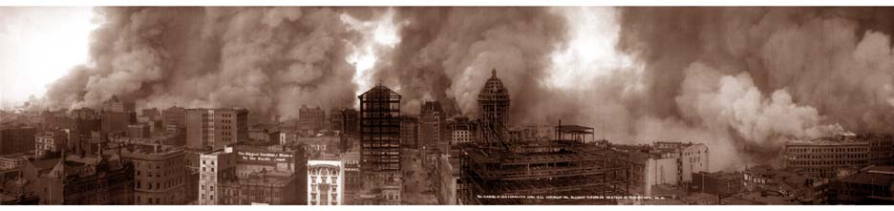
The 1906 San Francisco Earthquake

San Francisco had a serious earthquake in the early morning of April 18, 1906. The earthquake was felt from Oregon to Los Angeles. It was one of the worst natural disasters in United States history.

The earthquake damaged thousands of buildings in San Francisco. It also created a big fire. Firefighters couldn't stop it, because water pipes around the city were severely damaged. Today, we believe that the fire destroyed more buildings and killed more people than the earthquake.

We now estimate that at least 3000 people were killed – maybe as many as 6000. Most of the deaths happened in San Francisco, but 189 were reported across the San Francisco Bay Area. Nearby places such as Santa Rosa, San Jose, and Stanford University were also severely damaged. At the time, the government only reported 478 deaths. They thought reporting the true number of deaths would make it harder to rebuild the city.
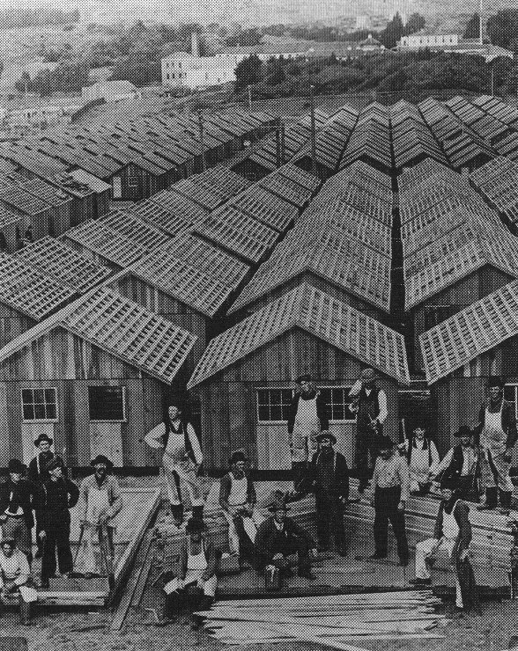 A 1906 refugee camp in SF

Between 225,000 and 300,000 people were made homeless, out of a population of about 400,000. Newspapers reported that Golden Gate Park and the beaches in San Francisco were covered with tents. (See back page) There were 21 refugee camps around San Francisco. Half of these refugees moved across the bay to Oakland.

The earthquake is infamous in part because it was the first natural disaster to be photographed so much. It also happened while scientists were studying earthquakes. The damage from the earthquake was estimated to be around $400,000,000.

Vocabulary
- create – noun and verb – Made. “About 200 years ago we created a new government here.”
- damage – verb – To hurt something, usually something that is not alive. “My car was damaged in an accident last week.”
- severely - adverb – Very badly. “My neighbor's home was severely damaged by a fire.”
- estimate – verb – An intelligent guess. “The mechanic estimates it'll be $900 to fix my car.”
- reported – verb – When a person or organization says something. “The president reported that Americans are making more money today than we were last year.”
- refugees – noun – People who have to leave where they live, usually because of a war or disaster. “There are more than one million refugees from Iraq.”
- infamous – adjective – Famous for a bad reason. “The Wendy's chili finger is infamous.”
Vocabulary Quiz
 A family living in a tent after the earthquake
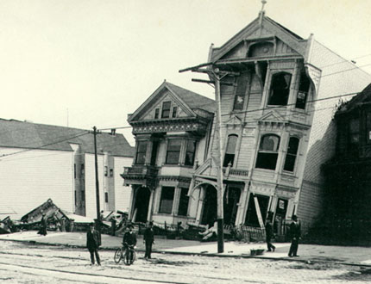 A San Francisco home after the earthquake
- ___ create | - Very badly
- ___ damage | - People who have to leave where they live
- ___ estimate | - To make something
- ___ reported | - An earthquake, fire, flood, or anything that hurts many people
- ___ severely | - Famous for a bad reason
- ___ refugees | - To hurt something
- ___ infamous | - An intelligent guess
- ___ ____________ | - When a person or organization says something

Questions
1. What hurt people in San Francisco in 1906?

2. How many people did the city report killed? How many do we estimate were really killed?

3. How many people were made homeless by the earthquake? What did they do?

4. Has anything like this happened in your country? Has anything like this happened to you?

