A Story
by Li-Young Lee
Sad is the man who is asked for a story  and can't come up with one.  His five-year-old son waits in his lap.  Not the same story, Baba. A new one.  The man rubs his chin, scratches his ear.  In a room full of books in a world  of stories, he can recall  not one, and soon, he thinks, the boy  will give up on his father.  Already the man lives far ahead, he sees  the day this boy will go. Don't go!  Hear the alligator story! The angel story once more!  You love the spider story. You laugh at the spider.  Let me tell it!  ... | come up with – think of  Baba – father  recall - remember  soon – in a short time  give up on – think someone can’t do it  once more - again

Questions
1. Who are the two people in this story?
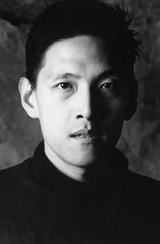
Li-Young Lee (李立揚)

2. What does one of the people ask for? What happens? Why?

3. How does the man in the story feel? Why?

4. Where do you think they are? Why?

