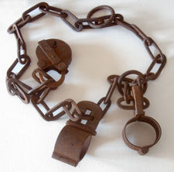
The Thirteenth Amendment

Section 1. Neither slavery nor involuntary servitude, except as a punishment for crime whereof the party shall have been duly convicted, shall exist within the United States, or any place subject to their jurisdiction.

Slavery is illegal in the United States – except for people in jail.

The Fourteenth Amendment

Section 1. All persons born or naturalized in the United States, and subject to the jurisdiction thereof, are citizens of the United States and of the State wherein they reside. No State shall make or enforce any law which shall abridge the privileges or immunities of citizens of the United States; nor shall any State deprive any person of life, liberty, or property, without due process of law; nor deny to any person within its jurisdiction the equal properties of the laws.

Anyone born in the US is a citizen of the US and of the state they live in. No state can make a law to take away a citizen's rights. A state cannot put you in jail or take your things – unless they make a law to put you in jail or take your things.

The Fifteenth Amendment

Section 1. The right of citizens of the United States to vote shall not be denied or abridged by the United States or by any State on account of race, color, or previous condition of servitude.
Section 2. The Congress shall have power to enforce this article by appropriate legislation.

1. Everyone can vote, even if they are not white, or they were a slave before.
2. The US government can make laws to make sure everyone can vote.
What happened after the Civil War?
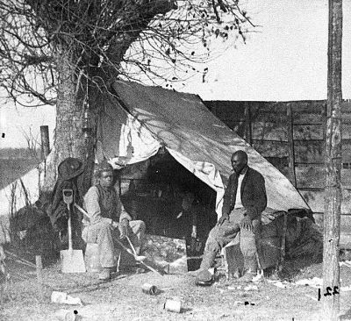Free black men after the Civil War

After the Civil War, slavery was illegal in the US. All slaves were made free. The good part was that black men and women could work and make money like everyone else. The bad part was that many of them were very poor. There were many poor white people in the South, too.

The Civil War killed hundreds of thousands of people, and made even more people lose all their money. Many white people in the South hated black people. They thought the black people made the Civil War happen. It was impossible to make black people slaves again. But the Southern states made many new laws after the Civil War. For example, they made laws to make it illegal to not have a job.

They also made laws so black people could not live in the same neighborhoods as white people, or have businesses next to white people's businesses. Some black people liked these laws. For the first time, black people could live free together. There were strong black businesses, because white people did not go to black stores. Other laws were not so good. They said black people could not ride on the same trains as white people, or go to the same hospitals.

It was also very difficult for black people to vote. The Southern states said new voters had to take difficult tests to vote. People whose grandfathers could vote did not have to take the test. This was not a problem for white people. But no black people in the South had grandfathers who could vote. These problems continued in the South for a long time.

Questions
1. Why do you think most free black men and women were poor?

2. Why did the states in the South make laws to make it illegal to not have a job?

3. Do you think the laws to make black people live and work away from white people were bad?

4. Why did the Southern states make it difficult for black people to vote? What do you think happened to black people who passed the test?

5. Why do you think there were problems in the South after the 14th, 15th and 16th Amendments?

