For the Teacher

Here are some links to help you learn more about this underappreciated moment in US history:

http://www.nps.gov/alcatraz/indian.html – From the National Parks Service, a good overiew of the occupation.

http://www.csulb.edu/~gcampus/libarts/am-indian/alcatraz/ - Amazing photos from the occupation.

http://www.pbs.org/itvs/alcatrazisnotanisland/educators.html – Lesson plans from PBS. For grades 9-12.

http://www.kqed.org/w/alcatraz/lessons.html – Lesson plans from KQED, SF's answer to PBS. For grades 9-12.

As with all my materials, please contact me with any comments or constructive criticism. Good luck! I hope your students enjoy this story as much as mine did.

Dan Spalding
Oakland, 2006
danspalding.esl@gmail.com
American Indians and Alcatraz
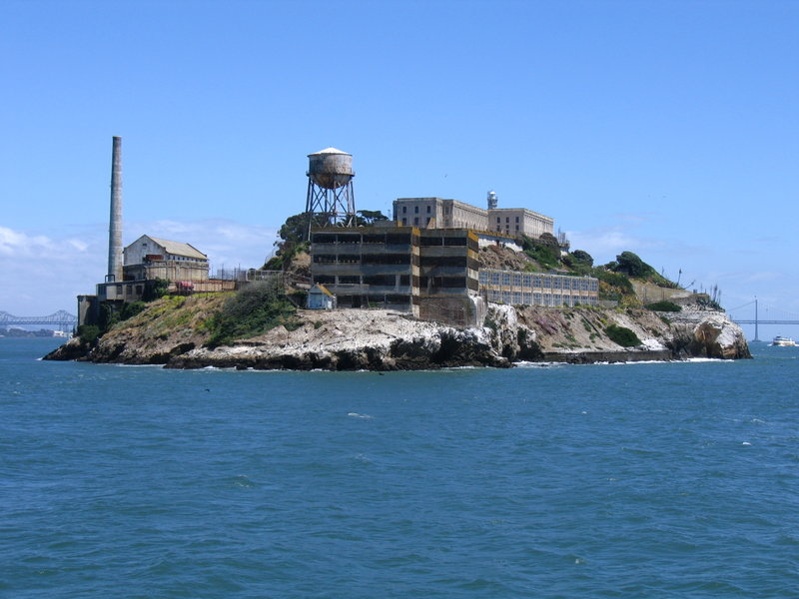 Alcatraz Island

There were many changes happening in 1969. People were fighting for their rights. More and more people wanted to stop the Vietnam War. American Indians wanted the US government to keep its promises to them.

American Indians were the first people here. When the United States was a new country, it took a lot of land from the American Indians. Many times, the government promised not to take any more land. Many times, the US broke its promises. The government also took gold, silver, oil, wood and other natural resources from American Indian land. The government gave them too little money, or no money at all.

The government made American Indians move to some of the worst places in the country. Many had to move to places called “reservations.” American Indians had to move to reservations, usually far away from their homes. In 1969, most American Indians were very poor. Most reservations had bad schools, bad hospitals and very few jobs. Half of all American Indians died by the age of 44. Most Americans thought they were all gone.

American Indians wanted to teach people that they were still alive. They wanted the government to keep all its broken promises. They decided to go to Alcatraz. For 29 years, Alcatraz Island was the most famous prison in America. It was close to San Francisco, California. It was closed in 1963.

In 1969, about 100 American Indians went to Alcatraz Island. The island had many old buildings and nothing else – no businesses, no homes, and no people. They told the US government that they wanted an American Indian museum and university on the island. They wouldn't leave until they got what they wanted.

People in San Francisco and around the country supported them. They sent food, clothes and money. The American Indians stayed there for almost two years. After a while, many of them had to leave. Finally, on June 10, 1971, the police arrested five women, four children, and six men – the last American Indians on Alcatraz. They didn't get a museum of university. But they taught millions of people that Americans Indians were still alive, and that the US needed to keep its promises.

Vocabulary
1. keep your promise – To do what you say you will do. “I kept my promise to my parents.”
2. break your promise – When you don’t keep your promise. “I broke my promise to my father.”
3. natural resources – Things from the Earth you can use, like oil, metal, and wood.
4. support – verb – To help. “I support my family by sending them money every two weeks.”
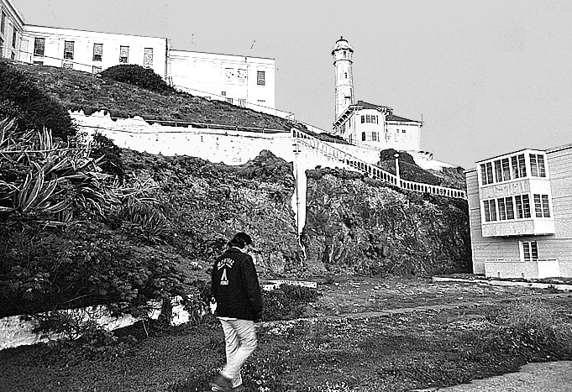
Vocabulary Practice

1. The past tense of “keep your promise” is “kept your promise.” What are some promises you have kept? For example, “I kept my promise to take my children to Disneyland.”

2. The past tense of “break your promise” is “broke your promise.” What are some promises you've broken? For example, “I broke my promise to study English every day.”

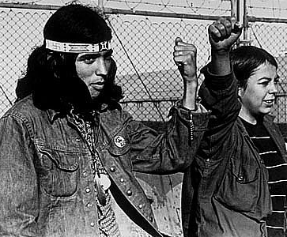
3. What are some natural resources your country has? For example, “My country has lots of oil.”

4. Do you support anyone? How do you support them?

Questions

1. What were reservations? Why did American Indians live there?

2. American Indian land had many resources. Why weren’t they rich?

3. The American Indians who went to Alcatraz Island didn’t get a museum or university. Was it still important that they went to Alcatraz?

