The American Red Cross
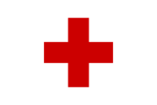 The American Red Cross Logo

The American Red Cross is one of the most famous organizations in the United States. They give people food and housing and after disasters.

Many different disasters have hit the US: Hurricanes, fires, floods, and more. The first people who help after a disaster are called “first responders.” Firefighters, medics and the National Guard are all first responders.

The Red Cross comes after the first responders. They help people who have no place to go or nothing to eat after a disaster. If you have no home, the Red Cross can help you find a hotel room or other place to stay. If you are hungry, they can serve you food. They give food to first responders, too. The Red Cross also has volunteers who speak other languages if you need an interpreter.
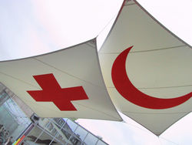 Flags for the Red Cross and Red Crescent
The American Red Cross has more than one million volunteers across the US. They teach first aid and other safety skills to about 12 million people a year.

The Red Cross is not part of the United States government. It is an independent organization. And the US is not the only country with a Red Cross. Almost every country has a Red Cross – or, in Islamic countries, a Red Crescent. About 97 million people around the world volunteer for the Red Cross or Red Crescent.

Vocabulary
- organization – noun – A group of people working together. “We started an organization to help young parents go back to school.”
- medic – noun – Someone who gives medical help in an emergency. A medic may or may not be a doctor. “A medic saved my father when he had a heart attack.”
- volunteer – noun and verb – Someone who works for free. “The Red Cross has thousands of volunteer doctors and nurses.” “I volunteer at my child's elementary school.”
- first aid – noun – How to help people right after they are hurt. “I'm not a doctor, but I learned first aid this year.”
- Islamic – adjective – The adjective for the religion of Islam. “When I was in college, I studied Islamic history in Iran and Iraq.”
Vocabulary
1.___ organization | a. The first people to help after an emergency.
2.___ medic | b. A hurricane, tornado, earthquake or fire.
3.___ volunteer | c. The adjective for the religion of Islam.
4.___ first aid | d. A group of people working together.
5.___ Islamic | e. How to help people right after they are hurt.
6.___ first responders | f. Someone who works for free.
7.___ ______________ | g. Someone who gives medical help in an emergency.

Questions
1. Had you heard of the Red Cross before? How?

2. What does the Red Cross do? What don't they do?

3. How many people volunteer for the Red Cross or Red Crescent? Why do you think they do it?
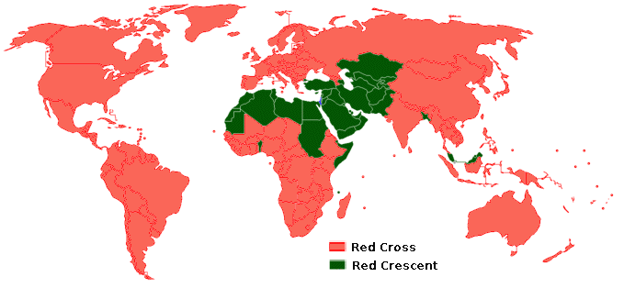 Countries with a Red Cross or Red Crescent

