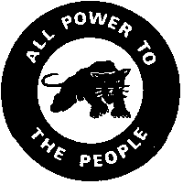
The Black Panthers, Part 1

In 1966, an organization started in Oakland, California that changed American history. It was called the Black Panthers. It was one of the most famous civil rights groups in the US.

Bobby Seale and Huey P. Newton started the Black Panthers. They saw Malcolm X and Martin Luther King, Jr. helping poor people and black people around the country. King said that you should never use violence, because if you do, the violence will only increase. He said that if you are peaceful, you will show other people how to be peaceful. King believed if black people worked hard and were peaceful, nobody could stop them from getting human rights.

Huey P. Newton and Bobby Seale disagreed with King. Black people were killed every day in America. Sometimes armed white citizens killed them. Other times they were killed by the police. Newton and Seale agreed with Malcolm X, another famous civil rights leader. Malcolm X said that you cannot tell black people to be peaceful with white people. White people killed black people every day. If black people are peaceful and white people are violent, black people will lose.

The Black Panthers started with 6 people. The first thing they did was watch the police. In the 1960s, the police were almost all white. They often arrested or hurt black people for no reason. The Black Panthers carried guns and followed the police around their neighborhood. They also studied the law together, so the police couldn't lie to them. Huey Newton had gone to Merritt College in Oakland, and had studied law in San Francisco.

The Black Panthers learned the law for tenants, and helped evicted people keep their apartments. They gave free breakfasts to poor children, and bags of groceries to poor people. They also had free clothing, free clinics, and free help for people with drug or alcohol problems.

Many young black people joined the Black Panthers. Some joined because they were doing good work. Others joined because they carried guns. This was a problem for the Panthers. Later, Huey Newton had problems, which became the Black Panthers' problems. But the police and government were the biggest problem for them.

Vocabulary
- increase –verb – Going up. “My rent increases every year.”
- armed – adj – If you have guns. “Police are armed in the US, but not in Japan.”
- leader– noun – Someone who people listen to, and tells people what to do.
- tenant – noun – Someone who rents an apartment or house. “There are 15 tenants in this building.”
- evict– verb – When a landlord kicks out a tenant. “If I can't pay my rent this month, I'll be evicted.”
Questions
1. What kind of people started the Black Panthers?

2. Why did they start the group?

3. Why did they call the group the Black Panthers?

4. Why did they disagree with Martin Luther King, Jr.?

5. Why did they have problems with the police and government?

6. Why do you think this story will have a sad ending?
The Black Panthers, Part 2
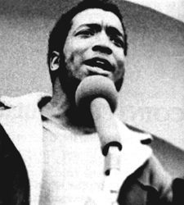Fred Hampton, 1948 to 1969

Soon there were more Black Panthers around the US. Their biggest organizations were in New York City and Chicago. There were thousands of Black Panthers. They worked with white, Asian and Latino people, and with many people in Hollywood.

They said many things that made people angry. The Black Panthers believed that the Vietnam war was wrong. They supported the people in Vietnam, and did not support the US military. They didn’t believe in elections, either. The Panthers believed that the government only worked for rich people. They said poor people had to come together to change the government.

The government, police and FBI wanted to stop the Black Panthers. The FBI followed and arrested many of them. There were armed fights between the police and the Black Panthers. In 1969, the police went into the home of Fred Hampton, the leader of the Panthers in Chicago. They shot and killed him while he was in bed with his pregnant wife. He was 21 years old.

The Black Panthers continued to work with poor people, but they spent much of their time and money in court. Huey P. Newton was arrested for shooting a police officer. Eventually, the courts said he didn't do it, but only after he was in jail for a long time.
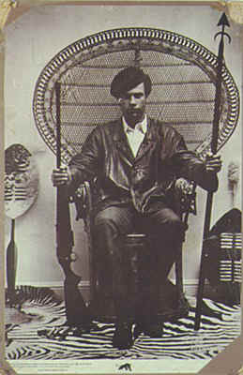Huey P. Newton, 1942 to 1989

The Black Panthers had other problems, too. They said they wanted the same rights for men and women, but the men in the group often did bad things to women. Many people believe the leaders made problems for them. When the leaders had problems, so did the Panthers. For example, Huey P. Newton had a serious drug problem, and this made it difficult for them to do work. Newton was killed in 1989, while he was buying drugs in Oakland.

The Black Panthers ended by the early 1980s. Today, they are remembered by many as a strong group that fought for poor people and black people in America.

Vocabulary
- support – verb – Help something or someone. “I support my family in my country.”
- FBI – noun – The police for the whole United States. “The FBI work in every state in the country.”
- eventually– adverb – After a long time. “Eventually, I moved out of my parents’ house.”
Vocabulary Quiz

1.__ support verb a. When a landlord kicks out a tenant.

2.__ FBI ________ b. Going up.

3.__ eventually________ c. Someone who people listen to and says what to do.

4.__ increase ________ d. Help something or someone.

5.__ armed ________ e. The police for the whole United States.

6.__ leader ________ f. After a long time.

7.__ evict ________ g. If you have guns.

Questions
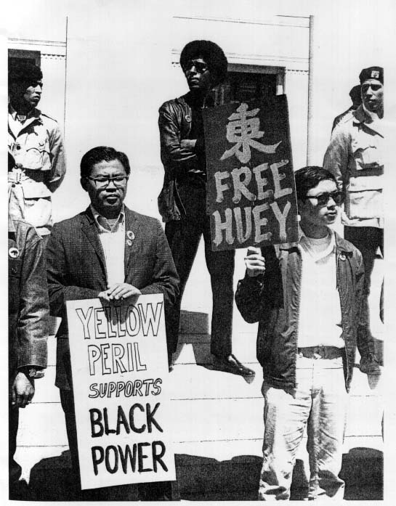Asian Americans supporting Huey Newton
1. What did the Black Panthers want?

2. Who wanted to stop them? Why?

3. What do you think was the most important thing they did?

4. What do you think the Black Panthers' biggest problem was?

The Young Lords

The Young Lords started as a Latino gang in Chicago in the 1950s. One of their members was Jose Jimenez. When Jimenez went to jail, he met Fred Hampton, who told him about the Black Panthers. Jimenez read books by Martin Luther King and Malcolm X. When he got out of jail in 1969, he changed his gang to be more like the Black Panthers.

The Young Lords served free food and had free clinics for Latino people. They made hospitals serve poor people better. Many Young Lords were from the island of Puerto Rico, which the US took in 1898. They wanted Puerto Rico to be a free country. The FBI and police arrested many Young Lords, and the group was finished by 1976.

