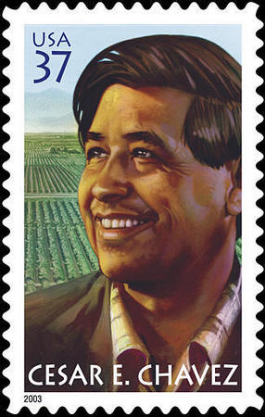
Cesar Chavez

Cesar Chavez was born in Arizona in 1927. He worked in the fields with his parents from the age of 10. He moved around a lot, and went to over 30 schools. After 8th grade, he quit school and worked full time picking grapes. He joined the military for two years at 17, and got married at 21.

At 25, Cesar Chavez was working in the fields, picking fruit. Farm workers had terrible working conditions: They made very little money. They got no breaks, no overtime, and were often paid late. Sometimes, the boss didn't pay them at all.

When he was working in the fields, Cesar Chavez met an organizer who was helping Latino people vote and fight discrimination. Chavez started working for the organization. Soon he became the president, but he quit after four years. His dream was always to help Latino farm workers. With Delores Huerta, a famous organizer, he started an organization called the United Farm Workers, or UFW.
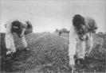 Farm workers

In 1965, the UFW started a strike of grape pickers in California. The UFW asked Americans to boycott grapes to help them. The strike lasted 5 years. The farm workers won! This was the first time farm workers won a big strike in the US. But there were many other farm workers doing dangerous work for too little money. The UFW continued to help them.

In 1968, Chavez fasted to make people pay attention to the working conditions of farm workers. A fast is when you stop eating, and drink only water. Chavez fasted for 25 days. His fast made many people learn about what was happening in the fields.

Before, many Americans thought only US citizens should have workers' rights. Cesar Chavez showed them that workers' rights are for everybody. Chavez died in 1993. In 2000, California made a holiday to remember him. Cesar Chavez Day is March 31 – Chavez's birthday. It was the first holiday for a Mexican-American, and the first for someone who fought for workers' rights.

Vocabulary
- organize – verb – Teach people to work together to help each other, or to join a union.
- working conditions – noun – How your work is. “I get good pay, but I have dangerous working conditions.” “Working conditions are not very good for many people in America.”
- discrimination – noun – When people treat people badly because of their race, sex, or other reason.
- united – adjective – When people work together for the same goals.
- boycott – noun – When people stop buying something because they don't like the business that sells it.
True or False?
 The logo for the UFW

- T / F : Cesar Chavez was born in 1926.
- T / F : Chavez was born in Mexico.
- T / F : Chavez went to more than 30 schools when he was a child.
- T / F : Cesar Chavez started the UFW to help farm workers.
- T / F : In 1965, the UFW asked Americans to boycott apples.
- T / F : In 1968, Cesar Chavez fasted for 25 days to lose weight.
- T / F : Cesar Chavez Day was the first holiday for a Mexican American, and the first for someone who fought for workers' rights.

Questions

1. Had you heard of Cesar Chavez before? What did you know about him?

2. Why did Chavez quit school? How old was he?

3. What is a fast? Why did Chavez fast for 25 days in 1968? What do you think about fasting?

4. Why did Cesar Chavez want to help farm workers?

5. What problems did farm workers have in the 1960s and 1970s? Do any other workers in America have the same problems today?

