Teacher’s Guide to “The Chickens and the Farmer”

This is a nice story to teach labor issues to students. The story comes from a short parable by Eduardo Galeano, famous Latin American historian.* You can read the story as an allegory about the false choice offered by electoral politics or the false freedom of neoliberalism. Or you can teach it to your ESL students and talk about problems they have at work.

For the question, “What can the chickens say to the farmer? What can they do?”, I’d have students brainstorm ideas. Then I write them on the board like this:

Nothing | “Please don’t eat us!” | “We’ll make more eggs,” | “No, you won’t eat us!” | Threaten to... | Run away.
 |  | “We’ll eat less birdseed.” |  |  | No eggs.
 |  |  |  |  | Ask the cows for help.
 |  |  |  |  | Fight!

I find this makes clear the spectrum of options available to the chickens, from total inaction to the most direct action. You can also brainstorm in what order you should do these things, and what the human equivalents are (No eggs=strike, fight=?).

As always, this is a work in progress. If you have any comments, questions or concerns, please drop me a line. I always appreciate feedback.

Dan Spalding
danspalding.esl@gmail.com

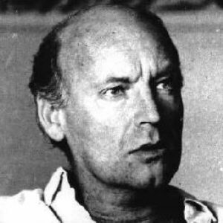Eduardo Galeano, 1940 -

* It’s from the 2005 documentary Granito de Arena, or Grains of Sand, about the radical teachers’ union movement in Mexico. Galeano wrote the Memory of Fire trilogy, a mesmerizing history of the last 400 years of Latin America, as well as Days and Nights of Love and War, among other amazing books.
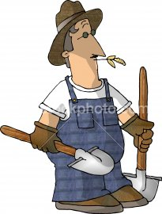
The Chickens and the Farmer

A long time ago, there was a farm. A farmer and many chickens lived there. The farmer gave the chickens a little birdseed to eat. He took their eggs and sold them.

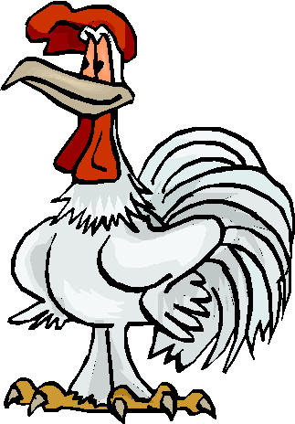
The farmer often had meetings with the chickens. Sometimes he told them to make more eggs. Other times, he wanted them to eat less birdseed. One day, the farmer had a meeting with the chickens. He told them he was hungry, and was going to eat some of them.

Then the farmer asked, “Do you want me to cook you in red sauce or green sauce?” The chickens said, “We don't want to be cooked at all.” The farmer said, “That's out of the question.”

Vocabulary
- birdseed – noun – Seeds for birds to eat. “I bought some birdseed at the pet store.”
- often – adverb – Many times. “I often eat cereal and fruit for breakfast.”

Questions
1. What does “out of the question” mean?

2. What can the chickens say to the farmer? What can they do?

3. In your life, who’s the chicken? The farmer? When are you the chicken or the farmer?

4. Do you have any stories like this where you come from?

5. What do you want the chickens to do?

