Coming to America
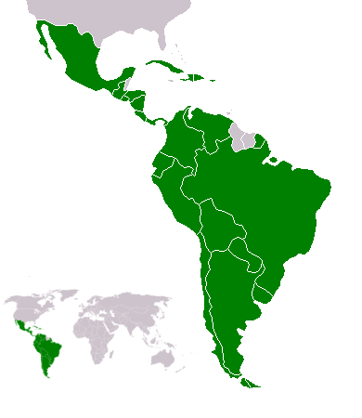 A map of Latin America

Some immigrants get visas to live and work in the US. Getting a visa is expensive and takes a long time. Those immigrants are lucky. They usually have family here. If you don’t have family living legally in the US, it’s extremely difficult to get a visa. The government doesn’t give out enough visas for everyone who wants one.

Some immigrants cross the southern border illegally. They come from Latin America (see map). These people can’t get visas from the US government, so they pay someone called a coyote. If you can pay a lot of money, the coyote will drive you from Mexico to a big city in the US, like Los Angeles, New York, or Chicago.

If you can’t pay a lot of money, the coyote will make you walk through the desert between the US and Mexico. It’s a dangerous trip. You can die if you run out of water, and sometimes people will rob you. Your coyote may lie to you, take your money, and run away – or leave you in the desert. And you might not get into the US. If the Border Patrol finds you, you have to go back to your country.

The trip from Mexico is hard but short. For immigrants illegally coming from China it’s a different story. The people who help you get here from China illegally are called snakeheads (蛇頭). If you have a lot of money, snakeheads can get you a fake passport and visa. You can fly into the US. If you have less money, you may have to hide inside a container ship (see picture).
 A container ship

It’s a long, long trip. There is very little to eat or drink for a few weeks until you arrive. When you get here you’re hungry, thirsty, tired and weak. But sometimes things go wrong. Sometimes container ships come to the US with many dead people inside of them: Chinese immigrants who wanted a better life in America.

Vocabulary
- extremely – adverb – Very, very much. “Buying a house is extremely expensive here.”
- coyote – noun – A person who helps people illegally come into the US from Mexico. Also, an animal like a dog that lives in the desert.
- desert – noun – A hot, dry place. “You have drink lots of water in the desert.”
- snakehead – noun – Someone who helps people illegally come into the US from China.
- fake – noun – Not real. “A customer gave me a fake $100 bill at work today.”
- hide – verb – Go where people cannot see or find you. “My cat hides under my bed.”
- weak – adjective – The opposite of strong. “I felt weak after working for so long.”
Questions
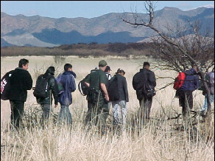 Immigrants crossing the US/Mexico border
1. What do coyotes and snakeheads do? How much money do they cost?

2. The US is spending billions of dollars to stop immigrants from illegally coming to the US. Do you think it will work?

3. If all undocumented immigrants had to go back to their countries, what would happen to the US?

Vocabulary Practice
1.___ coyote  2.___ desert  3.___ fake  4.___ hide  5.___ weak  6.___ snakehead  7.___ extremely  8.___ ___________ | a. Very, very much  b. Not real  c. A hot, dry place with lots of sand  d. Papers that let you move to another country, or work there  e. A person who helps people illegally come into the US from Mexico  f. The opposite of strong  g. A person who helps people illegally come into the US from China  h. Go somewhere so people cannot see or find you
A container ship

