What Do You See?

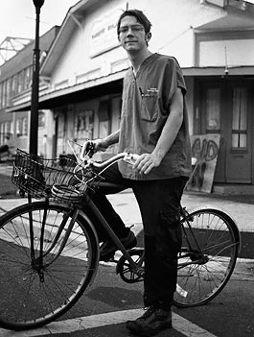
Please write down everything you see in this picture:
____________________
____________________
____________________
____________________
____________________
____________________
____________________
____________________
____________________

This person moved to New Orleans to help people after Hurricane Katrina in 2005. What does he do? Why?

__________________________________________________________________

__________________________________________________________________

__________________________________________________________________

__________________________________________________________________

__________________________________________________________________

__________________________________________________________________

__________________________________________________________________
The Common Ground Health Clinic
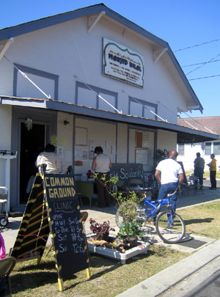Common Ground, New Orleans
Hurricane Katrina was a terrible disaster. It flooded 80% of New Orleans and killed close to 2000 people there. Thousands couldn't leave the city: The elderly, the disabled, and the poor. After Katrina, they had no food, water, phones or electricity.

Most people left in New Orleans were poor and black. They never had good medical care, and Katrina made everything worse. Most of the hospitals were closed. The American Red Cross and the US government were supposed to help, but they had no plan for New Orleans. A lot of people never saw the Red Cross – they only saw soldiers and the police.

Malik Rahim and Sharon Johnson stayed in New Orleans through Katrina. They knew their community needed medical care. Sharon put in $30 and Rahim put in $20 to start a free clinic for poor people in New Orleans. They sent an email telling their friends about their work.

Soon, volunteers from around the country came to help. Eleven days after Katrina they started the Common Ground Health Clinic. It was inside of a mosque – a place where Muslims meet and pray. At first, people didn't know about Common Ground, so medics rode around the neighborhood on bicycles, asking people if they needed medical help.

Six days after it opened, 40 volunteers were working at the clinic, sleeping outside of Rahim's home. By October, more than 100 people were coming every day for free check ups and medicine. Common Ground also traveled around the city. A lot of old and sick people couldn't come to the clinic. Common Ground started small, temporary clinics around New Orleans to help them.

Common Ground helped thousands of people with almost no money. Hospitals sent them free medical supplies. Doctors and nurses from around the world volunteered for the clinic. They worked long hours all around the city, and almost no one was paid for their work. The Common Ground Health Clinic still gives the people of New Orleans free medical care today.

Vocabulary
- worse – adjective – More bad, the opposite of better. “Mice are bad, but rats are worse.”
- plan – noun – What you are going to do. “I have a plan for next year: quit my job, move to Los Angeles, and become a movie star.”
- volunteer – verb and noun – To work for free. “I volunteered to rebuild homes after Katrina.”
- medic – noun – Someone who gives medical help in an emergency. A medic may or may not be a doctor. “A medic saved my father when he had a heart attack.”
- supplies – noun – Things that you need. “We keep a week of supplies in the basement.”
Vocabulary
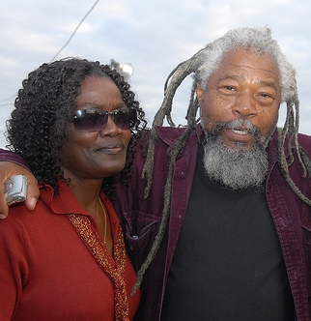Sharon Johnson and Malik Rahim
- ___ | worse | a. Someone who gives medical help in an emergency.
- ___ | plan | b. To work for free.
- ___ | volunteer | c. Things that you need.
- ___ | medic | d. When lots of water comes in and destroys things.
- ___ | supplies | e. What you are going to do.
- ___ |  | f. More bad, the opposite of better.

Questions
1. What percent of New Orleans was flooded? About how many were killed?

2. Why do you think the government didn't have a plan for New Orleans?

3. Has a disaster like Katrina happened in your country?

4. What was Common Ground Health Clinic? What did they do?

5. Why did they call the clinic “Common Ground”?

