Citizenship Lesson Plan

This lesson plan is designed to teach students about citizenship and democracy. It incorporates vocabulary, stories, and discussions to engage all learners. These materials are designed for intermediate-level English language learners, but can be changed without too much difficulty. You are free and encouraged to modify these materials. If you have any questions, comments or criticisms please contact me: Dan Spalding at danspalding.esl@gmail.com

Warm up/Introduction
Dictation
1. I drove to work and went shopping today.
2. I woke up early and voted. Didn’t you vote?
3. I can’t vote, because I’m not a citizen.
4. When will you become a citizen?
5. Well, I’m undocumented, and I’m going home in a few years, so...

Comprehension questions
“Who’s having this conversation? Is the person who voted an immigrant? How do you know? Will the other person become a citizen? Why do you have to be a citizen to vote?”

Vocabulary
Give students the Democracy Vocabulary. Have them read the words and answer the questions below. Let students correct their answers together and review them as a class.

Presentation
“Democracy and the First Citizens”
Have students read this story and do the writing exercise on the back. Read the story together using choral repetition. Ask comprehension questions. Allow students to work together in small groups to answer the questions on the back. Review answers as a whole class.

“The First Democracies”
Same as with “Democracy and the First Citizens”; reading, writing, choral repetition, comprehension questions, small group discussions, whole class review.

Evaluation/Assessment
Have students write a few short sentences. Encourage students to write perfect English. Collect their writing.
1. What is democracy?
2. What was good about democracy in Athens?
3. What was bad about democracy in Athens?
4. Why is democracy important?
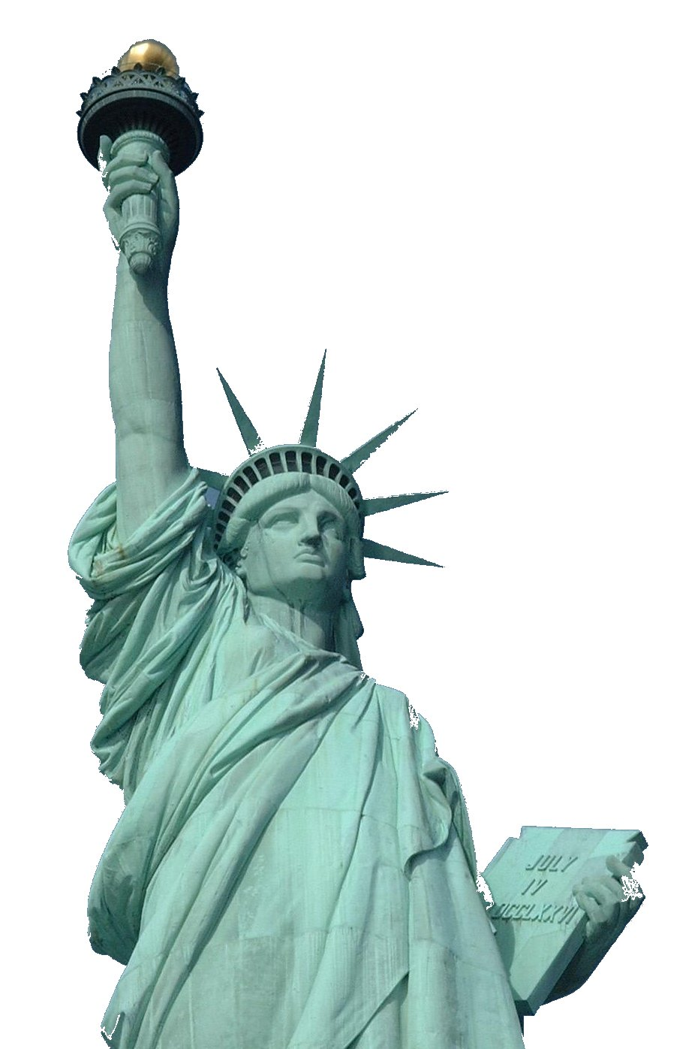
Democracy Vocabulary
1. citizen - noun - A person who is part of a country, and has all the rights of that country.

2. decide – verb – To choose what to do. “Let’s decide what we want for dinner tonight.” “I can’t decide if I want to live here.”

3. decision – noun – What you choose to do. “We made a decision to move to the US.”

4. democracy – noun – A government where people vote and have rights. The idea that everyone has human rights and helps make the decisions.

5. law – noun – What the government says you have to do. If you don’t do it, the police can arrest you. “The law says I have to pay taxes every year.”

6. responsibility – noun – What you have to do. “It’s my responsibility to open the store.” “It’s every citizen’s responsibility to vote.” “My little brother is my responsibility.”

7. rights – noun – What you can do, or how the government must help you. “I have the right to say anything I want in America.” “I have the right to workers comp. if I'm hurt at work.”

8. undocumented – adjective – A person with no US citizenship or visa. “Half the guys at my job are undocumented.” “Undocumented people have some of the rights that citizens have.”
9. vote – verb – When citizens choose their politicians. “I voted for Obama in 2008.”

Practice
Please use the words from the vocabulary above to answer these questions.

1) My friend is not a US citizen. She’s an ____________________ immigrant.

2) The American government is a ________________________________.

3) I want to be a ____________________ of the US, but it’s difficult.

4) What are a citizen’s ____________________ and ____________________?

5) I don’t always like the ____________________ my country makes.

6) I need to learn small business ____________________ in California.
The First Citizens
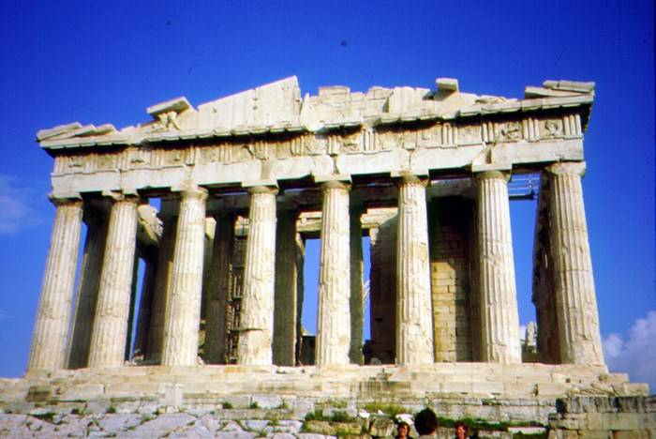 A building from Athens

Where did democracy come from? Today, we think a democracy is where citizens can vote. Two thousand five hundred years ago, the country of Athens was the first place to have citizens. Athens was in Europe. In other European countries, the king told everyone what to do. Athens was different. The citizens voted to make the decisions.

Citizens were people born in Athens who were not slaves. Some were rich and some were not. Only adult male citizens could vote. All the soldiers were also adult male citizens. Up to 6000 citizens met one to four times a month. They made the laws and voted for leaders. They decided if people had broken the law. They could also make someone leave Athens for 10 years. Citizens voted by raising their hands.

Not everyone was a citizen. Immigrants could work and live in the city, but weren’t citizens. They could not vote. Slaves were not citizens. They had to work for citizens, or the city, and they received no money for their work. (Unlike in America, slaves in Athens couldn’t be hurt or killed.) Sometimes slaves were made free - but they still couldn’t be citizens and vote. It is possible only 10% to 20% of people in Athens could vote.

Many people at that time thought democracy was a bad idea. Some thought regular people were too stupid to make important decisions. They wanted a few, smart people to make all the decisions. Others thought democracy was a way many poor people could take money from the rich.
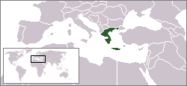 Athens was in the European country of Greece.

Vocabulary
- decision – noun – What you choose to do. “I made a decision to find a new job.”
- slave – noun – A person who must work for free. “America had slaves for 200 years.”
- decide – verb – To choose what you are going to do. “I decided to buy a used car.”
- soldier – noun – Someone who fights for a country. “My cousin is a soldier in the army.”
- break the law – verb – When you do something against the law. “The police officer said I broke the law when I drove at 90 miles per hour down International Boulevard.”
- raise – verb – To lift up. “We raised the roof on a house today.” “They raised my pay to $9 an hour.”
Writing
Try to remember and write the missing words.

1. We think a democracy is where _____________ can vote. Most people say that Athens was the first place to have _____________.

2. A few kinds of people lived in Athens. __________ were free to work and live in the city, but weren’t citizens. __________ were people who had to work for citizens and Athens for no money.

3. Many people at that time thought __________ was a bad idea. Some thought regular people were too __________ to make important __________.

Questions
1. Who were the first citizens? What rights did they have?

2. Who was not a citizen?

3. Who can be a citizen today?

4. Is it fair to have some people who can vote and some people who can't?

The First Democracies

A democracy is where everyone makes decisions together. The idea is for everyone to agree on the decisions. Many think Athens was the first democracy, because they had citizens and voting. But it’s possible there were thousands of democracies before Athens.

Most democracies were in villages. Not many people lived in villages, so if you wanted to do something – like build a new building – you needed everyone’s help. There were no police to make people do things for you. You had to tell people why what you wanted to do was a good idea. For example: “We need a new building for our food, because the old one is falling down.” Sometimes you had to change the idea to make people happy: “We can make the building in the middle of the village, so everyone can walk to it.”

People say Athens was the first democracy, because it was the first big city in Europe where a king didn't tell everyone what to do. But only male citizens could make decisions in Athens.
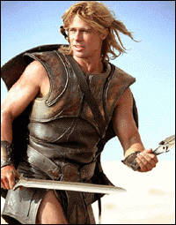
In Athens, if a citizen wanted the city to build a new building, only 50% of citizens plus one needed to vote for it. Women, immigrants and slaves couldn’t vote – about 80% to 90% of the people who lived in the city. But they all had to do what the citizens decided. That was because the military made everyone do what the citizens decided. And all the soldiers in the military were male citizens.

What do you think? Was there more democracy in a small village or in the big city of Athens? Where do America’s ideas of democracy come from? Can you have a democracy where no one is a citizen?

Vocabulary
- agree – verb – When everyone thinks something is ok, or say they will do something. “My husband and I agreed to live in the US for five years.” “My friends all agreed to help me move.”
- village – noun – A very small town. Usually, people in villages were mostly farmers. “In my country, most people live in villages.” “I moved from a village to the city.”
- military – noun – The part of the country that fights other countries. “There are more than 100,000 soldiers in the US military.”
Vocabulary Practice
1.___ break the law | a. Someone who fights for a country
2.___ decide | b. To lift up
3.___ raise | c. A government where the people decide what to do
4.___ village | d. To choose what you are going to do
5. ___ agree | e. The people who fight for a country
6. ___ soldier | f. When everyone thinks something is ok
7.___ military | g. When you do something against the law
8.___ ______________________ | h. A place where a small number of people live

Questions
1. What do you think a democracy is? Why is it important?

2. What do you think about the democracy in a village?

3. What do you think about the democracy in Athens?

4. In a village, almost everyone has to decide on something to do it. In Athens, only half the citizens had to. Why? What was the difference between Athens and a small village?

5. Would you like to live in Athens? Why?

6. What kind of democracy do we have in the US today? Who makes you do something you don’t want to do?

