The Dog and the Wolf
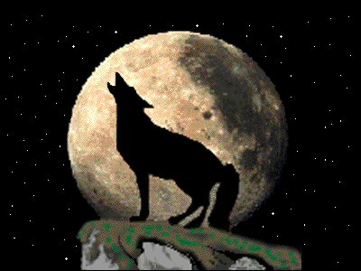 A wolf

Long ago there was a hungry wolf in the forest. The wolf hadn't eaten for weeks. It was like all the animals had left the forest. The wolf was so hungry that he hunted near where the people lived. It was dangerous for a wolf to get close to people. But the wolf was so hungry he walked all the way to the farmer’s fields.
The wolf smelled the air and looked across the field for something to eat. Then he heard a strange sound. It came from an animal that looked a lot like him.
“Woof!” said a dog.
“Cousin, why do you talk that way? We wolves never talk like that,” said the wolf.
“I am not your cousin. I am a dog, and we say 'woof' when animals come near the farm.”
“Well, maybe we're related," said the wolf. And then he saw how fat the dog was. “Cousin, why am I so hungry when you eat so well?” asked the wolf.
“I work for my meals. I chase animals away from the farm. Every evening, my master puts his leftover food into my bowl,” said the dog.
“You don't have to hunt for your food in the forest?” asked the wolf.
“Of course not, why would I do that? I only hunt for fun,” said the dog.
“Cousin, does your master need another worker? I can chase animals, too,” said the wolf.
“There is always work to do,” said the dog. “Let's go ask my master.”
The wolf and the dog went to the farmhouse. As they got near the house, the light from the windows fell on them. For the first time, the wolf saw that the dog had no fur around his neck. The wolf was surprised because the dog’s fur was soft and shiny everywhere else.
“Dog, why do you have no fur on your neck?” asked the wolf.
“Oh that, it's nothing, you'll get used to it,” said the dog.
“Get used to what?”, asked the wolf.
“Well, it's nothing, really. My master doesn't want me to run away in the daytime. He puts me on a rope, and when I pull at the rope, it rubs away the fur on my neck. It's fine, though. All I do is sleep through the day. You'll get used to it,” said the dog.
The wolf stopped. He looked at the forest, then back at the dog and then back at the forest again.
“No, Dog, I don't think I can get used to that,” said the wolf, and he ran back to the woods. “That is too high a price to pay for food. I prefer to work harder and run free.”
The dog said to him, “But Wolf, I may be tied up every day, but I am more free than you. I do not have to worry about hunting and I have a safe place to live, where my master gives me food.”
“But the life you live is not your own!” cried the wolf.

Vocabulary
- forest – noun – A place with many trees. “There are many plants and animals in a forest.”
- hunt – verb – When you look for an animal to kill and eat. “I hunt for rabbits in the spring.”
- near – adjective – Close to. “I live near a bus stop and the subway.”
- chase – verb – To run after something. “The police chased a man on my street last night.”
- fur – noun – The hair on an animal. “My cat’s fur is long and soft.”
Vocabulary Practice
1.___ | forest | a. When you look for an animal to kill and eat.
2.___ | hunt | b. To run after something.
3.___ | near | c. A place with many trees.
4.___ | chase | d. An animal that is like a big dog that lives in the forest.
5.___ | fur | e. The hair on an animal.
6.___ | _________________ | f. Close to.

Questions
1. Why is the dog happy?

2. What do you think the wolf should do?

3. Who do you know who’s like the wolf? The dog?

4. Are you like the wolf or the dog? Why?

5. Why does the wolf run away?

6. What does the last sentence of the story mean?

