Dolores Huerta
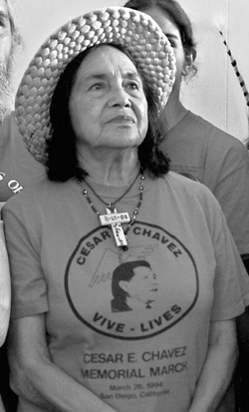
Dolores Huerta, born 1930

Almost everyone has heard of Cesar Chavez. But not so many know about Dolores Huerta. Huerta started organizing before she met Chavez, and continues fighting for workers' and immigrants' rights today.

Born in New Mexico in 1930, Dolores Huerta moved to Stockton, California when she was three years old. Her mother owned a restaurant and a 70-room hotel. She often let farm workers stay in the hotel for free.

Dolores Huerta started working as a teacher. But her students had trouble learning in the classroom. They were hungry, and came to school with no shoes on. Their parents were all farm workers. She decided it was more important to organize the parents than to try to teach the children.

She started an organization to help farm workers. They tried to stop the police from hurting immigrants, and helped immigrants become citizens and vote. In California, it was impossible for immigrants to get unemployment and other benefits. In 1965, Dolores Huerta organized people to make the government change the law so everyone could get benefits.

She met Cesar Chavez, and in 1962 they started an organization called the United Farm Workers, or UFW. Three years later, the UFW supported workers on a grape farm in Delano, California. The boss wouldn't give them a raise or benefits. The Filipino farm workers were on strike to make more money.

Chavez and Huerta taught people around the US about how the workers needed a raise, and asked them to support the workers by boycotting grapes: They asked people to stop buying grapes until the workers got a raise. They even talked to the President of the United States! After five long years, they won. This was the first big win for farm workers in America. After that, the UFW helped many more farm workers make more money, get better working conditions, and respect.

Dolores Huerta still travels around the country to teach people about farm workers. She continues to fight for immigrants' and workers' rights. She also started a school to teach people how to organize, and teaches a class about organizing at the University of Southern California.

Vocabulary
- organize – verb – Teach people to work together to help each other, or how to start a union.
- united – adjective – When people work together for the same goals.
- boycott – noun – When people stop buying something because they don't like the company or store.
- working conditions – noun – How your work is. “I get good pay, but I have dangerous working conditions.” “Working conditions are not very good for many people in America.”
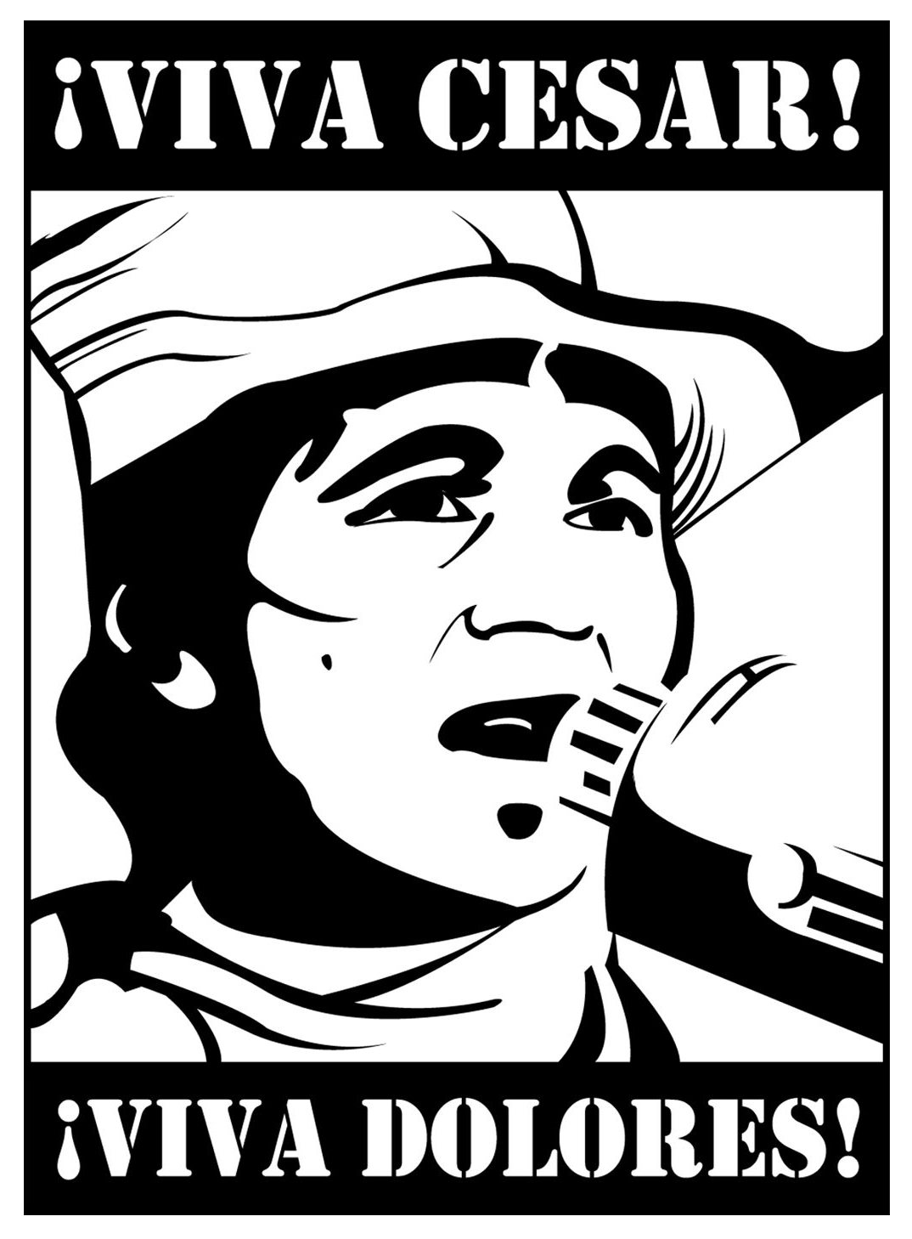
True or False?

1. T / F : Dolores Huerta was born in Mexico.
2. T / F : She was married to Cesar Chavez.
3. T / F : Huerta continues to fight for workers' rights.
4. T / F : Huerta is retired.
5. T / F : Cesar Chavez was her boss.

Questions
1. Why did Dolores Huerta quit teaching?

2. What did Huerta's first organization do?

3. How did the UFW support the farm workers in 1965?

4. What does Dolores Huerta do today?
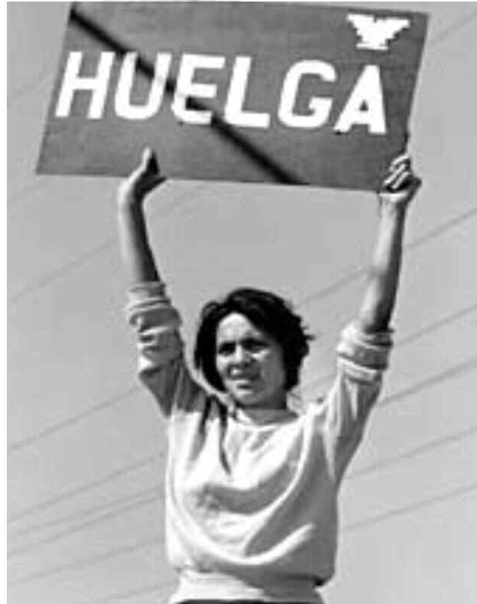
Dolores Huerta in Delano

5. Why do you think Cesar Chavez is more famous than Dolores Huerta?

