The Duck and the Moon
By Leo Tolstoy

A duck was once swimming along the river looking for fish.
The whole day passed
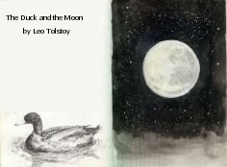
without her finding a single one.
When night came
she saw the moon reflected on the water,
and thinking it was a fish
she dove down to catch it.

The other ducks saw her,
and they all made fun of her.

From that day
the duck was so ashamed and so timid,
that even when she did see a fish under water
she would not try to catch it,
and before long she died of hunger.

Vocabulary
- once – adjective - One time.
- whole – adjective – All of it.
- passed – verb – Finished. (past tense)
- finding – noun – To see, or discover.
- single one – Even one.
- reflected – verb – When you can see something in a mirror, or in the water. (past tense)
- dove – verb – Go down into the water. (past tense)
- made fun – Make jokes about someone, say someone is stupid.
- ashamed – verb – Feel bad and stupid.
- timid – adjective – Afraid.
- before long - Soon, in a short time.

Questions
1. Why does the duck die?

2. What else can the duck do?

3. What does this story mean to you?

