Teacher Notes: Duels

This is the beginning of an unfinished unit on dispute resolution. The final unit would (will?) have stories about civil suits, criminal cases/going to the police, mediation, and so on.

Haven't done it yet. So what we have here is a fun, quirky standalone story about duels. You may want to introduce the concept of honor and talk about it briefly before passing out the story. Then have students read it and discuss. As always, the story on the back has slightly more sophisticated language; it's for the higher-level students in your class who finish early, or for students to read at home.

Finally, the tale of Lincoln's would-be duel, which is mentioned on the last line of the story. To make a long story short: Back when he was in the Illinois state legislature, Lincoln wrote meanspirited letters about another state politician. The other man, James Shields, got angry and challenged Lincoln to a duel. Lincoln, being the one challenged, got to choose the weapons, and chose long swords. Being much taller than Shields already, he intimidated the other man, because his reach was so much greater. Shields backed down. Lincoln agreed to write a letter of apology. The two rebuilt their political relationship, and Lincoln would later appoint Shields a Union general.

http://www.failedsuccess.com/index.php?/weblog/comments/abraham_lincoln_duel/
(The long version of the story is even better.)

Good luck with the story! Let me know if you get around to writing those other disupte resolution stories!

Dan Spalding
danspalding.esl@gmail.com

What do you see?

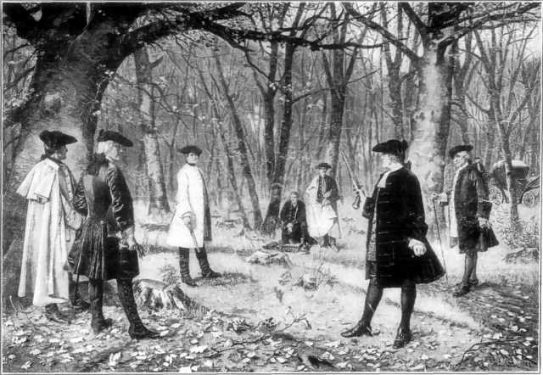
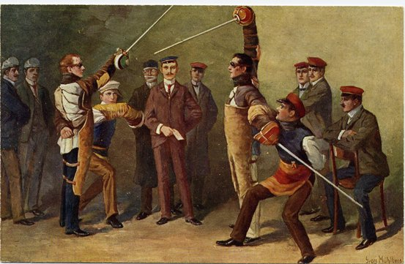
Please look at these three pictures. What do you see? Please talk about these pictures and write down everything you see.
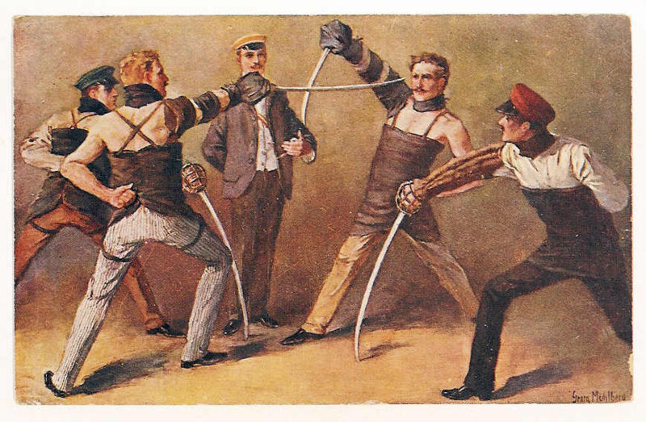
1. _______________________________

_________________________________

_________________________________

_________________________________

_________________________________

_________________________________

2. _______________________________

_________________________________

_________________________________

_________________________________

_________________________________

_________________________________

3. ___________________________

_____________________________

_____________________________

_____________________________

_____________________________

_____________________________

_____________________________
Duels
An old picture of a duel

Sometimes people disagree. You can usually talk to the person you disagree with, or write them a letter. If they broke the law, you can call the police or go to court.

For 500 years, there was one more thing people did. They had duels. A duel happened when one man thought another man insulted him. They would fight. Sometimes, one of them would kill the other. This was a duel. They were popular in Europe from the 1400s to the early 1900s. They were popular in early America, too.

Only a gentleman could duel. A gentleman was someone with land and money. Honor was important to them. If one gentleman insulted another gentleman’s honor, he had to apologize, or they had to have a duel. If a regular person insulted a gentleman’s honor, the gentleman’s workers would beat them.

The man who was insulted is called “the challenger.” He challenged the other gentleman to a duel. The man who received the challenge chose the weapons. After that both men chose a second - another man who would help them.

The seconds would find a place for the duel. They would look at the weapons to make sure they were the same. Often, the seconds would also talk together to try to stop the duel. They would try to get the gentleman who insulted the challenger to apologize, or get the challenger to stop it.

There were many types of duels. When the weapon was a gun, usually each person would shoot only one time. Sometimes both people missed and no one was injured. But if the challenger said he was happy, the duel was over. With swords, sometimes the duel continued until one person was cut – or killed. Many famous Americans and Europeans were in duels. One man even challenged Abraham Lincoln!

Vocabulary
- insult – verb or noun – To say that someone or something is no good. “He insulted me and called me stupid.” “My boss is giving me 50 cents more an hour. That’s an insult.”
- honor - noun – Your respect, if people believe you and think you’re a good person. “The gentleman’s honor was insulted by his evil brother.”
- beat – verb – To hit someone, usually with your hands. “It’s illegal to beat your children.”
- challenge – verb – To tell someone to do something difficult or dangerous. “I challenge you to climb that mountain.”
- weapon – noun – Something you use to hurt or kill people. “Guns are dangerous weapons.”
- apologize – verb – To say you're sorry. “I apologized to my boss for being 25 minutes late.”
Questions
1. Does your country have the idea of honor? Duels?

2. What does a second do? Who would be your second? Why?

3. Who would you want to duel? Why?

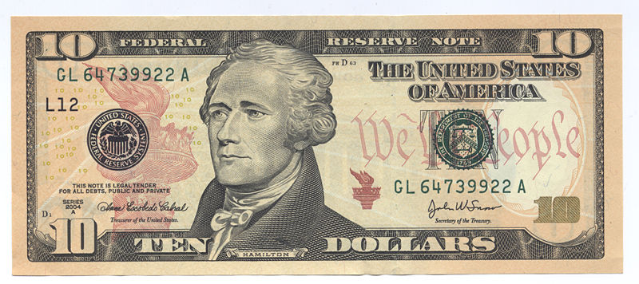 Alexander Hamilton, 1755 (or 1757) to 1804
America’s Most Famous Duel

Two politicians fought America’s most famous duel. In 1804, Aaron Burr was the Vice President of the United States. He was enemies with another politician, Alexander Hamilton. When Burr was running for President, Hamilton helped make sure that he lost. Later, Burr ran for Governor of New York. Hamilton helped make sure he lost that time, too.

Soon after the election, Hamilton insulted Burr’s honor in a newspaper article. Their friends tried to make them change their minds, but they agreed to duel on July 11, 1804. They had both dueled different people in the past. They had even dueled each other once before! They met in a park in New Jersey – the same place where Hamilton’s son was killed in a duel three years before.
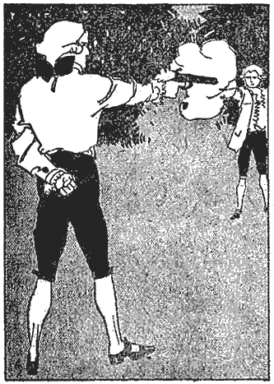 The duel between Alexander Hamilton
and Raymond Burr

Both men shot at the same time. Hamilton’s bullet hit the tree above Burr. Burr’s bullet hit Hamilton. Alexander Hamilton died at his home the next day. Dueling was illegal at the time. The states of New York and New Jersey said he was guilty of murder. However, Burr did not go to jail.

This was the end of Burr’s political career. He finished being the Vice President, but he was never elected again. Aaron Burr died in 1836. He never apologized to Alexander Hamilton’s family.

