The Emperor's New Clothes, Part I
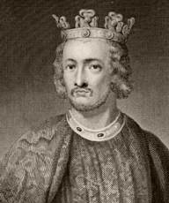 An emperor

Many years ago there was an emperor. He loved clothes, and spent all his money on them. He often walked through the city to show his new clothes. He had a different coat for every hour of the day.

The emperor's city was very busy. Every day new people came to the city. One day two men came and told everyone they were tailors. They said they made the most beautiful clothing in the world. They also said stupid people couldn't see the clothing. Only smart people could see their beautiful clothing.

“Those clothes are perfect!” thought the emperor. “When I wear them, I can learn who isn't smart. Yes, I must have the tailors make me some clothes today.” The emperor gave the men a lot of money.
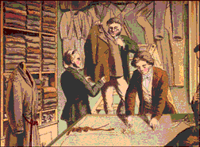 Tailors
The men went into a building and told everyone they were working. But they didn't do any work. The emperor wanted to know if his clothes were done. Everyone else in the city wanted to know, too. People wanted to see if their neighbors were stupid.

The emperor had many ministers. Ministers were very smart people who helped the emperor. The emperor asked one minister to go to the tailors. The minister went inside the building. “Oh no! I can't see the clothes!” he thought. But he said nothing.

The men asked the minister if he liked the emperor's new clothes. The minister opened and closed his eyes. “Can I be so stupid?” he thought.

The men asked, “What do you think?” The minister said, “Oh, it is beautiful, very beautiful. I will tell the emperor that I think it is perfect.” Then the men asked the minister for more money. The next day, the emperor sent more minsters to the tailors. The same thing happened. The ministers were afraid to look stupid. They came back and told the emperor about his beautiful new clothes.

Vocabulary
- emperor – noun – A king.
- often – adjective – Many times. “I often drink a beer when I come home from work.”
- tailor – noun – Someone who makes clothing.
- beautiful – adjective – Very, very pretty. “I think our city is beautiful at night.”
- stupid – adjective – Dumb. The opposite of smart. “I think my new boss is stupid.”
- perfect – adjective – Exactly what you want or need. “This apartment is perfect for me.”
- thought - verb – Past tense of think. “She thought about her English vocabulary.”
Vocabulary Practice

1.G emperor A. Exactly what you want or need
2.__ often B. Very, very pretty
3.__ tailor C. Smart people who help the emperor
4.__ beautiful D. Many times
5.__ stupid E. Someone who makes clothing
6.__ perfect F. Dumb. The opposite of smart
7.__ thought G. A king
8.__ _____________ H. Past tense of think

Please write the correct vocabulary word for the sentences below.

1. My pants are too long. I need to go to a _____________.

2. I'm a smart person, but I can be _____________ sometimes.

3. The flowers in my country are ______________.

4. Jenny doesn't go to the movies very _____________.

5. I think this class is _____________ for me.

Questions
1. What kind of person is the emperor? Do you know anyone like him?

2. What kind of people are the tailors? The ministers?

3. Why didn't the ministers say they couldn't see the emperor's new clothes?

4. What do you think will happen?
The Emperor's New Clothes, Part II
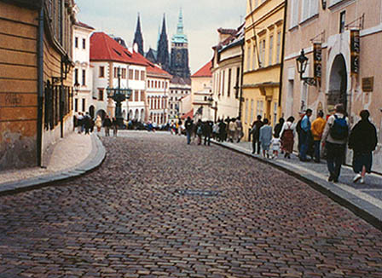
Everyone in the city was excited about the clothing. Now the emperor wanted to see his clothing. He went to the tailors with all his ministers. The ministers pointed to the empty room and said, “Look at your wonderful new clothes!” They thought everyone else could see them.

“What?” the emperor thought. “I can't see anything! Am I stupid? Am I too stupid to be the emperor? Everyone else can see the clothes!”

The emperor said, “The clothes are perfect! I am very, very happy with them.” He looked at the empty room. The ministers also looked at the empty room, and said, “Yes, the clothes are very nice.”

The tailors said, “Your new clothes are ready for you, emperor!” They pretended to lift up pieces of clothing. “Look, it's your pants! And here is your coat! They are so light, you will think you are not wearing anything. But that is because they are so expensive and nice. Please take off your clothes, so we can put on your new clothes.”

The men pretended to give the emperor clothing, and the emperor pretended to put it on. “How beautiful!” everyone said, “They are perfect for the emperor!” The emperor pretended to look at the clothing in the mirror.

The emperor went outside to walk down the street. Everyone said, “Look at the emperor's new clothes! They're wonderful! They have so many colors!” No one could show that they were stupid. The people in the city liked this clothing more than any other clothing the emperor had.

“But he has nothing on!” a little child said.

“Oh, what children say,” said his father.

Then everyone said, “But he has nothing on!” The emperor thought, “Maybe they're right, but I must finish my walk.” And all the emperor's ministers walked behind him, looking at the emperor's new clothes.

Vocabulary
- wonderful – adjective – Very nice. “I have a wonderful new friend.”
- pretend – verb – To show you are doing something you are not doing. “I pretended to listen to my mother. But I was thinking about my new job.”
Vocabulary Practice

1.__ emperor A. Dumb
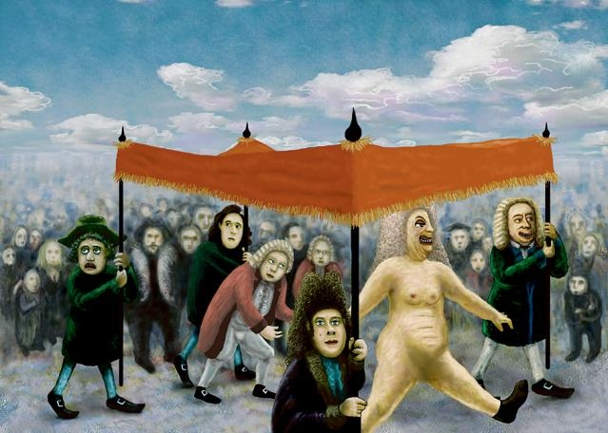
2.__ often B. Very, very pretty
3.__ tailor C. A king
4.__ beautiful D. Exactly what you want or need
5.__ stupid E. Very nice
6.__ perfect F. Many times
7.__ thought G. Past tense of think
8.__ wonderful H. Someone who makes clothing
9.__ pretend I. To show you are doing something you are not doing

Please write the correct vocabulary word for the sentences below.

1. I found the __________ job. It pays a lot of money and it's close to my house.

2. I __________ to be Santa Claus for my children.

3. Is this coat __________ or ugly?

4. I __________ my boss was __________, but he is very smart.

Questions
1. Did the ministers talk to each other about the clothing? How come?

2. Why did the emperor finish his walk?

3. Are you like the emperor, the tailors, or the ministers?

4. What is the idea behind this story? Do you think it's a true story?

5. Do you have a story like this from your country? What is that story called?

