Teacher Notes: The Four Freedoms

Welcome. These pages form an activity for students to understand the Four Freedoms, proposed by FDR as World War II broke out in Europe. The Four Freedoms were:

- Freedom of speech
- Freedom of religion
- Freedom from want
- Freedom from fear

The four freedoms were illustrated by Normal Rockwell for The Saturday Evening Post. (The US Department of Treasury later toured them around the country and raised $130,000,000 for war bonds.)

The first 5 pages are 5 separate handouts for 5 small groups of students. The first four each have one painting of Rockwell's; the fifth has all four paintings. This gives some groups the chance to look at one painting in detail, and the last a chance to look for patterns and commonality between all of them.

This is followed by a story about the four freedoms for all the students to read, before they get the chance to guess what each of the freedoms is.

I hope this is useful to you and your students. As always, if you have any questions or thoughts, please drop me a line and let me know!

Solidarity,
Dan Spalding
danspalding.esl@gmail.com
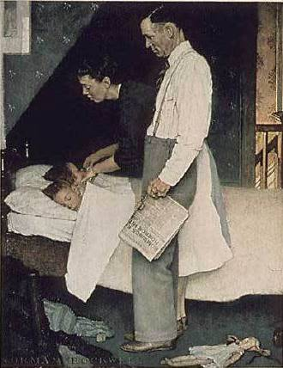
1. The Four Freedoms

In 1941, the President of the United States said that everyone in the world should have four freedoms. Two of these were things people should be free to do. Two of them were things people should be free from – that means, things people should not have happen to them.

An artist, Norman Rockwell, made famous paintings of each of these four freedoms. Please take a look at this Norman Rockwell painting and answer the questions below.

Questions
1. Who is in the painting? What’s happening?

2. How does the painting make you feel?

3. What freedom is this painting about? Is about a freedom to do something, or freedom from something?

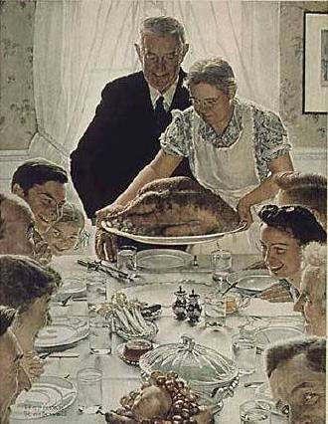
2. The Four Freedoms

In 1941, the President of the United States said that everyone in the world should have four freedoms. Two of these were things people should be free to do. Two of them were things people should be free from – that means, things people should not have happen to them.

An artist, Norman Rockwell, made famous paintings of each of these four freedoms. Please take a look at this Norman Rockwell painting and answer the questions below.

Questions
1. Who is in the painting? What’s happening?

2. How does the painting make you feel?

3. What freedom is this painting about? Is about a freedom to do something, or freedom from something?
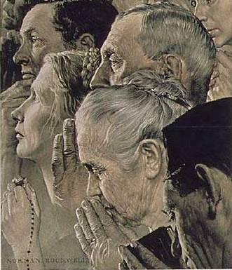
3. The Four Freedoms

In 1941, the President of the United States said that everyone in the world should have four freedoms. Two of these were things people should be free to do. Two of them were things people should be free from – that means, things people should not have happen to them.

An artist, Norman Rockwell, made famous paintings of each of these four freedoms. Please take a look at this Norman Rockwell painting and answer the questions below.

Questions
1. Who is in the painting? What’s happening?

2. How does the painting make you feel?

3. What freedom is this painting about? Is about a freedom to do something, or freedom from something?
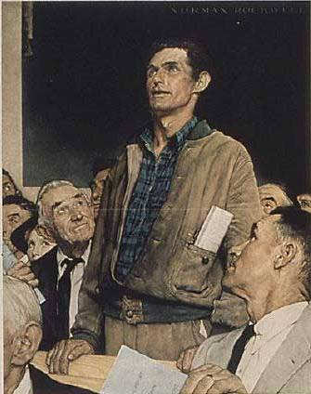
4. The Four Freedoms

In 1941, the President of the United States said that everyone in the world should have four freedoms. Two of these were things people should be free to do. Two of them were things people should be free from – that means, things people should not have happen to them.

An artist, Norman Rockwell, made famous paintings of each of these four freedoms. Please take a look at this Norman Rockwell painting and answer the questions below.

Questions
1. Who is in the painting? What’s happening?

2. How does the painting make you feel?

3. What freedom is this painting about? Is about a freedom to do something, or freedom from something?
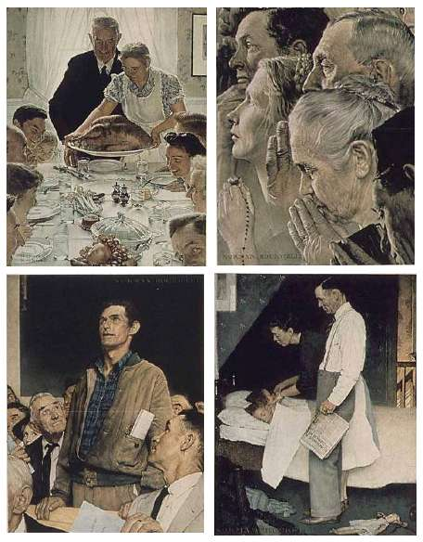
5. The Four Freedoms

In 1941, the President of the United States said that everyone in the world should have four freedoms. Two of these were things people should be free to do. Two of them were things people should be free from – that means, things people should not have happen to them.

An artist, Norman Rockwell, made famous paintings of each of these four freedoms. Please take a look at all four of these paintings and answer the questions below.

Questions
1. Who is in all of these paintings?

2. Where are these paintings happening?

3. How do these paintings make you feel?

4. Do you think people liked these paintings? Why or why not?

The Four Freedoms
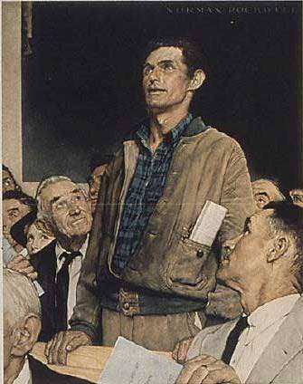
Freedom of Speech, by Norman
Rockwell

In 1941, President Franklin D. Roosevelt made a famous speech. It was about four freedoms he wanted everyone in the world to have. Two of these were freedoms Americans always had. Two of them were new.

The two old freedoms were freedom of speech and freedom of religion. These were freedoms that are in the Constitution – the highest law in the country. Freedom of speech means you can say anything you want. The government can’t put you in jail because they don’t like what you say. Freedom of religion means you can be any religion, and you don’t have to be Christian to get a job or be a politician in the US.

The two new freedoms were the freedom from want and freedom from fear. Freedom from want means you don’t need anything. You have food, a good job and a place to live. Freedom from fear means you aren’t afraid. In 1941 a war was starting – World War II. This war would kill about 50 million people around the world. President Roosevelt wanted all countries to spend less money on weapons. But to prepare for the war, he first wanted to send weapons to countries we were friends with.
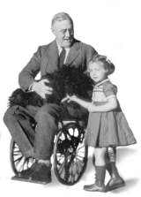
President Franklin
Delano Roosevelt,
1882 to 1945

Vocabulary
- speech- noun – When one person stands up and tells many people their ideas. Politicians give many speeches. “I listened to the Governor’s speech on the radio last night.” This also means “to talk.”
- weapon – noun – Something you use to hurt or kill someone. “The military has guns and bombs and many other weapons.” “A knife can be a dangerous weapon.”
- prepare – verb – To get ready for something. “I need to prepare for work tomorrow.”

What Freedoms are These?

Please write what freedom you think each painting is about.
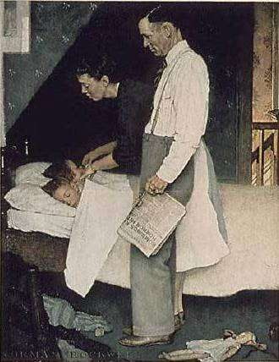
1. Freedom _________

__________________
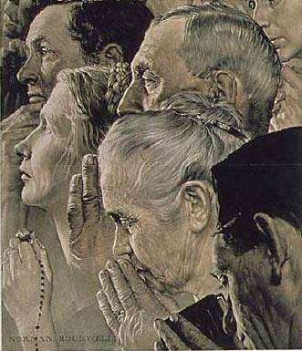
2. Freedom ___________

____________________
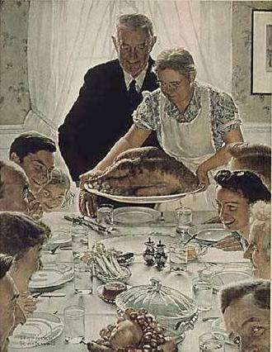
3. Freedom _________

__________________

Questions

1. What do you think about the four freedoms? Which ones are good ideas? Which are bad?

2. Which freedom is the most important to you? Why?

3. Which freedoms did we have in the US in 1941? Which ones do we have in the US today?

4. Is it possible for everyone in the world to have all four freedoms? Why?

