Frederick Douglass
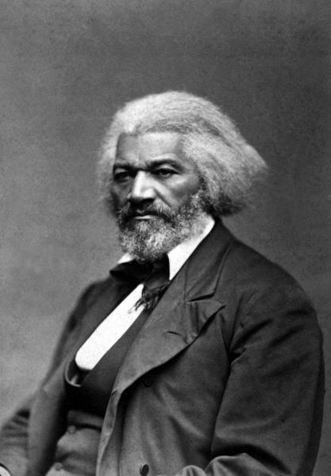 Frederick Douglass, 1818 to 1895

Frederick Douglass was born a slave in Maryland in 1818. His owner took him away from his mother when he was a baby. He never knew her. Douglass had to do hard work from the time he was a child.

It was illegal for slaves to learn to read. Douglass never went to school, but he taught himself to read and write. He escaped from the South when he was 20. He dressed up as a sailor and went on a boat to the North.

It was illegal for slaves to learn to read, but Douglass read constantly. Frederick Douglass spoke out against slavery. He became the most famous professor in America, writing books and speaking to thousands around the country. He wrote for at least five newspapers and talked to people around the US about slavery.

When he was 27, Frederick Douglass wrote his autobiography. A lot of white people believed slavery wasn’t so bad. They thought black people weren’t smart, and couldn’t do anything by themselves. Douglass’s book taught them the truth. A few people just couldn’t believe a black person could write a book so powerful and beautiful. His autobiography sold thousands of copies.

Frederick Douglass did more than fight against slavery. He also fought for women’s rights. Most women couldn’t vote in the 1800s. They couldn’t have the same jobs as men. Douglass was one of the first important men to say women should have the same rights as men. When he died at the age of 77, Frederick Douglass was almost as famous for speaking for women’s rights as he was for speaking against slavery.

Vocabulary
- escape – verb – To get away from something bad. “I escaped from a bad marriage when I was 25.”
- constantly – adverb – All the time. “I’m constantly looking for a better job.”
- autobiography – noun – A book you write about your life. “Only I can write my autobiography.”

Questions
- What did Frederick Douglass teach himself to do?

- How did he escape to the North?

- What did Douglass' autobiography teach many Americans?

