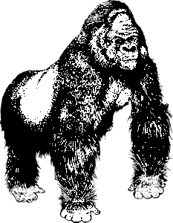
The Crocodile and the Gorilla – Part 1

Once upon a time, there was a gorilla as strong as an elephant. All day long he played in the forest, jumping from tree to tree and eating juicy fruit. Near the forest was a river where a crocodile lived. One day the crocodile was relaxing in the sun when she saw the gorilla. He was sitting in a peach tree eating fresh peaches.
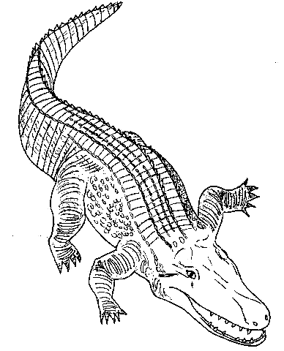
“What a handsome animal,” she thought, “I wish that I could be strong like him.” Then she had an idea. “Maybe I could be as strong as him if I eat his heart!” She decided to get the gorilla’s heart. She thought of a plan and went to find the gorilla. As she raised her head above the water, she saw the handsome gorilla drinking water from the river.

“Hello, Mr. Gorilla,” she said, “how are you this morning?”

“Just fine, thank you.”

“Are you sure? You look pretty bored. I have an idea for something fun that you can do.”

“Really?” said the gorilla.

“Yes. On the other side of the river the forest is full of fruit trees. The fruit is ripe and juicy, and you’ll be the only gorilla over there and you will be king!”

“But I can’t swim,” sighed the gorilla.

“I can help you if you climb on my back, I’ll carry you across the river,” said the crocodile.

Vocabulary
- forest – noun - A place with many trees and animals.
- raise – verb - To lift up. “I got a $2 an hour raise at work.”
- plan – noun - An idea for how to do something. “My plan is to study English for a year.”
- climb – verb - To go on top of something. “Today, I climbed a ladder. Tomorrow, a mountain!”

Questions
1. Why does the crocodile want to be like the gorilla?

2. Is there anything the crocodile can do that the gorilla can’t?

3. What do you think is going to happen next? Why?
The Crocodile and the Gorilla – Part 2
The heart

The gorilla agreed and climbed on the crocodile’s back. Half way across the river, the crocodile quickly went under the water.

“What are you doing, trying to drown me?” asked the gorilla.

The crocodile only laughed. “Did you really think that I was your friend?” she asked him. “I tricked you so that I could eat your heart.”

Quickly, the gorilla thought of a plan. “Well, my friend, you should have told me because I don’t have my heart with me today. I put it somewhere safe.”

“Oh, no!” said the crocodile, “Can you please take me to your heart? I won’t hurt you!”

“Okay, I’ll take you to my heart. It’s by the apple tree down the river. Take me there and I’ll be happy to give you my heart.”

When they got to the apple tree the gorilla quickly climbed up the tree and laughed at the crocodile. “You stupid crocodile, did you think I would give you my heart?” The crocodile lay down in the sand to cry. Tears ran from her eyes.

The gorilla felt bad for her. “Why did you want to eat my heart, crocodile?” he asked.

“Because I want to be strong like you, jumping from tree to tree and eating juicy fruit.”

“To be strong you only need to feel happy in your own heart. Wanting to be someone else will only make you sad. Go home with this and learn to be happy with who you are.”

The crocodile saw that the gorilla was telling the truth. She went back home and said to herself, “From now on, I will find the strength that I need in my own heart!”

Vocabulary
- agree – verb – To say yes to something. “I agreed to see a boring movie with my family.”
- drown – To die in the water because you can’t breathe.
- trick – To lie to someone so they do what you want. A trick can be a small joke or very serious. “I tricked my son into eating his vegetables.” “I only gave him money because he tricked me!”

Vocabulary Practice
1.___ fur | a. To go on top of something
2.___ forest | b. To die in the water because you can’t breathe
3.___ plan | c. An animal’s hair
4.___ climb | d. The part of your body that moves your blood
5.___agree | e. A place with many trees and animals
6.___ drown | f. To lie to someone so they do what you want
7.___ trick | g. To say yes to something
8.___ _____________ | h. An idea for how to do something

Questions
1. How is the gorilla strong? How about the crocodile?

2. What is this story’s idea?

3. Is it important to be happy with who you are? Why?

4. Have you ever tricked anyone? Have you ever been tricked?

5. Do you ever feel jealous? When?

