The History of Haiti
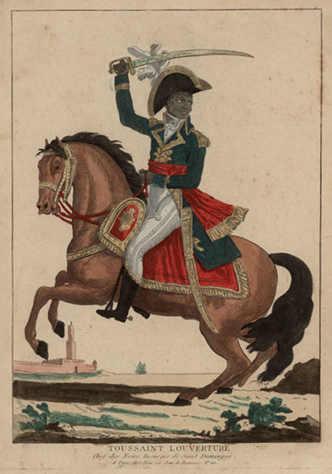 Toussaint, 1743 to 1803

Haiti has a long and difficult history. Indians were the first people to in Haiti, and lived there for thousands of years. Christopher Columbus went there in 1492, and soon after Spain made the Indians find gold for them. They killed all the Indians - between one million and eight million people.

France took Haiti from Spain in 1664. At the time, sugar was more expensive than gold. The French made slaves from Africa work on sugar plantations in Haiti. Slaves are people who work for free and have no rights. Plantations were big farms where slaves work. The French had hundreds of sugar plantations in Haiti. There were many plantations in the US, too. Slaves did all the work in Haiti. The French killed many thousands of slaves.

There was a revolution in Haiti in 1791. In one month, the slaves set 200 plantations on fire. French ships brought in more and more French soldiers, and brought out less and less sugar. By the end of the year Haiti made almost no sugar. The slaves were led by a man named Mackandal. The French caught him and set him on fire. There is a story that when Mackandal died, he said, “I will come back as a mosquito to fight the French.”

The slaves didn't give up. One slave named Toussaint who was a house cleaner. He was a brave and brilliant man. He became Haiti's most important leader.

A disease called malaria also helped. Malaria is a common disease in Africa. You get it from mosquitoes. If you get it when you’re a child, you don’t get too sick, and you can’t get it again. If you get malaria as an adult, it can kill you. The slaves all had malaria when they were children in Africa. There was no malaria in France, and it killed thousands French soldiers.
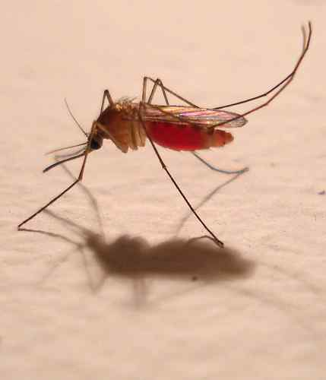 A mosquito

France was losing the war in Haiti. In 1801, they asked Toussaint to come to France to talk about peace. When he got there, they put him in jail. He died two years later, but the Haitians didn't stop fighting. France gave up in 1802. Haiti was the first black country to become free.

The United States was not good to Haiti. The US government made it illegal to trade with Haiti. In 1825, France said Haiti could be free if they paid 21 billion dollars to France. Paying that money made Haiti one of the poorest countries in the world.

Vocabulary
- Indians – noun – The people who lived in the Americas before Europeans came here.
- revolution – noun – When people in a country change the government. “The American Revolution happened in 1776.”
- mosquito – noun – An insect that sucks your blood. (see picture)
Questions

1. Where did the slaves in Haiti come from? Why did the French make them work on plantations?

2. Who made the revolution in Haiti? Why?

3. Who do you think had more money, the French army or the Haitian slaves? Why do you think the slaves won the war in Haiti?

4. Why didn’t the US government help Haiti during the war? After the war?

5. If you were the US President during the war in Haiti, what would you have done?

Mackandal, Mosquitos and Malaria
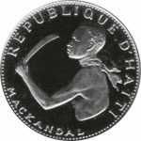 A Haitian coin with a
picture of Mackandal

Life on a sugar plantation was very difficult. Haitian slaves never got enough food or sleep. The French made so much money from sugar that they killed their slaves by making them work hard.

One slave named Mackandal wanted to change this. He escaped, or ran away, from his plantation. He worked with other runaway slaves to burn down plantations and make the French leave.

After six years the French caught Mackandal. They killed him by burning him in a fire. When Mackandal died, he said he’d come back as a mosquito to kill the French. Later, thousands of French soldiers were killed by malaria. Even more were killed by slaves who wanted to be free. Later, when Toussaint started the war with France, many plantation owners moved to the city of Philadelphia. Some of them were sick with malaria. Mosquitoes in Philadelphia sucked their blood and gave malaria to many people in Philadelphia.

Many people died from malaria, but no one knew that you got it from mosquitoes – no one except, maybe, Mackandal.

