Teacher's Guide to the Harriet Tubman lesson

This story uses basic theater, conversation and reading to teach students about the slavery, the Civil War, and Harriet Tubman. The teacher may even learn a little something about Tubman's military history and the connection between the underground railroad and the Sanctuary movement in the 1980s.

Warmup
Ask students to read the Conversation to themselves.
Answer any questions about the Conversation.
Have students practice it in partners. If it hasn't come up already, explain that the words in brackets are how you read the sentence.
Ask the partners if they enjoyed reading the Conversation. Ask one of the partners who did to perform the Conversation. Make sure to clap for them when they're done.

Intro
Ask the questions at the bottom of the Conversation. Ask students for answers.
You may need to briefly explain who slaves were (e.g. “people who had to work for no money, and had no freedom”) and slavery (“A slave is one person. Slavery is when people make black people work for for no money, and take their freedom.”). This helps later, when explaining how Harriet Tubman fought slavery and helped slaves.
You may also need to explain the Civil War. It's good to point out that not everyone in the North was opposed to slavery, and one of the things that lead to the Civil War was that the things they made in the south were cheaper. (Ask students why. They'll figure it out.)

Presentation
Have students read the front page story. If they finish early, they can start the back, particularly “The Underground Railroad” at the bottom.
When they're done, answer any questions.
Ask students what the story was about.
Review the vocabulary at the bottom.

Practice, Evaluation and Assessment
Have students answer the questions on the back. You may want students to work together.
Ask students how they want to go over the questions. Discuss them in partners? Write their answers? Discuss them together?

Overplanning – “The Underground Railroad”
FYI – Latin-American countries with US-supported civil wars/repressive governments in the 1980s include: Guatemala, Honduras, Nicaragua, El Salvador, Columbia, Chile, Argentina.
Conversation

A: [tired] I'm tired of doing all this hard work.

B: [angry] I agree. We have bad food, no rights, and no freedom.

A: [scared] Be quiet! If your owner hears you, you'll get in trouble!

B: [quietly] We can't live like this. We need to run away.

A: Where can we go?

B: We can go north, where we'll be free.

A: How can we get there?

B: There's a woman named Harriet Tubman. I heard she can help us.

A: I think it's too dangerous to run away.

B: Maybe. But we don't have a choice.

Questions

1. Who are the people in this conversation? When and where did it happen?

2. Who do you know who is like A? Who do you know who's like B?

3. Who do you think Harriet Tubman is?

4. What do you think will happen to A and B?

5. Are you more like A or B?

Harriet Tubman
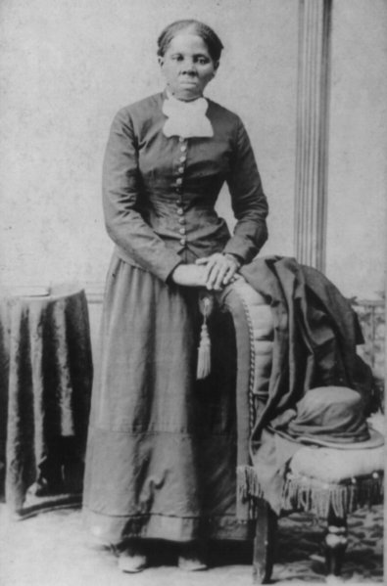 Harriet Tubman, 1822 to 1913

Before 1865, one of the biggest problems in America was slavery. Slavery is when some white people made black people work for no money, and took away their freedom. The black people with no freedom were called slaves. There were hundreds of thousands of slaves in the United States. The Civil War, which killed 500,000 Americans, was fought over slavery.

Many slaves tried to end slavery. Some of them fought the people who owned them. Some of them escaped to the northern part of the United States, where slavery was not legal. Some even came back to the South, to help more slaves run away. The most famous person who did this was Harriet Tubman.

Harriet Tubman was born a slave. From the age of five, she had to do difficult work. The woman who owned her beat her every day. When she was seven, Tubman ate some sugar. Slaves were not allowed to have sugar, and her owner tried to beat her. Harriet Tubman ran away for five days. But she had nothing to eat, so she went back to her owner, who beat her very hard. When she was fifteen, she helped one of her friends escape from his owner. His owner hit Tubman in the head with a piece of metal. She was badly hurt, and had to stay in bed for almost six months to get better.

In 1849, Harriet Tubman decided to escape to the North. Black and white people helped her get to freedom. It was very dangerous. If anyone found her or the people who helped her, they could have been killed. After she got away, she went back to the South to save her four brothers.

Tubman went back to the South 13 times before the Civil War. She helped about 70 slaves escape slavery. During the Civil War, she did even more work. One time, she helped over 700 slaves get away from a city in South Carolina. The slaves went onto ships from the Northern army. Soldiers from the North fought with soldiers from the South. It was a big success. This was the first time a woman was a military leader for the United States.

The North won the Civil War. After the war, the government gave money to soldiers from the North. But it was 30 years before the government gave any money to Harriet Tubman. When she died on March 10, 1913, Harriet Tubman was the most famous black woman in America. March 10 is Harriet Tubman Day in the US.

Vocabulary
- beat – verb – To hit someone. “I don't think people should beat their children.”
- escape – verb – Run away from something bad. “I escaped a bad marriage when I was 21.”
- save – verb – To help someone who was in trouble. “My seatbelt saved me yesterday.”
Vocabulary Quiz
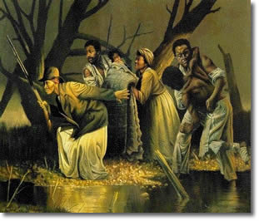 A painting of Harriet Tubman
Please write the definitions of these vocabulary words.

1. Beat:

2. Escape:

3. Save:

Questions
1. What do you think was the most important thing Harriet Tubman did? Why?

2. Why do you think it took 30 years for Harriet Tubman to get her retirement money?

3. What do you think Harriet Tubman is most famous for?

The Underground Railroad

When slavery was legal, there were many people who helped slaves escape to the North. They did this in secret. These people hid slaves in their homes, and helped them travel north. This network of people around the US was called “the Underground Railroad.” It was not a real train. It was a way for thousands of slaves to get to freedom. White people and free black people made the underground railroad. They had to be very careful. Many people, even in the North, did not want slaves to be free.

In the 1980s, the many people from Latin America came to the US. They were escaping wars in their country. The wars started because the US gave money and guns to bad people in their country. The people who came to the US had no papers. Some Americans helped them stay here. The Americans said they got their idea to help from the Underground Railroad.

Vocabulary
1. hid – verb – Past tense of “hide.”
2. network - noun – A group of people, far away from each other, who work together.

