Hawaii
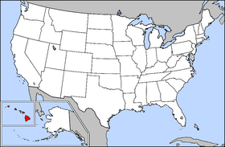 A typical map of the US with Hawaii and Alaska

1. What do you think of when you think of Hawaii?

2. Is Hawaii a city? A state? A country?

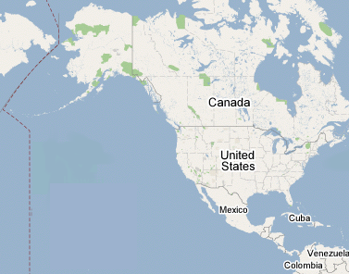
3. Please show where you think Hawaii is on this map. How big is it?
The History of Hawaii
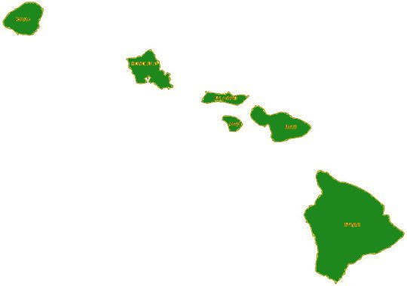The islands of Hawaii

Hawaii is the name for a group of islands in the Pacific Ocean. The first people arrived there around 1000 years ago. They came by boat from islands near Australia. People on some islands made boats, while others made cloth or caught fish. Usually the islands traded together, but sometimes they fought against each other, too.

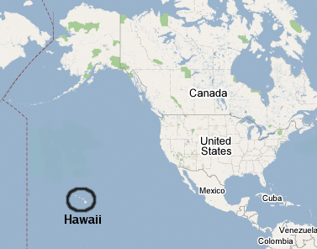
In 1778, sailors from England were the first Europeans to go to Hawaii. There was a fight, and Hawaiians killed the leader of the sailors. Soon after, a Hawaiian man became king and made all the islands one country. The Hawaiian islands were a country for almost 100 years.

At this time, more and more Americans and Europeans moved to Hawaii. Some got rich selling delicious Hawaiian fruit to the rest of the world. In 1887, a group of wealthy American and European businessmen brought a small army to the king. They wanted to change the law so that only rich people with money and land could vote. They said that if the king didn’t change the law, they would kill him. The king changed the law.

In 1894, wealthy Americans, Europeans, and a few wealthy Hawaiians started a new government in Hawaii. They wanted to make Hawaii part of the US. President McKinley took Hawaii in 1898. This made it easier for businesses in Hawaii to trade with the rest of the US. Hawaiians became US citizens and could move to the US. But Hawaii was not a state, and Hawaiians couldn’t vote. The US President chose the Governor of Hawaii.

President McKinley wanted to make America more powerful. He fought a war against Spain to take the islands of Puerto Rico and Guam. The US government built many warships in Hawaii, and kept them there so we could fight against countries in Asia.

Hawaii didn’t become a state until 1959. First, the US government voted to make it a state. Then, the people of Hawaii voted to make it a state. Almost everyone voted for Hawaii to become a state. Today, Puerto Rico and Guam are still parts of the US, but they aren’t states.

Vocabulary
1. trade – verb – To buy or sell many things. “The US and Canada trade many products.”
2. sailor – noun – Someone who works on a ship. “Sailors work on ships all around the world.”
3. wealthy - adjective – Very rich. “Wealthy people don’t live in my neighborhood.”
4. warship – noun - _____________________________________________________________
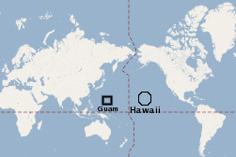
Questions

1. Who wanted the king to change the laws in 1887? Why did the king do it?

2. In 1898, who wanted Hawaii to become part of the US? Why?

3. Why did the US government have so many warships in Hawaii?

4. Do you think it was good for Hawaii to become part of the US? Why?

5. What other countries should become US states?

6. Did people ever change the government in your country to make more money?

