Teacher Notes for Haymarket

I've had great success teaching this lesson after the story about worker-run businesses in Argentina, “Who's the Boss?” That way students have an idea of what worker-run businesses look like. Another quick point: After going over the story, I inevitably have to explain the idea of a society based on anarchism. I do so by first making the diagram below of society under capitalism and socialism. (the “w”s are workers, and the groups of them are workplaces; the blue boxes indicate who has control over those workplaces) This makes it a lot easier for students to understand at least the ideal of an anarchist society.

(This is also a great lesson to teach on May Day.)
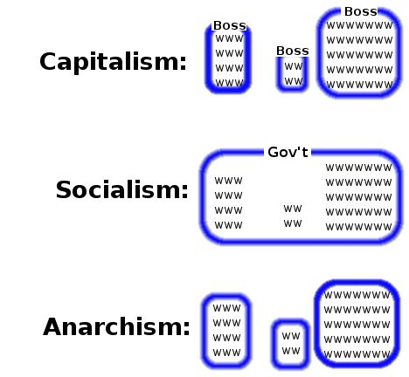
Haymarket and the Eight-Hour Workday
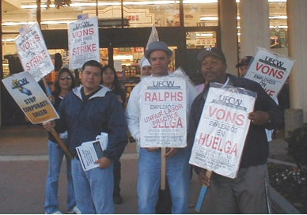 A strike at Vons grocery store.
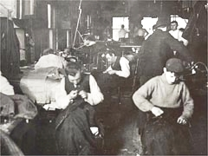 Children worked in factories
for very little money.
Most workers in the US work eight hours a day. But it wasn't always this way. In 1886, the rich made everyone work too much, for too little money, in dangerous jobs. People worked 10 to 12 hours a day, 6 days a week. Children did the same work as adults – sometimes even more. If you wanted to make things better, the police would stop you.

Workers had to fight to get better lives. One big union said that after May 1st, 1886, no one should work more than eight hours in one day. On May 1st there was a march of 80,000 people for the eight hour day. The next day there was a huge strike all around the United States. About 350,000 people went on strike.
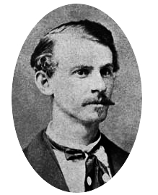 Albert Parsons, one
of the eight protest
organizers.

In Chicago, the police killed four people and hurt many more at a strike. The next day there was a large protest at Haymarket Square in downtown Chicago. At the end of the protest, someone threw a bomb at the police. Then the police shot many people. About 11 people, including 8 police officers, were killed.

The police arrested eight organizers of the protest. No one said they threw the bomb. The police never found out who did it. But because they organized the protest, the courts said the bomb was their fault.
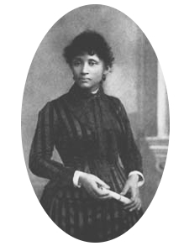 Lucy Parsons,wife
of Albert Parsons.
She never stopped
fighting for
workers' rights.

Workers around America and the world said it wasn’t their fault. There were huge protests for them. Five of the eight organizers were immigrants. And all eight were anarchists. Anarchists believe people want to work together and help each other, and that we don’t need bosses or the police. Anarchists believe in democracy in our jobs. Immigrants and anarchists were not popular in America. The courts killed four of the eight organizers, and the rest went to jail for a long time.

Haymarket was one of the most important protests for workers' rights in America. After the protests, May 1st, or “May Day,” was a holiday to celebrate how important working people are. Almost every country celebrates May Day – except for the US.

Vocabulary
- union – noun – An organization of workers who help each other get good work with respect. “I'm in a carpenters union.”
- march – noun – When many people walk together, to protest or a celebrate.
- huge – adjective – Very, very big. “That new building is huge!”
- strike – noun – When workers stop working to get what they need.
- protest - noun – People come together to make something better.
- A march is one kind of protest. A strike is another kind.
- organizer – noun – A person who makes something big happen.
- organize – verb – To make something big happen. “I organized a wedding.”
Vocabulary Practice

Please match the vocabulary words to their definitions.
1.___ Protest | A. The day we remember Haymarket and working people.
2.___ March | B. When workers do not go to work so they can get what they need.
3.___ Organizer | C. Many people come together to change something bad.
4.___ Strike | D. Very, very big.
5.___ Organize | E. When many people walk together.
6.___ Union  7.___ Huge  8.___ _________ | F. A person who makes something big happen.  G. To make something big happen.  H. An organization of workers who help each other get more money and  benefits.

Questions
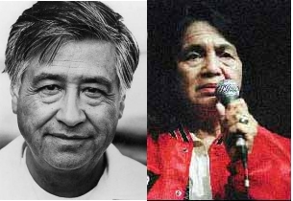Dolores Huerta & Cesar Chavez were union organizers. They helped immigrant farm workers get more money and safer work – and more respect from the boss.

1. Do you think the 8 hour workday is important? Why?

2. Why do companies want you to work more than 8 hours?

3. Why do workers today have the 8 hour day and benefits?

4. Why do you think the courts sent the Haymarket organizers to jail, and killed some of them?

5. They Haymarket Protests were not successful. Were they still important? Why?

6. Why do you think we don't celebrate May Day in the US?

