The Best Adult School in the World?
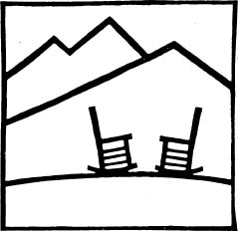The Highlander School logo

The history of the Highlander School is the history of unions and the fight for civil rights in America. Started in Tennessee in 1932, Highlander believes that people can, and must, find the answers to their problems. The teachers can help their students find their answers, but they can't give them the answers. The students can then work together to make a better world. This made Highlander one of the most famous schools in the world.
When Highlander started, its students were workers and unemployed people in Tennessee. Not many people knew about the school. That changed when the teachers started creating new unions. They helped start unions and teach new union members in 11 states.

Highlander always wanted to stop discrimination in America. It was the only school in the South that taught black people and white people together. But the big unions didn't want to help black workers or other black people in the US. It was years before this changed. The unions worked less and less with Highlander, so Highlander focused on civil rights. Black people couldn't vote, get good jobs, or have human rights in most of the South. Hundreds of black and white people who wanted to change America went there – including Rosa Parks and Martin Luther King, Jr.

States in the South didn't let black people vote if they couldn't read. White voters in those states didn't have to read. Several black teachers who visited Highlander helped start Freedom Schools, to help black men and women learn to read, write, and vote.
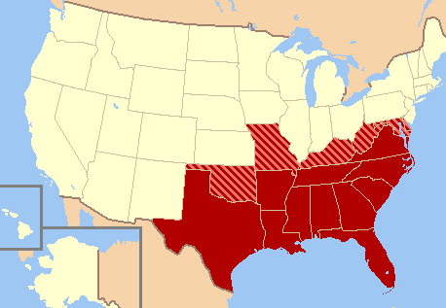The American South

While they were teaching, powerful people were trying to close Highlander. Politicians, businessmen and newspapers in the South hated the school. In 1962, the state of Tennessee closed Highlander and took away their buildings and land.

This wasn't the end of Highlander. They started a new school, and it still teaches people how to make change. Today, they teach more and different people. They have classes for people working to save the environment, stop the war in Iraq, and fight for immigrants' rights in the US. After more than 70 years, Highlander is still an important and dangerous school.

Vocabulary
- the South – noun – The states in the south eastern part of the US. (see picture)
- focus – verb – To think about and study one thing. “We focused on conversation in class today.”
- environment – noun – The land, air, forests, rivers, mountains, and oceans.
Questions

1. Who went to Highlander? Why?

2. Why do you think “politicians, businessmen and newspapers” hated Highlander?

3. Why is Highlander “an important and dangerous school”? Who is it dangerous for?

4. Do you think Highlander is a good school? Why?

5. Is your school like Highlander? Why?


How does Highlander Work?

Rosa Parks was famous for fighting for civil rights for black people. But before she was famous, she went to Highlander. She said it was the school for the civil rights movement. Highlander didn’t tell her what to do. But Parks learned that she had value as a black woman, and how to work with white people she could trust. That was difficult to learn in the South.

Highlander doesn't teach the way most schools do. They believe people don't only learn in school. They learn at work, with their families, and living their lives. Highlander doesn't believe teachers know all the answers. Highlander believes teachers must help people learn from each other.

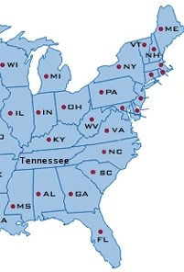
Classes at Highlander are from two days to eight weeks long. Students come from around the US and live at the school while they're taking classes. Fifteen to forty students come, all from different places, some rich, some poor, some college-educated and some who never finished high school. The idea is for people to focus on problems they and their neighbors have.

The process of studying problems is as important as finding the answers. The school has no tests. Students choose what they need to know, and Highlander will help them learn about it. When students ask for more information, the teachers bring them books, movies, and music. Teachers also ask the students lots of questions. This helps them understand their problems and think of how to solve them.

Highlander doesn't teach what to think. They want to teach how to ask questions about your problems, how to learn about them, how to talk to your coworkers and neighbors, and how to work together to solve problems.

Vocabulary
- movement – noun - Many people fighting for the same thing.
- trust – verb – When you know that someone is good and will help you.
- the South – noun – The states in the south eastern part of the US.
- focus - verb – To think about or study one thing. “I want to focus on learning English this year.”
- process – noun – How you do something. “The process of finding a job takes a long time.”
- coworkers – noun – The people you work with.
How does Highlander work?

Please write in answers for a regular school and Highlander below.
 | Regular School | Highlander
1. Who knows the most?
2. How do students learn?
3. Do they use tests?
4. Do students work together or separately?

Questions

1. What do you like about how Highlander works?

2. What don't you like?

3. Do you think Highlander would be a good school for you? Why?

4. Does your school do anything the same way Highlander does?

5. What do you want your school to do the same as Highlander?

