Guide for teachers: How Can We Solve Our Problems?

This story is an introduction to the concept of direct action – that is, to create the world we need with the fewest intermediaries possible. It's not enough for them to actually “get” what direct action is; however, it will help give them framework for when they read about direct action.

Students should read this story first and then read one (or more) of the following stories about direct action:
- The IWW Free Speech Story – Hundreds of IWW union members broke an anti-free speech law until the authorities had to give up enforcing it
- The Sanctuary Movement - (the photo in the story) Helped refugees escape US-funded wars in their country
- The Occupation of Alcatraz – American Indians used direct action to draw attention to their struggle
- When Regular People Stand Up 2 – About people using direct action to save refugees
- Who's the Boss – Argentine workers took over their factories and ran them without bosses
- Food Not Bombs – Using direct action to feed the hungry since the 1980s
- Needle Exchange – A movement that could only have started through direct action

Here are some more stories that involve direct action, but in a way that may be a little less obvious to students:
- John Brown – The one man who did more than perhaps any other to foment the Civil War
- Bread and Roses Strike – Primarily immigrant women strikers invented the picket line and fought the police and army (!) to win better wages and working conditions
- Rosa Parks & Martin Luther King, Jr. – Perhaps the best-known practitioners of direct action in the US
How Can We Solve Our Problems?
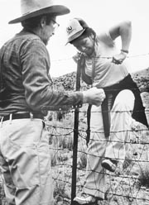
Direct action helped
refugees get into the US.

Everyone has problems. Sometimes the problems are in your community, like hunger or homelessness. Sometimes the problems are bigger, like war. There is the same question for every problem: How can we solve our problems?

There are many answers to that question. One answer is the government. Citizens can vote for politicians or laws they think will solve their problems. Of course, sometimes politicians do not do what they say they will do. They don't always care about poor people's problems.

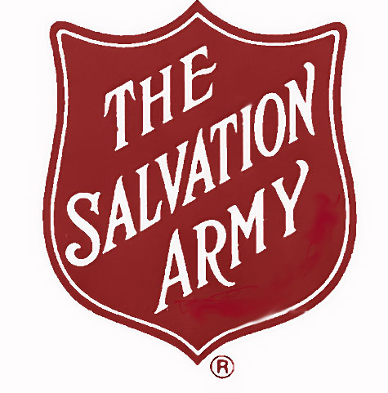
Sometimes people start non-profit organizations to solve their problems. They are called “non-profits” because they are not businesses – they don't try to make money. Non-profits do a lot of important work in the US. But to start one, you must have a lawyer, and you have to send lots of information to the government. And if a non-profit breaks the law, the government can shut it down. One non-profit everyone knows is the Salvation Army. The American government doesn't help all the hungry people in the US. The Salvation Army gives food to the hungry.

There's one more way to make change. It's called “direct action.” That's when people solve their problems right away. They don't wait for the government or non-profits to do it for them. With direct action, people often start organizations to do important work. These organizations are not non-profits. They do not hire lawyers or send information to the government. And sometimes they break the law. In fact, when the law is the problem, these organizations must break the law. This makes direct action very powerful, but also a little dangerous for the people who do it. You're going to read a few stories to help you understand direct action.

Vocabulary
- hunger – noun – When people are very hungry. “Thousands die of hunger every year.”
- solve – verb – To find the answer to a problem. “I need to solve 10 problems for math class.”
- vote – verb – When you choose a solution or a politician. “I voted for George Bush in 2004.”
- organizations – noun – A group of people who work together to do something. “I started an organization to help high school students go to college.”
Vocabulary
1.___ hunger | a. When you choose a solution or a politician
2.___ solve | b. Organizations that help people solve their problems
3.___ vote | c. When people solve their problems right away
4.___ organizations | d. A group of people who work together to do something
5.___ direct action | e. To find the answer to a problem
6.___ _________________ | f. When people are very hungry

Questions
1. What are some problems in your community? In the US?

2. How does the government solve these problems?

3. What non-profits help you or your neighbors?

4. How is a direct action organization different than a non-profit?

