Teacher Notes: “Hurt”

I chose “Hurt” because I wanted to use more music in my class. All the other teachers were using songs like “My Heart Will Go On” (Love theme to the Titanic). Johnny Cash's cover of “Hurt” is perfect because it's slow and clear and uses simple language, but is darker and more complex than Richard Marx - another local favorite. My students also liked the way it sounded

Materials: A CD with the Johnny Cash and, ideally, Trent Reznor versions of “Hurt” on it. Copies of the lyrics with missing words, the whole lyrics, and the short bio of Johnny Cash.

Start by playing “Hurt,” by Johnny Cash. Tell your students they only have to listen to it – no writing! Explain that the singer did not write the song. Ask the following questions about the singer: (before they see his picture in the info-gap handout)
- How old do you think the singer is? (He was 71 when the song was recorded)
- What does he look like?
- How does he feel?
- [I save the substantive questions about the song until a little later]

Tell students they don't have to understand every single word, and that you'll give them all the words soon. Tell them this is a good exercise because when they're listening to English there will often be new words for them, and they just have to keep listening and keep trying.

Then pass out the info-gap handout and have them listen again and write in the missing words. Ask, “Is this what you thought the singer would look like?” Play the Cash version at least twice more.

Ask the following:
- What is the song about?
- How does the singer feel? Why?
- What was the writer of the song like? How old was he? (Trent Reznor was 32 when the song was recorded)

In my class, they actually guessed the singer had lost his wife. June Carter, his wife, didn't die until after Cash recorded the song. Cash himself died shortly thereafter. The internet says it's an anti-drug song. Who knew?

Then play the Trent Reznor original version and see what they think. (My class still envisioned Trent as pretty much the same as Johnny Cash.) Then pass out the lyrics sheet with Trent's photo and ask what they think. Finally, pass out the short biography. Let students read it and answer any questions. Then they can discuss it in small groups.

Let me know how this works for you. Good luck!
Dan Spalding
danspalding.esl@gmail.com
Hurt
Written by Trent Reznor
Sung by Johnny Cash
I hurt myself today
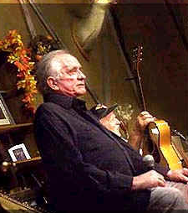Johnny Cash
To see if I still feel
I focus on the pain
The only thing that's ________

The needle tears a hole
The old familiar sting
Try to kill it all ________
But I remember everything

What have I become?
My sweetest friend
________I know
Goes away in the end

And you could ________
My empire of dirt
I will let you down
I will ________________

I wear this crown of thorns
Upon my liar's chair
Full of broken thoughts
I ________repair

Beneath the stains of time  The ________disappear  You are someone else  I am ________________  What have I become?  My sweetest friend  ________I know  Goes away in the end | And you could have it all  My empire of dirt  I will let you down  I will ________________  If I could start again  A million miles ________  I would keep myself  I would find ________

Hurt
Written by Trent Reznor

I hurt myself today
To see if I still feel
I focus on the pain
The only thing that's real

The needle tears a hole
The old familiar sting
Try to kill it all away
But I remember everything

What have I become?
My sweetest friend
Everyone I know
Goes away in the end

And you could have it all
My empire of dirt
I will let you down
I will make you hurt

I wear this crown of thorns
Upon my liar's chair
Full of broken thoughts
I cannot repair

Beneath the stains of time
The feelings disappear
You are someone else
I am still right here

What have I become?
My sweetest friend
Everyone I know
Goes away in the end

And you could have it all
My empire of dirt
I will let you down
I will make you hurt

If I could start again
A million miles away
I would keep myself
I would find a way

focus – Think about

tear –to make a hole in
sting – A sharp pain.

become – Turn into.

empire – A big country.
let you down – Make you feel bad

crown of thorns – What Jesus had on his head when he died

stain – A dirty part of something.
disappear – Go away forever
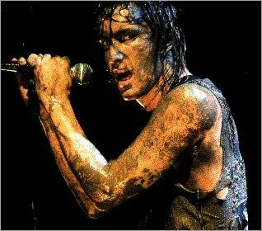Trent Reznor

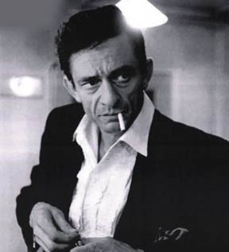
The Story of Johnny Cash

Johnny Cash was born in 1932. He was a very influential country music singer and guitar player. His parents were poor farmers in Arkansas. His father was an alcoholic, and abused his family. By the time he was 5 years old, Johnny Cash was working in the fields, picking cotton. He sang songs while he was working.

He started playing guitar, and sang on the radio in high school. He joined the military, and worked on radio in the air force. After he left the military, he moved to Tennessee and got married. Johnny Cash was a salesman and studied to be a radio announcer.

Johnny Cash tried to sell some songs to a record company, but he only sang about God. The record company told him to do some bad things, so he could sing about something more interesting. He came back with more popular music and they bought his songs. Johnny Cash became very successful. He played music with the most famous singers in rock and roll. But he also became addicted to drugs.

Johnny Cash wrote many songs for people in jail, and for American Indians. He wanted better things for them. He also wanted to stop the war in Vietnam. He wore black clothing, and people called him “The Man in Black.” He wrote a song that said,

I wear the black for the poor and the beaten down,
Livin' in the hopeless, hungry side of town,
I wear it for the prisoner who has long paid for his crime,
But is there because he's a victim of the times.

Johnny Cash divorced his first wife and married another woman, June Carter, who he met in 1968. June Carter was also a famous country singer. June wrote his most famous song, “The Ring of Fire.” It was about their love, and how Johnny Cash was addicted to drugs. The two wrote many famous songs together, and she helped him quit taking drugs. They were in love for 35 years. June Carter died in May of 2003, and Johnny Cash died less than four months later.

Vocabulary
- influential – adjective – Changed the way many people did things. “Martin Luther King was an influential American.”
- abuse – verb – Hurt people. “If you abuse your dog, the police will take it away from you.”
- radio announcer – noun – Someone who talks on the radio. “Radio announcers read the news and commercials.”
- addicted – adjective – When you need to do something bad for you, usually drugs or alcohol. “I was addicted to alcohol for almost 10 years.”
- beaten down – adjective – People who have no money, no chance, and no hope.
- victim – noun – Someone something bad happened to. “He was a victim of crime.”

Questions
1. What was Johnny Cash's life like when he was young?

2. Who did Johnny Cash write songs for? Why?

3. Why did Johnny Cash start doing drugs? Why did he quit?

4. Is there anyone like Johnny Cash in your country? Do you know anyone like him?

