Teacher’s Guide

Here’s a quick guide to this lesson on Japanese-American internment. Have students form small groups and give them copies of the first page. Let them know the photos tell a story. (The first picture is a store in Oakland, California that had been owned by a Japanese-American sent to an internment camp.) The second photo is a train station from which people were going to the camps. The third photo is people being processed into a camp. You’d be surprised how many people guess pretty accurately what’s going on in these photos.

Ask students what they came up with, but don’t give away what the photos are about. Give students the next two pages (copied front and back on one piece of paper). Have students read the story silently, then read it together and answer any questions. Then have students answer the questions on the back, as a whole class or in small groups.

If there’s extra time, students should read about the No-No Boys. It’s an amazing example of resistance that very few people know about. If you want to learn more, you can read Free to Die for Their Country, the Story of the Japanese Draft Resisters in World War II, by Eric Muller.

Good luck with this lesson! As always, let me know if it was useful to you, and if you have any constructive criticism.

Dan Spalding
danspalding.esl@gmail.com
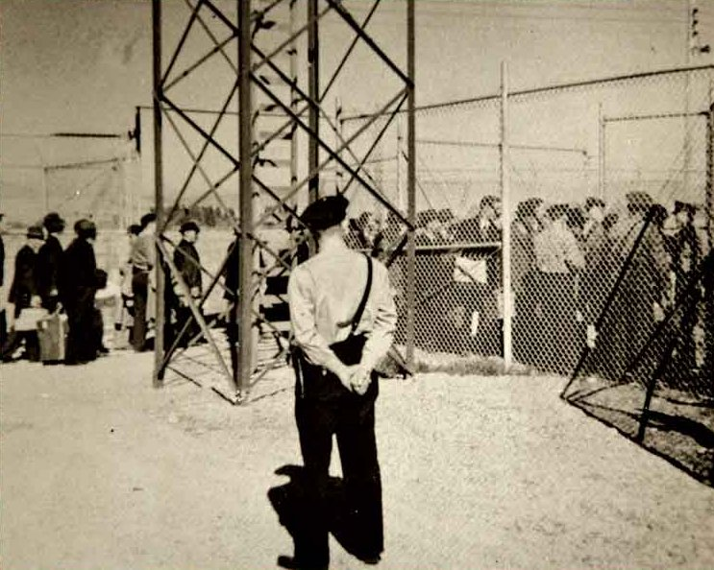
What Happened?
These pictures tell a story from the US in 1942.
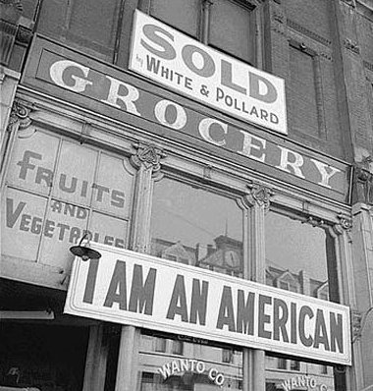
1. What is this a picture of? Where do you think it is?

2. What do you see in this picture?

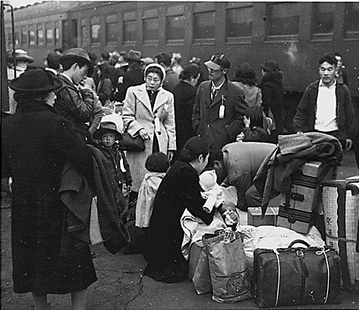
3. What is this a picture of?

4. How do these people feel?

5. What’s happening?

6. What is this a picture of?

7. How do these people feel?

8. What’s happening?

Japanese-Americans
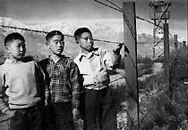 Japanese-Americans in an internment camp
in World War II

Japanese people were some of the first Asian immigrants to come to the US. Starting in 1890, many went to work on Hawaiian farms. Later, they moved to California and other western states. Immigrants from China and the Philippines soon followed. The government wanted cheap workers, but they didn’t want too many Asians in the US. The government stopped Asian women from coming to the US. Men could work here, but they couldn’t buy land. After 1924, the government made it almost impossible for Asian immigrants to come to the US.

On December 7, 1941, World War II started for the United States. The Japanese military attacked the American military in Pearl Harbor, Hawaii. This was a big surprise for the US. Over 3000 Americans were injured or killed.

In May of 1942, the government made almost all Japanese-Americans move to internment camps. Internment camps were small cities far away from everyone else (see photo). The only people there were Japanese-Americans and military guards. More than 100,000 Japanese-Americans had to go to internment camps. Most of them came from California, Oregon and Washington. Most of them were US citizens. They could bring only a few boxes with them. Many Japanese-Americans had to sell their cars and homes for very little money.
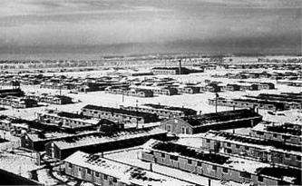 An internment camp in Colorado

The internment camps were not good places to live. Too many people lived in too little space. Many people had to share just a few bathrooms. Japanese-Americans had to make things for the US military for very little money. At some internment camps, you could go outside the camp during the daytime. At others, the guards would shoot you if you left the camp.

The internment lasted until 1945. When Japanese-Americans went home, they often found that people had taken their homes and their things. It was not until 1988 that the US said that the camps were a mistake. They gave $20,000 to everyone alive they sent to an internment camp. Many of them had died. But the government finally said the internment camps were wrong.

Vocabulary
- follow – verb – To come after someone or something. “When I drove to LA, my sister followed in her car the whole way.”
- guard – noun – Someone who watches over something. “There are guards with guns at my bank.”
Questions
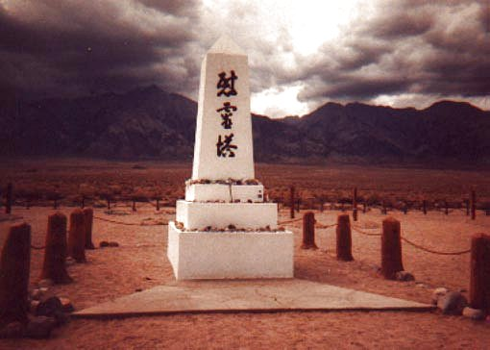 A Japanese grave
at an internment camp
1. Why was the US afraid of Japanese-Americans?

2. What is an “internment camp”?

3. What happened when the war was over?

4. Some people today say Japanese-Americans were happy in internment camps, and the guards made them safe. What do you think?

The No-No Boys
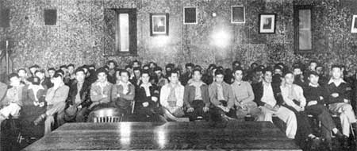 There were 63 No-No Boys from Hart Mountain internment camp.

Most Japanese-Americans in internment camps were US citizens. But some of them were still Japanese citizens. The government asked all of the men who were Japanese citizens two important questions: Will you fight for the US, and will you give up your Japanese citizenship?

Most answered yes to both questions. Many Japanese-Americans fought in World War II. But some men answered no to those questions. These men were angry the US made them live in an internment camp. They didn’t want to fight for the US military. They also didn’t want to give up their Japanese citizenship. It was their only citizenship. If they gave it up, they would be citizens of no country.

The men who answered no to those questions were called “No-No Boys.” The government tried to make them join the military. They refused, so the government sent them to jail. The No-No Boys laughed. The jails were the same as the internment camps! But when the war ended in 1945, the other Japanese Americans got out of the internment camps and went home. The No-No Boys had to stay in jail.

After World War II ended, many Japanese-Americans were mad at the No-No Boys. They said they made all Japanese-Americans look bad. What do you think?

Vocabulary
refuse – verb – When you will not do something. “I refuse to work for my old boss again.”

