John Brown
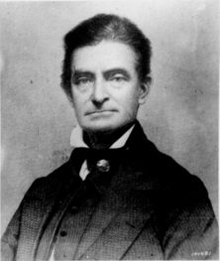 John Brown, 1800 to 1859

John Brown is an important man in American history. He was one of the first white people to fight against slavery. He wanted everyone to be free. He also killed many people. Today, some people call him a hero while others call him a terrorist.

Slavery was one of America’s biggest problems in the 1800s. Most black Americans were slaves – they had no rights. White people made millions of black people work for no money. Slaves did much of the difficult work here.

Born in 1800, John Brown wanted to start a church, but he ran out of money. He got married and had 7 children. One of his sons died in 1831. In 1832, his wife and newborn son died, too. He soon married again. He and his new wife had 13 children. Brown had many jobs but lost a lot of money. Four more of his children died in 1843.

In 1848, Brown met one of the great American thinkers, Frederick Douglass. Douglass was a world-famous professor and writer who fought his whole life to stop slavery. John Brown told Douglass he wanted to start a war to free the slaves. Frederick Douglass thought this was impossible. But Brown found six rich white people who believed in him. They gave him money to start an army. He traveled around the US to find people for his army. He also helped 11 slaves get to Canada, where they were free.

In 1859, Brown rented a house in Maryland and waited for men to come to join his army. He hoped for 4,500 men. Only 21 arrived: 5 black men and 16 white men, including two of his sons. Brown took 18 of them to Harpers Ferry, Virginia. They took the armory, a building with many guns for the army. They wanted to give the guns to slaves in Virginia. Brown wanted so many slaves to join his army that slavery would end.

Their plan didn’t work. People in Harpers Ferry didn’t let them leave the armory. Then the army came. John Brown and his soldiers killed several people. The next day the army told John Brown to give up. Brown said, “No, I prefer to die here.” The soldiers fought them and made them give up. One of Brown’s sons was killed. Only 7 of Brown’s 18 men survived.

John Brown was sent to jail in Virginia. He wrote letters to newspapers in the North, and thousands of people read about his fight against slavery. Virginia killed John Brown on December 2, 1859. White people in the South said John Brown was crazy. Only a crazy man would give guns to slaves and change the American way of life. Politicians in the North said the same – they weren't ready for a war against slavery. But in 1861, the Civil War started between the states in the North and South. The Civil War killed over 500,000 Americans.

John Brown probably helped start the Civil War. As Frederick Douglass wrote, “John Brown began the war that ended American slavery... I could live for the slave; John Brown could die for him.”
Questions
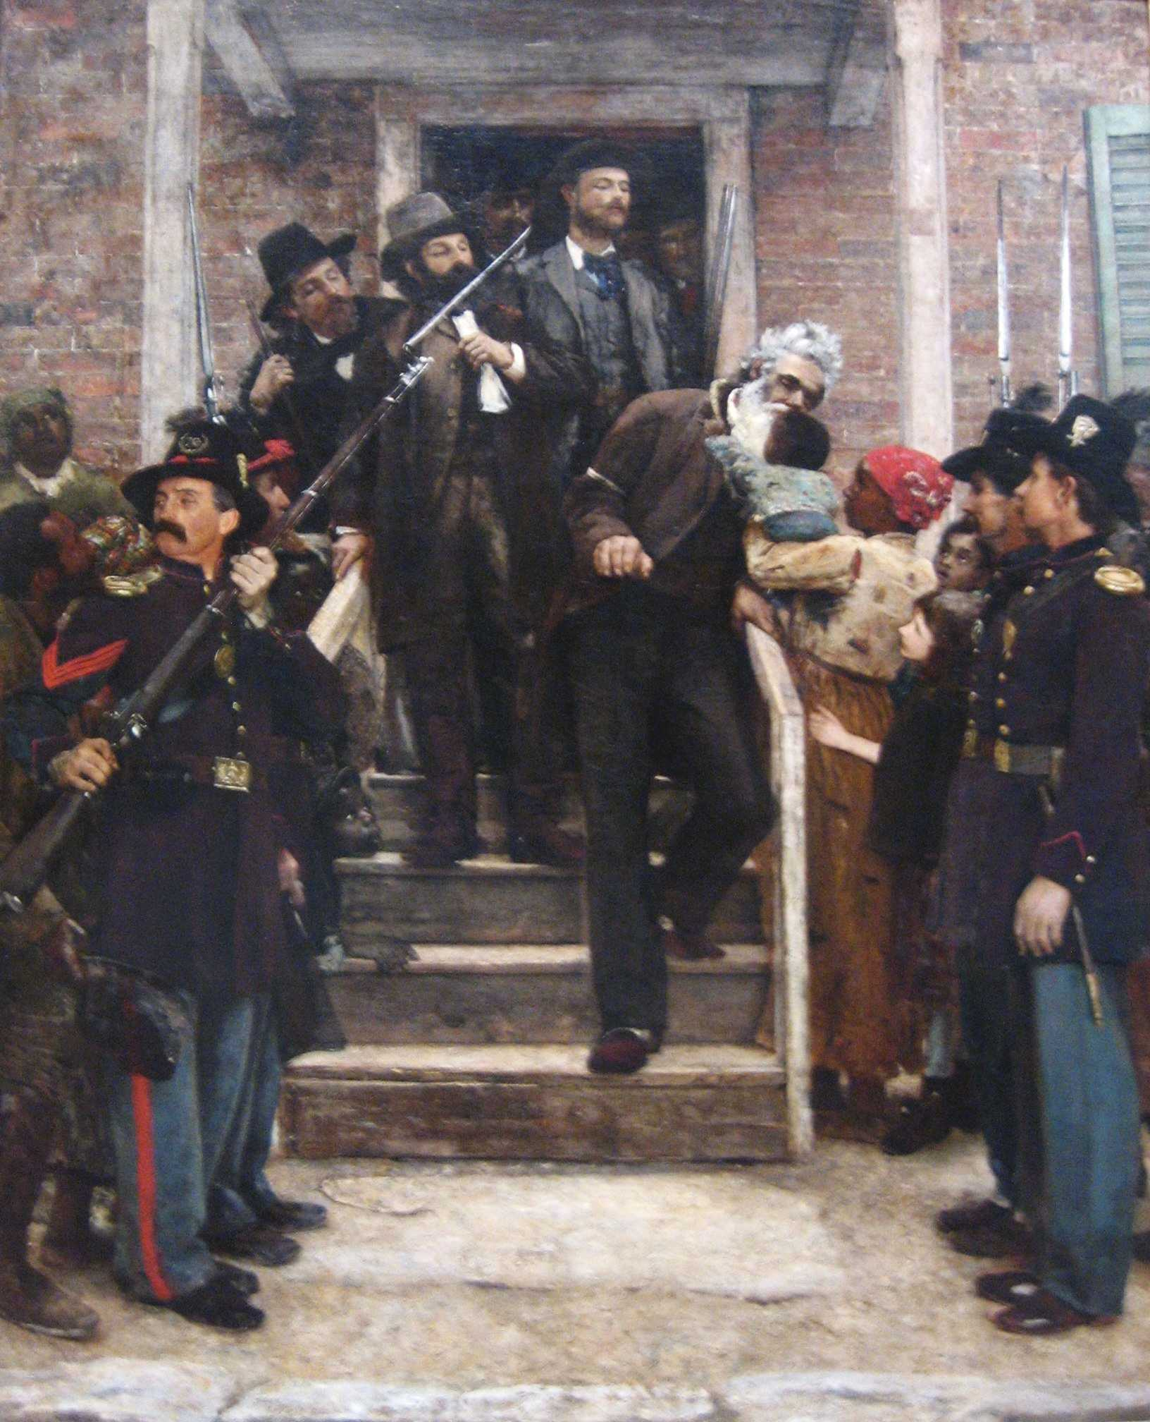 A painting of John Brown right before he was
killed

1. Slavery lasted over 200 years in America. Do you believe we needed a war to end slavery?

2. Was it ok to John Brown to kill people? Is it ever ok to kill people?

3. Was John Brown a terrorist? Is it possible to be a good terrorist?

4. Is there anyone like this in your country’s history?

