Teacher Notes: Kidnapping the Boss

I am deeply indebted to journalist Angelique Chrisafis of the amazing newspaper the UK Guardian. She wrote several articles in February and March of 2009 on the phenomenon of French bossnappings. I highly suggest reading her stories below. The third story is by Stuart Jeffries, a tongue-in-cheek account of kidnapping their own boss at the Guardian to get better cakes. I guess it's a British thing.
As always, contact me with any questions, or to let me know how the story went over in your class. Enjoy!

Dan Spalding
danspalding@riseup.net

http://www.guardian.co.uk/world/2009/mar/27/bossnapping-france-workers-fight-layoffs
http://www.guardian.co.uk/world/2008/feb/06/france.workandcareers
http://www.guardian.co.uk/money/2009/apr/10/bossnapping-emily-wilson
Kidnapping the Boss
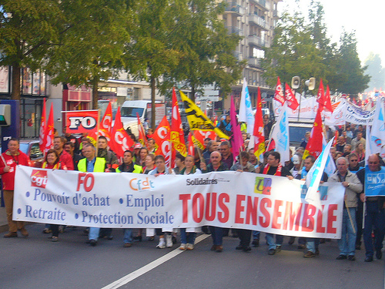 French workers on strike

The boss wants to close your factory. The company won't give you any severance pay. What do you do?

In France, you might kidnap the boss. To kidnap someone is to take them away. Usually, the news talks about children getting kidnapped by strangers. But in this situation, angry workers kidnap their boss.

It happens like this: The boss tells the workers he's going to fire them. Suddenly, workers run up to the boss and take him away to a small room. They lock all the doors and demand that fewer people get fired, and better severance pay. The workers never hurt the boss. And, because this is France, they give him a delicious dinner. They let the boss out after a day or two – after he agrees to give the workers a better deal.

These kidnappings are happening more frequently these days. Many big businesses are closing factories. Frequently, these same businesses are getting lots of money from the government. Sometimes, the bosses are getting bonuses at the same time the workers are getting fired without severance.

The same thing is happening all around the world. So why are there so many bossnappings in France? There area a few reasons. For one, unions fighting companies is like a national sport in France. The people – and the news – love it when workers go up against the boss. Europe also has a tradition of unions that will fight for anything.

Workers don't always get what they want when they kidnap the boss. In one case, all they got after 24 hours was a promise to start talking again. One worker said, “Holding him for a few more days would have allowed us to get more. The advances we made were minimal, but we wouldn't have got anywhere without kidnapping the boss.”

Vocabulary
- severance – noun – Money you get when you are fired from a job. “Some of us got fired, but we each got one month of severance for every year we worked.
- Suddenly – adverb – Very quickly. “I was suddenly unemployed after working for 10 years.”
- frequently – adverb – How many times something happens. “I eat out less frequently now.”
- advances – noun – Progress, or going forward. “The soldiers made several advances during the fight.”
- minimal – adjective – The smallest amount. “We got a minimal pay raise this year.”
Vocabulary Practice

Word | Letter? | Definition
- Severance |  | - To take someone away
- Suddenly |  | - Very quickly
- Frequently |  | - Going forward
- Advances |  | - Money you get when you are fired from a job
- Minimal |  | - The smallest amount
- __________ |  | - How many times something happens

Questions
- What is kidnapping? What is bossnapping?

- Why do French workers sometimes bossnap?

- Why is it happening more frequently today?

- Why does this happen so much in France?

- Do workers in your country ever kidnap the boss?

- Could bossnapping work in the US? What would happen if workers tried it?

