King and the Big Strike
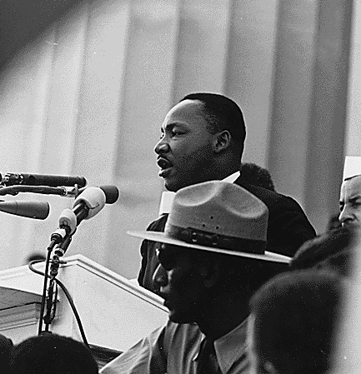King speaking for the sanitation workers' strike in Memphis, Tennessee

Almost everyone knows who Martin Luther King, Jr. was. But not many people know what he was doing when he died. King was killed in Memphis, Tennessee, in 1968. He was helping a big strike of the Memphis sanitation workers.

In 1968, not many black people had good jobs. Sanitation workers in Memphis were mostly black people, because it was dangerous, low-paying work. They demanded more money and safer work conditions.

The mayor refused to help them. The sanitation workers tried everything to change his mind. They waited a long time. Finally, they went on strike.

A strike is the strongest and most difficult thing workers can do. When workers cannot get what they need from their employer, they can all stop working. No work is done. When the sanitation workers went on strike, none of them picked up the garbage for over two months.

When the workers were on strike, they made no money. The mayor said the strike was illegal, because the sanitation workers were city employees, and city employees could not strike. The mayor also paid lots of money to other people to do the sanitation workers' jobs.

Many churches and unions helped the workers. Martin Luther King, Jr. helped them, too. King talked to many people about the strike. He also spoke on TV and the radio. On April 3, 1968 he gave a speech about the “Promised Land.” That was an America where everyone could live together and have what they needed. He said, “I may not get there with you. But I want you to know tonight, that we, as a people, will get to the Promised Land. And so I'm happy tonight. I'm not worried about anything. I'm not fearing any man.” King was killed the next day.

The sanitation workers were sad, but they did not stop fighting. The Mayor started talking to them. Two weeks later, he agreed to their demands. Martin Luther King, Jr. won his last big fight.

Vocabulary
- sanitation workers – People who pick up garbage and work as janitors.
- demand – verb – To ask for something very important. “I demand respect at work.”
- change his mind – To make him think something different.
- finally – adverb – At the end, after a long time. “I finally got my green card.”
- demands – noun – Something you need. “Our demands are for more money and safe work.”
- fearing – noun – (old English) Afraid of.
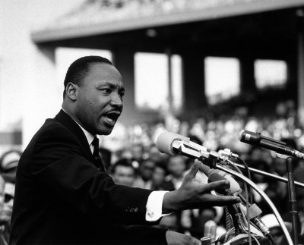
“I may not get there with you”

“And I've looked over, and I've seen the Promised Land. I may not get there with you. But I want you to know tonight, that we, as a people, will get to the Promised Land. And so I'm happy tonight. I'm not worried about anything. I'm not fearing any man.”

1. What do you think “I may not get there with you” means?

2. Why do you think King says he is happy, and not afraid?

3. What is your Promised Land?

4. (This is not in the story) Four days after King was killed, his wife, Coretta Scott King, went to Memphis. Why did she go?

5. Do you think we will ever get to the Promised Land?

The Strike
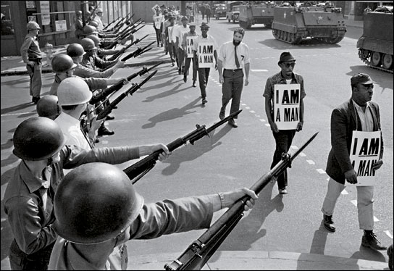A march by the sanitation workers
Sometimes, the workers on strike had a sign that said, “I am a man.” The Mayor thought they were children, not men.

The Mayor used the police and soldiers to make them afraid. One time, King, the workers and their friends were all had a march in Memphis. The police arrested 280 people and hurt 60 of them, mostly black people. They also shot and killed a 16-year old boy. After that, the soldiers left.

Vocabulary
march – verb – When many people walk together to change something, or to celebrate. “We all marched to get the 8 hour work day.”

