You Do What You Have To
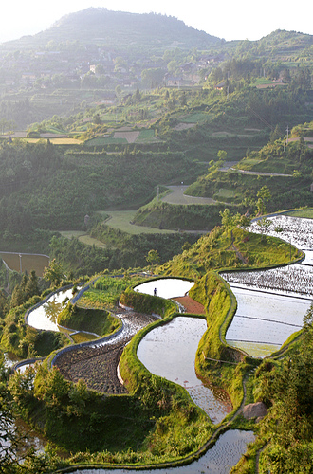
A rice farm in Laos

Foua is an immigrant from Laos. She came here with her family years ago. Her children are doing ok in the US, but she has a lot of trouble here. This is part of Foua’s story.

“I am very stupid, because I don’t know anything here. I don’t know your language. American is so hard, you can watch TV all day and you still don’t know it.

“I can’t dial the telephone because I can’t read the numbers. If I want to call a friend, my children will tell me and I will forget and the children will tell me again and I will forget again. My children go to the store to buy food because I don’t know what is in the packages.

“One time when I went to the hospital I went to the bathroom, and the hall went that way and that way and that way, and I didn’t know which way to go, and I couldn’t get back to where I was because too many sad things have happened to me and my brain is not good anymore.

“In Laos, it was easy. I didn’t know how to do anything but farm.”

Questions
1. Why is life so difficult for Foua here?

2. Do you know anyone like Foua?

3. What do you think Foua had to do in Laos?

4. Do you think Foua is stupid?
What did Foua have to do in Laos?
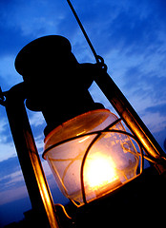
A lamp

First, Foua woke up when it was still dark outside. She had to use a lamp to see. (see picture) Then, she cooked rice for her children and cleaned her home. Then, she cut grass to give to the pigs, cows and chickens. Then, she and her husband carried the children on their backs to the fields. They planted rice, corn, peppers and cucumbers. They had to work all day.

The farm was far away from where her family lived. They had to walk all the way there and all the way back. They left the fields in the daytime, but it was dark when they got home. After getting home, they would get water from the creek and bring it to their home. They used this water to cook and bathe.
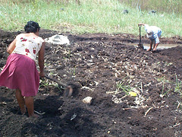
People planting corn in a field
Next, they fed the animals and ate dinner. Usually, dinner was just what was left from breakfast. At night, Foua repaired her family’s clothes.

Today, Foua’s life is very different. Now she has to learn how to live in the US. She has to learn how to read, use a telephone, and go shopping. It’s difficult, but that’s what she has to do.

Questions
1. What did Foua have to do every day?

2. Why did she say her life was more difficult in the US?

3. Was her life more difficult in the US or Laos? Why?

4. Do people live like this in your country?

