Life on a Plantation
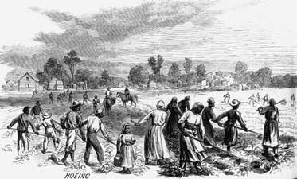 Slaves on a plantation.

America was a different country in the past. Rich men in the South usually owned large farms. They raised tobacco, cotton, and other crops. Slaves did almost all of the work. Large farms with slaves were called plantations. (see picture)

There were two kinds of workers on a plantation. Slaves worked for no money, and had no rights. The white people who owned the plantation made them work from early in the morning until late at night. The plantation owners gave them a little food and clothing. They never got any money. If they didn't work, the plantation owner would beat them – or kill them.
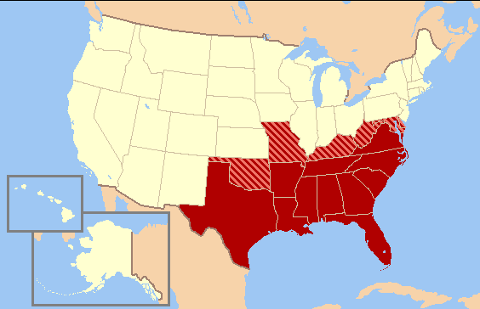 The American South
Poor white people also worked on some plantations. They had to borrow money from the plantation owner at the beginning of the year. Then they worked all year, and had to give most of their crops to the plantation owners. Many times they made no money, and needed to borrow more the next year. It was very difficult for poor white people to save enough money to buy land. Sometimes they did not have enough money for clothing or food. Most white people did not have enough money to own slaves.
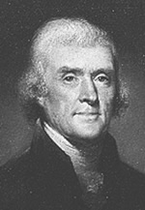 President Jefferson

Many of the first Presidents and leaders of the United States were plantation owners. George Washington owned over 300 slaves. He made them free – after he and his wife both died. Thomas Jefferson was the third US President. He owned over 200 slaves. One of those slaves was Sally Hemmings. Thomas Jefferson was married to a white woman, and they had 7 children. But he also had 6 children with Ms. Hemmings. These children were slaves. Thomas Jefferson got his first slaves from his father. One of these slaves was his father's son. Thomas Jefferson never made his slaves free – even after he died.

Vocabulary
- raise – verb – To make something grow or get bigger. “I raised chickens in my country.” “I raised my nephew when he was a young boy.”
- crops – noun – Plants on a farm. “Rice and grapes are some of California's biggest crops.”
- own – verb – When you have something. “I don't want to rent an apartment, I want to own a house.”
- beat – verb – To hit someone. “I think my neighbor beats his children.”
- borrow – verb – When you get something that you must give back later. “I borrowed $20 from my sister, but I will pay her back tomorrow.” “Can I borrow your car tonight?”
Questions
1. What was a plantation? Who owned them?

2. Who were the two kinds of workers on a plantation?

3. What did the slaves and poor white people on a plantation have in common? What was different?

4. Why do you think so many of the first Presidents and leaders of the US were plantation owners?

5. One of Thomas Jefferson's slaves was his father's son. What is another name for your father's son? What do you think about this?

6. Do you think poor white people ever worked with slaves to get better work? Why or why not?

Presidents and Slaves
Please write down how many slaves you think these US Presidents had.

President #1: George Washington _______ slaves

President #3: Thomas Jefferson _______ slaves

President #4: James Madison _______ slaves

President #5: James Monroe _______ slaves

President #7: Andrew Jackson _______ slaves

- - - - - - - - - Fold this section over before copying - - - - - - - - -
Answers
George Washington: 317
Thomas Jefferson: 237
James Madison: 118
James Monroe: 75
Andrew Jackson: 200

