Malcolm X
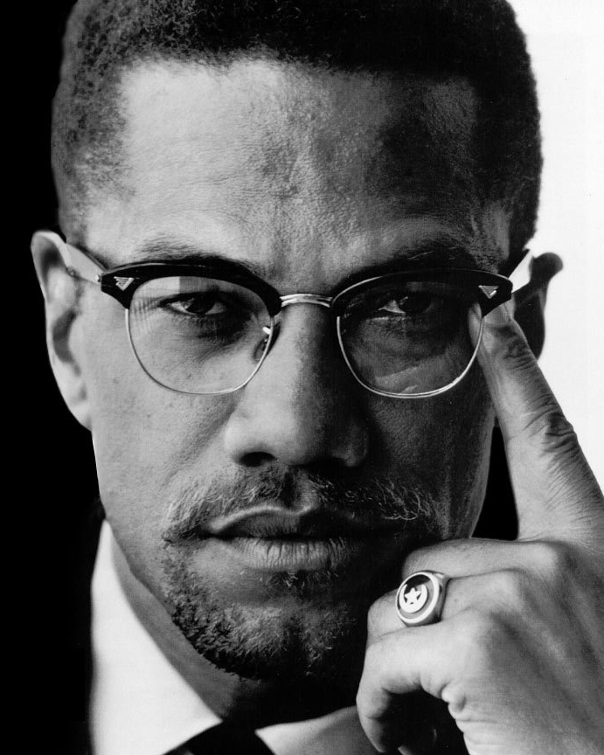 Malcolm X, 1925 to 1965

Malcolm X was a famous black leader. He was born in 1925 with the name Malcolm Little. His father was a preacher, who believed that black people should have the same rights as white people. His father also wanted black people to live only with other black people. Many white people in his city were afraid of this preacher. Malcolm Little's father was killed when Malcolm was very young. Then, the state said his mother was crazy, and made her go to a hospital.

When he was young man, Malcolm Little sold drugs, gambled, and stole. He went to jail for 6 years when he was 20. The jail had a big library, and he read almost every book in it. He copied every word from a dictionary to teach himself writing and vocabulary. Malcolm Little became a Muslim when he was in jail. He decided to stop selling drugs and stealing. He changed his last name, because he said “Little” was a white, Christian name. His new name was Malcolm X.

Another famous black leader at that time was Martin Luther King, Jr. Malcolm X disagreed with many of King's ideas. King said that sometimes, black people must ask the government for help. Malcolm X said black people should not beg for help from white people. King wanted black people and white people to live and work together. Malcolm X thought that was impossible. He believed white people would always try to hurt black people. He believed black people needed to live and work away from white people. Later, he changed his mind.

White people hurt and killed black people every day. White police officers killed black people for no reason. Martin Luther King, Jr. said that when a white person hurt a black person, the black person should not hurt them. King believed that being peaceful would teach other people to be peaceful. He believed that only peace could save white people and black people.

Malcolm X had different ideas. He believed that when a white person hurt a black person, the black person must fight them. He also believed black people should start their own businesses, and not work for white people.

A trip to Mecca changed some of Malcolm X’s ideas. Mecca is the most important place in the world for Muslims. All Muslims must try to go there one time in their life. When Malcolm X went to Mecca, he saw black and white people together from around the world. All of them were Muslim. After this, he thought that black and white people could live together.

Malcolm X believed that all black people around the world must be free. Like Martin Luther King, he wanted to stop the Vietnam War. Malcolm X was a black leader who was never afraid of anyone. Many black people learned from Malcolm X. He taught millions of people to stop being afraid. Others hated him. They thought he only wanted to hurt people. Malcolm X was shot and killed in 1965. Today, he is one of the most important people in American history.
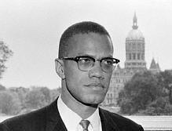
Malcolm X Vocabulary
- preacher – noun – The leader of a church.
- rights – noun – Laws that help you. “You have the right to make a minimum wage in America.”
- gamble – verb – To play games for money. “I went gambling in Vegas.”
- stole – verb – Past tense of “steal,” to take something from someone. “Someone stole my car from my driveway last night.”
- decide – verb – Choose to do something. “I decided to get a new job yesterday.”
- disagree – verb – Do not agree. “I disagreed with my friends about the movie.”
- beg – verb – Ask for something you can't buy or get. “The poor person begged me for money.”
- peaceful – adjective – No violence. “My neighborhood is not peaceful. We have lots of crime.”

Questions
1. What were some of Malcolm X's ideas?

2. Why do you think Malcolm X had different ideas than Martin Luther King, Jr?

3. Do you agree more with Martin Luther King, Jr. or Malcolm X? Why?

Why Did He Change His Name to X?
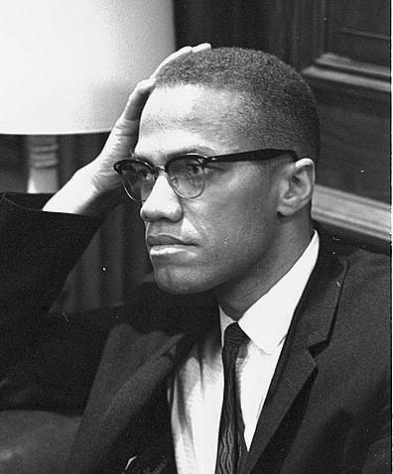
“To take one's 'X' is to take on a certain mystery, a certain possibility of power in the eyes of one's peers and one's enemies... The 'X' announced what you had been and what you had become: Ex-smoker, Ex-drinker, Ex-Christian, Ex-slave."

1. one's – pronoun – A polite way to say “your.”
2. mystery – noun – Something people can't understand.
3. peer – noun – Someone who is like you.
4. enemy – noun – Someone who wants to stop you or hurt you.
5. announce – verb – To tell everyone something.
6. ex- – Something you quit being.
7. slave – noun – Someone with no freedom, who must work for no money.

