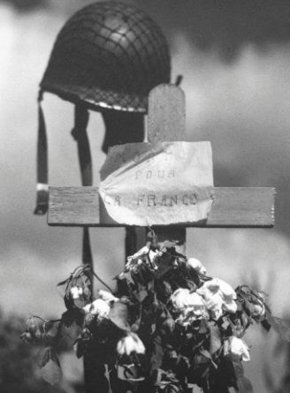
Memorial Day

In America, the last Monday in May is Memorial Day. We created Memorial Day to remember soldiers killed in the American Civil War. We fought the Civil War to end slavery. More than 500,000 soldiers were killed between 1861 and 1865. Today, Memorial Day is to remember all American soldiers killed in war.

The Civil War was not America's last war. After the Civil War, the US Army had many new guns. They used these guns to fight American Indians. Before the Civil War, American Indians lived on a lot of land in the middle of the US. This was good land they had lived on for thousands of years. The US government wanted poor white Americans to move to this land. The government killed the Indians who did not move away to the mountains or the desert. Many American Indians live in these places today. They still want their land back.

We started wars to take the Philippines and much of Mexico. The US military also took control of Haiti, a small, poor island country close to the US. The military took money from the people of Haiti to send back to the US. The US fought Cuba and took the island of Hawaii, too.

Our next big war was World War I, in 1917. About 126,000 American soldiers were killed in World War I. About 400,000 US were killed less than 30 years later, in World War II. Next was the Korean War. About 54,000 Americans were killed there.

The US fought a war in Vietnam between 1957 and 1975. About 58,000 American soldiers were killed. The US killed between one million and two million people in Vietnam, Laos, and Cambodia. Most of those people were not soldiers – they were women and children. Vietnam was a very unpopular war in the United States. Every day on TV, Americans saw US soldiers hurt and killed. Vietnam was also unpopular because the US lost the war.

After Vietnam, the US did not want American soldiers to get killed. So we helped governments in other countries fight for us. We gave soldiers in these countries guns and money, and taught them how to fight. We often helped bad governments kill people who wanted democracy. This was not popular in the US, but the American government often lied about it. We helped bad governments in Guatemala, Honduras, El Salvador, Nicaragua, Argentina, Chile, Angola, Mozambique, South Africa, Iraq, Cambodia, and many other places. Very few Americans died, but many people in those countries were killed. These were called “dirty wars.”

Today, the US is fighting a war in Iraq. In the first Iraq War in 1991, about 300 Americans were killed. Between 10,000 and 20,000 Iraqis were killed. In the Iraq War today, over 4,000 Americans have been killed. It's possible more than one million Iraqis have been killed. Most of them were women and children, not soldiers.

Vocabulary
- create – verb – To make something, usually something important. “Did God create people?”
- desert – noun – A dry place without water. “I walked across a desert to come to America.”
Questions

1. Why did we create Memorial Day?

2. Who did we fight right after the Civil War? What did we want? Did anything like this happen in your country?

3. What was the first war the US lost?

4. What were the dirty wars? Where did we fight them? Why did we do it?

5. Do you think Memorial Day is an important holiday? Why?

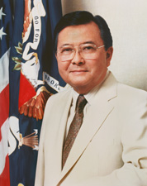
Senator Daniel Inouye wants
Memorial Day moved back
to May 30th.
May 30th or the Last Monday of the Month?

Today, Memorial Day is on the last Monday in May. But Memorial Day was originally on May 30th. The US government changed this in 1968. They wanted to make the holiday more convenient and give Americans a three day weekend. They changed Presidents Day and a few other holidays, too.

Memorial Day is on a different day every year now. This change made some Americans angry. They think Memorial Day should be a holiday, not just another three day vacation. They want to change Memorial Day back to May 30th. Others disagree. They think it's better to have more convenient holidays.

Vocabulary
originally – adverb – First, from the beginning. “I’m originally from Beijing, China.”

