Migrant Mother
Lesson plan by Mark Trushkowsky

Pre-Activity Warm Up
- In their journals, ask students to write about why people take photographs.
- Have students share their thoughts on why people take photographs. Record their responses on newsprint.

Looking at a Photograph
- Hand out copies of the photo Migrant Mother. Ask students to make a list of every detail (and I mean “everything”) that they see with their eyes. Tell them to consider how they would describe the photo to someone who was blind (in order to enable that blind person to imagine the way the picture looks.) Make sure you give students more time then they think they need. Walk around the room and encourage them to go deeper and deeper into their compilation of details.
- Ask the students to share all their details and record their answers. Make sure they keep their details to literal descriptions of the picture. They will have an opportunity to use these details to make inferences later.
- Once you have a list of what they see with their eyes, ask them to look over the details and back at the photograph and share, “What do you see with your minds?” (To help them answer this, you can focus them on one of their details and ask what that detail tells us about her. If they get stuck, you can also ask them questions like - “What does she care about?”, “What kind of woman is she?”, “What is important to her?”
- Ask them to come up with a title for the picture.
- Have the class vote and choose the top two or three winning titles.
- Ask the class to choose one of the remaining titles and write briefly why they think it is the best title for the photograph.
- Bring the class together and write each of the 2 or 3 titles on the board. For each one, record the reasons why students believe that title fits the photograph best.
- Tell them the photo is called Migrant Mother. The photographer was named Dorothea Lange. Ask them why they think Dorothea Lange took this picture. (At first, they might need help focusing on why she might have taken it, beyond the reasons they gave for photography in general. If they need a way to start, you can ask them why Lange called it “Migrant Mother.” You can also refer them back to the reasons they gave as to why people take photos and ask which seems to fit with this photo. You might also juxtapose her motives with one of those motives – if someone said something like, “People take photographs to remember wonderful times and keep those memories.”

Possible Writing Topics
  - Write a letter to the woman in the photo. If you could ask her for advice, what would you ask her? What do you think her answer would be like?
  - Describe a photograph that is important to you. (Remember I have never seen it!) Why is that photograph so important to you?
  - Is there a moment in your life you wish you had a picture of? Describe everything you can remember about that moment. Why do you wish you had a photograph of that moment?
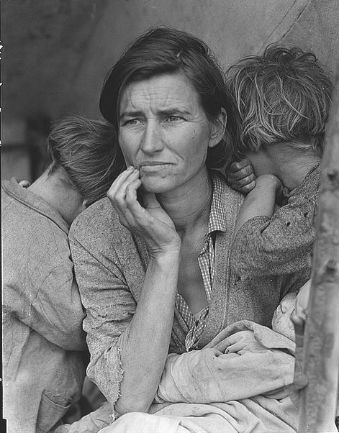
What do you see in this picture?
Please write down everything you see in this picture.

_____________________________________________________________________________
_____________________________________________________________________________
_____________________________________________________________________________
_____________________________________________________________________________

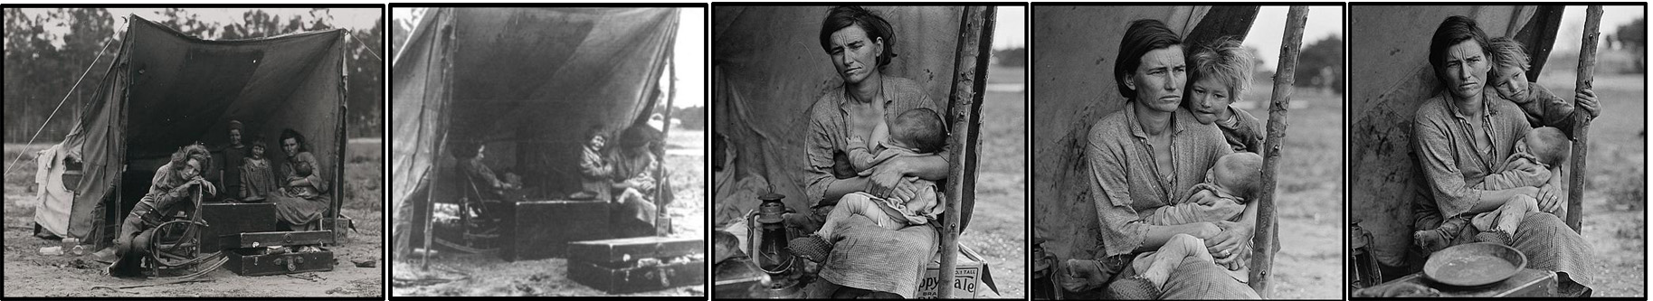
Migrant Mother

This famous American photograph is called “Migrant Mother.” It’s a picture of Florence Owens Thompson and three of her children. Her picture was taken by photographer Dorothea Lange in 1936.

The United States was in the Great Depression. Millions of Americans had lost their jobs and homes. Thompson was one of those people.

Florence Owens Thompson was born in Oklahoma in 1903. She came from a poor family. She married in 1921, and she and her husband moved to California for work. They moved three times in three years to find work, mostly on farms.

Thompson’s husband died in 1931. This was also when the economy crashed. Florence had four children, and was pregnant with her fifth child. They continued to move around California to find work. The family moved back to Oklahoma for a little while before returning to California. They were very poor. At one time, they lived under a bridge in Bakersfield.

In 1936, Florence Owens Thompson was driving down Highway 101 with her family and serious boyfriend. The car broke down at a camp for poor people. The boyfriend and two of her sons went for help. Florence and her young children waited for them.

At this time, Dorothea Lange drove by. She was taking pictures of poor people during the Great Depression. Over 10 minutes she took six pictures of the Thompson family. The picture above is the best-known one. Lange called it “Migrant Mother.” It was a symbol of poor families surviving the Depression.

The photograph helped make Dorothea Lange famous. But it didn’t help Florence Owens Thompson. She said that Lange promised to send her a copy of the picture, and that she never made any money from it. She died of cancer in 1983. Her grave says, “Migrant Mother–A Legend of the Strength of American Motherhood.”

