Mississippi Goddam
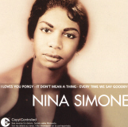Nina Simone, 1933 to 2003
by Nina Simone, 1964

The name of this tune is Mississippi Goddam  And I mean every word of it  Alabama’s gotten me so upset  Tennessee made me lose my rest  And everybody knows about Mississippi goddam  Alabama’s gotten me so upset  Tennessee made me lose my rest  And everybody knows about Mississippi goddam  Can’t you see it  Can’t you feel it  It’s all in the air  I can't stand the pressure much longer  Somebody say a prayer  Alabama’s gotten me so upset  Tennessee made me lose my rest  And everybody knows about Mississippi goddam  This is a show tune  But the show hasn’t been written for it, yet  Hound dogs on my trail  School children sitting in jail  Black cat cross my path  I think every day’s gonna be my last  Lord have mercy on this land of mine  We all gonna get it in due time  I don’t belong here  I don’t belong there  I’ve even stopped believing in prayer | pressure – The feeling something bad will happen  prayer – When you ask god for help  show tune – A song for a movie  Hound dogs on my trail – Men with dogs are following her  Lord have mercy – An expression that means, “God, please forgive them.”

Don’t tell me  I tell you  Me and my people just about due  I’ve been there so I know  They keep on saying go slow!  But that’s just the trouble (Do it slow)  Washing the windows (Do it slow)  Picking the cotton (Do it slow)  You’re just plain rotten (Do it slow)  You’re too damn lazy (Do it slow)  The thinking’s crazy (Do it slow)  Where am I going  What am I doing  I don’t know  I don’t know  Just try to do your very best  Stand up be counted with all the rest  For everybody knows about Mississippi goddam  I bet you thought I was kiddin’ didn’t you  Picket lines  School boycotts  They try to say it’s a communist plot  All I want is equality  For my sister my brother my people and me  Yes, you lied to me all these years  You told me to wash and clean my ears  And talk real fine just like a lady  And you’d stop calling me sister Sadie  Oh, but this whole country is full of lies  You’re all gonna die and die like flies  I don’t trust you any more  You keep on saying go slow!  Go slow! | due – It's time for you to get something.  rotten – A bad person  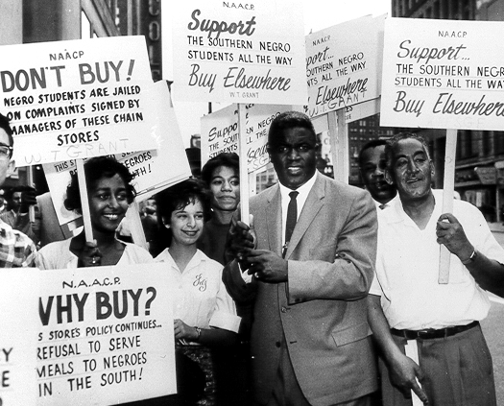A picket line  plot – Idea  equality – When you have the same rights as everyone else  trust – Believe you, think you are a good person

But that’s just the trouble (Do it slow)  Desegregation (Do it slow)  Mass participation (Do it slow)  Reunification (Do it slow)  Do things gradually (Do it slow)  But bring more tragedy (Do it slow)  Why don't you see it  Why don't you feel it  I don't know  I don't know  You don't have to live next to me  Just give me my equality  Everybody knows about Mississippi  Everybody knows about Alabama  Everybody knows about Mississippi goddam  Thats it!  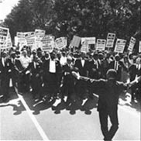Mass participation | reunification – When people come back together  gradually – Slowly, bit by bit  tragedy – Something very sad  School desegregation

