Martin Luther King, Jr.
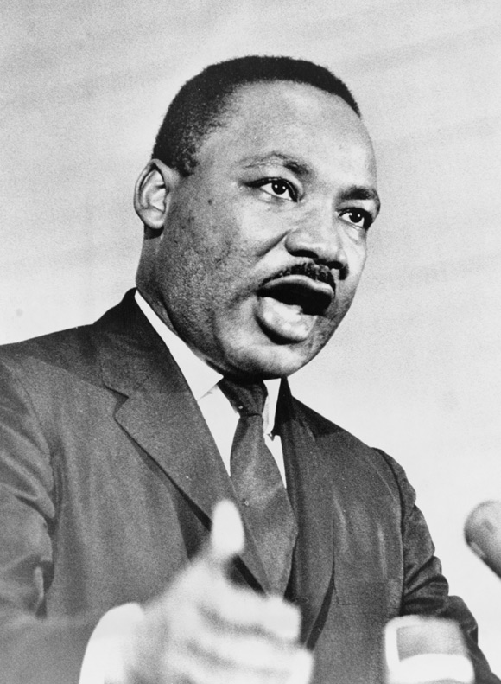 Martin Luther King, Jr., 1929 to 1968

Martin Luther King, Jr. was an American genius. He thought of many ways to help black people in America. He had brilliant ideas to fight racism. Many people loved him. Some people hated him. Today, he is one of America’s greatest heroes.

Martin Luther King, Jr. became famous in 1955. He was a young preacher in Alabama. He lived and worked in the city of Montgomery. The laws in that part of the US were very bad. Some laws made black people take bad jobs for very little money. Other laws made black people feel bad. One law made black people sit at the back of city buses.

None of the black people in Alabama wanted those laws. But only white people could vote in Alabama. All of the politicians were white. White people also owned almost everything. Many white people thought that black people were stupid.

Martin Luther King, Jr. helped organize a bus boycott. A boycott is when everyone stops buying something. Almost all the black people in Montgomery stopped riding the buses. They walked everywhere, or sometimes many people rode in one car. A few white people helped them. Many white people tried to stop them. Some cruel people hurt or killed black people who tried to make things better. The police were all white, and never helped the black people.

The bus company gave up after almost one year. The boycott won! It was a very difficult fight. After the boycott, many more black people in the US fought for their rights. They found many ways to get their rights.

By 1968, Martin Luther King, Jr. was the most famous person in America against the Vietnam war. He also believed the US was helping the wrong people in Latin America and South Africa. King said that black people and poor white people needed to work together. He wanted thousands of poor people to go to Washington, DC, to make the politicians help them. If they didn't help them, they would stop the politicians from going to work. However, he died before this could happen. Martin Luther King, Jr. was shot and killed on April 4, 1968.

Vocabulary
- genius – noun – Someone who is very smart. “Einstein was a genius.”
- brilliant – adjective – Very smart and creative. Can think in new ways.
- preacher – noun – Someone who is the leader of a church.
- stupid –adjective – The opposite of intelligent. Not careful. “I made a stupid mistake.”
- cruel – adjective – Very mean, sometimes to get something you want. The opposite of kind. “The boss is cruel to his workers.” “The cruel landlord lied to his tenants.”

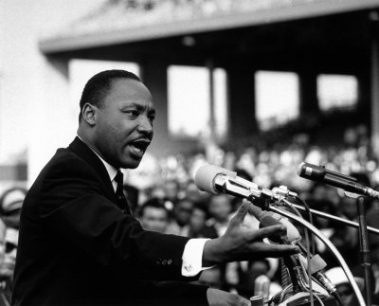
Questions

1. What is a boycott?

2. Why did King start a bus boycott?

3. How did people get to work without riding the bus?

4. What did King want to do in Washington, DC? Why?

5. Did you know about Martin Luther King, Jr. before today? What did you know?

