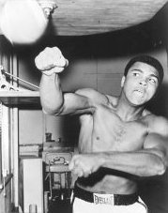
Muhammad Ali

One of America’s most famous athletes is Muhammad Ali. Born in the state of Kentucky in 1942, Ali was the best boxer in world. He was also famous for his politics and religion.

Muhammad Ali was born with the name Cassius Clay. He started boxing when he was 12 years old. He learned to move fast and hit hard. When he was just 18 years old he went to the 1960 Olympics in Rome, where he won a gold medal for boxing.

Clay loved his gold medal. He wore it every day in Rome – to restaurants, the movies, even to bed. When he returned to Kentucky, he tried to go to a restaurant. The owner refused to let him in because he was black. That day, Ali went to the river and threw his gold medal into the water.

He fought many more times after the Olympics. Soon, he became the number one boxer in the world. He also became a Muslim. It was a big surprise to people around the country. Muslims were not popular, and he was the first famous Muslim in America. When he changed his religion, he changed his name, too. His new name was Muhammad Ali.

The Vietnam War changed everything for Muhammad Ali. The US government said all healthy young men had to fight. If you didn’t, you would go to jail. However, it was easy for rich white men to stay home. Too many black men and poor white men were killed in Vietnam. American soldiers killed millions of Vietnamese people in the war.

Ali did not want the US to fight in Vietnam. He said the Vietnamese never hurt black people, but white Americans hurt black people every day. Black Americans couldn’t vote in much of the country, and couldn’t get good jobs or homes. Muhammad Ali refused to fight in the Vietnam War. Instead, he spoke at colleges around the country against the war. This made the President and many politicians angry at Ali. In 1967, they tried to send him to jail. They also made him stop boxing.

Muhammad Ali couldn’t box again until 1971. He missed the best boxing years of his life, but he fought many more times. In the 1980s, doctors learned he had Parkinson’s disease. Parkinson’s makes it difficult to move. Doctors agree that boxing made his Parkinson’s worse.

Many of the best boxers in the US have been black. Almost all of them came from poor families, and finish boxing injured and poor. Muhammad Ali was lucky. He was the best boxer in the world, and is one of the most famous Americans today.

Vocabulary
- athlete – noun – Someone who plays a sport. “My daughter is a great athlete.”
- refuse – verb – When you don’t do something, usually something other people want you to do. “I refuse to work for less than $10 an hour.” “I refuse to give up.”
Questions
1. What do you think about boxing? Do you have boxing in your country? Is it popular?

2. What was Muhammad Ali’s old name? When did he change it? Why?

3. Why was Ali against the Vietnam War? What did he do?

4. What do you think about Muhammad Ali’s life? Are there people like him today?

5. Why were so many boxers black and poor? Is this true today?

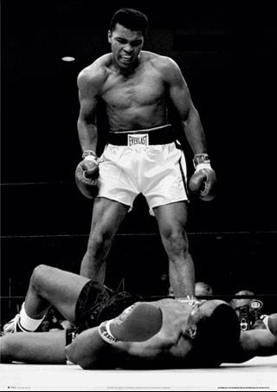
“What’s my name, fool?”
Muhammad Ali was born a Christian named Cassius Clay. Like many other black Americans in the 1960s, he thought that Christianity was a religion for white people. He also thought that Cassius Clay was a Christian name. After he became the number one boxer in the world, he told everyone he changed his name and religion. He became a Muslim named Muhammad Ali.

Black Muslims in the US wanted to stop racism. They wanted black Americans to have human rights: Good jobs, good homes, good schools and hospitals, and to be able to vote. Many white people were afraid more black people would fight for their rights. They called Muhammad Ali by his old name, Cassius Clay, and said he was stupid.

A few black people did the same thing. One of them was the boxer Floyd Patterson. He said a Christian should be the number one boxer, not a Muslim. He always called Ali “Clay.” Floyd Patterson was a good boxer, but Muhammad Ali was the best. When they fought in 1965, Ali knocked Patterson down many times. When Patterson was on the ground, Ali said, “Come on, America! Come on, white America! Is my name Clay? What’s my name, fool?”

Today, Ali has Parkinson’s disease. He doesn’t say much about racism or the war in Iraq. But no one calls him Cassius Clay. Around America and the world, he will always be Muhammad Ali.

