New York City

- You called me last night on the __________________
- And I was glad to hear from you __________________ I was all alone
- You said, "It's snowing, it's snowing! God, I hate this ___________!"
- Now I walk through blizzards just to get us back ________________

- We met in the springtime at a rock-and-roll __________________
- It was on the Bowery when it was time to_________
- We __________________ on the subway in the middle of the night
- I held your _____________, you held mine, it was the best night of my life

- 'Cause __________________ your __________________ in New York City
- And ________________ looks _______________ when you're young and pretty
- The streets are paved with diamonds and there's just so much to ____________
- But the best thing about New York City is you and __________________

- The Statue of __________, Staten Island Ferry, Co-op City, Katz's and Tiffany's
- Central Park, Brooklyn Bridge, the Empire State where Dylan lived
- Coney Island and Times Square, Rockefeller Center
- Wish I was _________

- You wrote me a __________________ just the other day
- It said, "Springtime is coming soon so why don't you come to stay?"
- I packed my stuff, it's on the bus, I can't believe it's __________________
- I'm three days from New York City and I'm three days from ________________

- 'Cause __________________ my __________________ in New York City
- And ________________ looks _______________ when you're young and pretty
- The streets are paved with diamonds and there's just so much to____________
- But the best thing about New York City is you and _______
New York City
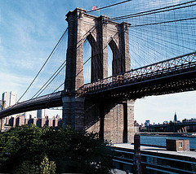 The Brooklyn Bridge
Written by Cub, sung by They Might Be Giants

- You called me last night on the telephone
- And I was glad to hear from you 'cause I was all alone
- You said, "It's snowing, it's snowing! God, I hate this weather!"
- Now I walk through blizzards just to get us back together
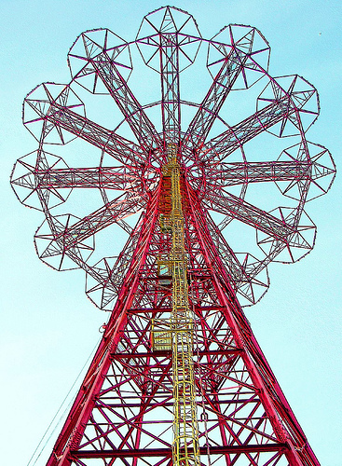 A ride at Coney Island
- We met in the springtime at a rock-and-roll show
- It was on the Bowery when it was time to go
- We kissed on the subway in the middle of the night
- I held your hand, you held mine, it was the best night of my life

- 'Cause everyone's your friend in New York City
- And everything looks beautiful when you're young and pretty
- The streets are paved with diamonds and there's just so much to see
- But the best thing about New York City is you and me

- The Statue of Liberty, Staten Island Ferry, Co-op City, Katz's and Tiffany's
- Central Park, Brooklyn Bridge, the Empire State where Dylan lived
- Coney Island and Times Square, Rockefeller Center
- Wish I was there

- You wrote me a letter just the other day
- It said, "Springtime is coming soon so why don't you come to stay?"
- I packed my stuff, it's on the bus, I can't believe it's true
- I'm three days from New York City and I'm three days from you
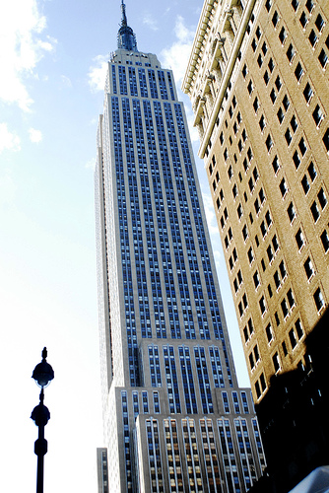 The Empire State
Building
- 'Cause everyone's my friend in New York City
- And everything looks beautiful when you're young and pretty
- The streets are paved with diamonds and there's just so much to see
- But the best thing about New York City is you and me

