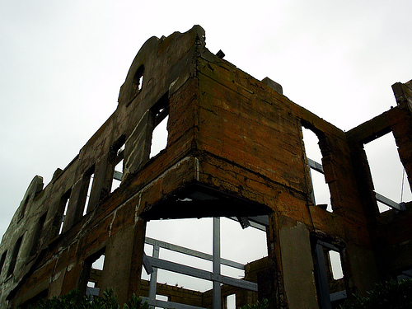
The Oakland Hills Fire

The fire started October 19, 1991 in the hills of Berkeley, California, and strong winds quickly spread it to the Oakland Hills. There are thousands of big eucalyptus trees in the hills. Eucalyptus trees have bark that’s long, dry, and very flammable. When eucalyptus trees catch on fire, they make embers that can travel far away.

Most houses in the Oakland Hills were old, and had flammable roofs. They caught fire when embers touched them. The houses were close together, and the fire spread quickly from house to house, faster and faster. There was a dry, fast wind that spread the embers and made the fire stronger.

The fire was so powerful it burned 790 buildings in the first hour, and grew very quickly. The fire hit the closest highway. Traffic in Oakland and Berkeley made it hard for firefighters to come. The traffic also made it hard for people living in the Oakland Hills to leave. The streets are very narrow, and turn a lot. It was hard to get away from the fire.
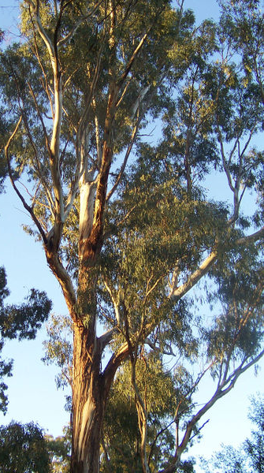 A eucalyptus tree

The 1991 fire was one of the worst in California's history. It took three days for firefighters to stop it. It killed 25 people, injured 150 more, and destroyed more than 3,000 buildings. It burned two-and-a-half square miles of forests and homes.

The first people in California were the American Indians. The name of the Indians from the Bay Area is the Ohlone. They made small fires every year. The small fires made more room for people and animals to live. When the Spanish came to the Bay Area, they took the land away from the Ohlone. The United States came later and did the same thing. We planted many eucalyptus trees around California. We stopped making small fires every year. Now, fires in California are very powerful, and burn trees, buildings and people.

Vocabulary
- spread – verb – Go to. “The fire spread from the kitchen to the living room before I saw it.”
- bark – noun – The rough outside part of a tree – the “skin” of a tree. “Some kinds of tree bark make good medicine.”
- flammable – adjective – Easy to catch on fire. “Paper and gasoline are very flammable.”
- embers – noun – Small pieces of something that’s on fire. “Embers can start fires.”
- narrow – adjective – Skinny. “My apartment is long, but very narrow.”
Vocabulary Practice
1.__ spread  2.__ bark  3.__ flammable  4.__ embers  5.__ narrow  6.__ _______________ | a. The rough outside part of a tree  b. Skinny  c. Small pieces of something that’s on fire  d. Lots of people driving at the same time  e. Go to  f. Easy to catch on fire

Questions
1. When and where did the Oakland Hills Fire start?

2. Why did the fire spread so quickly?

3. Why are fires in California so big and dangerous?

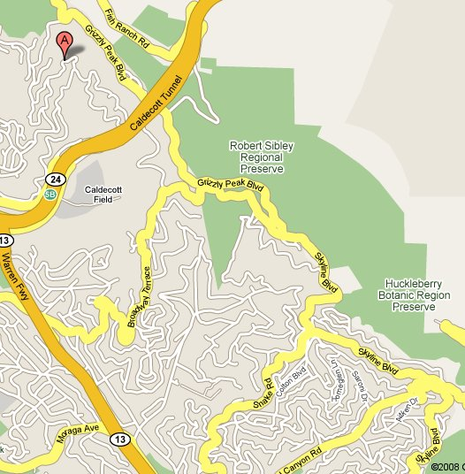6. This is a map of where the Oakland Hills Fire happened. The letter “A” is where the fire started. What do you notice about the neighborhood in the map?

4. How can we stop big fires from starting?

5. Are there fires like this in your country?

