The First Californians
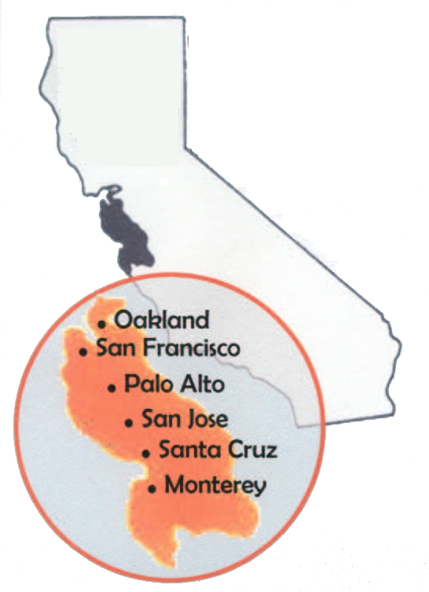 Where the Ohlone lived

The first people to live in the San Francisco Bay Area were called the “Ohlone.” They were American Indians. The Ohlone people lived mostly by the ocean. They spoke eight different languages.

The Ohlone lived in villages of 50 to 300 people. Most of the villages had about 200 people. Each village had a leader, who was usually a man, but sometimes a woman. The leader had a helper, or assistant. The assistant would invite other villages to trade or to feast.

The Ohlone also had their own religion. They believed that everything in nature was important – plants, animals, people, and the earth. The Ohlone ate fish, birds, rabbits, deer, and many plants. They also ate acorns from oak trees.

People from Europe came to the Ohlone land in the 1500s. They came from England and Spain. At first, they did not do very much. But Spanish priests came back in the 1700s. They built missions, or big churches, on Ohlone land. The priests wanted the Ohlone to become Christian.

If an Ohlone person became a Christian, they had to leave their village and live on the mission. They had to work on the mission, too. If they left the mission, the Spanish people would find them and hurt or kill them.

Many Ohlone died from diseases the people from Spain brought with them. The people from Spain also killed many of them. There were about 10,000 Ohlone people before the Spanish came to California. By 1832, there were less than 2,000. The people from Spain also took away much of the Ohlone’s land.

Today, the Ohlone do not have any land. The US government will only give land to people it thinks are American Indians. The government does not believe there are any Ohlone people alive. But there are about 550 Ohlone alive today. They are fighting for the government to give them back a little bit of the land they used to have.
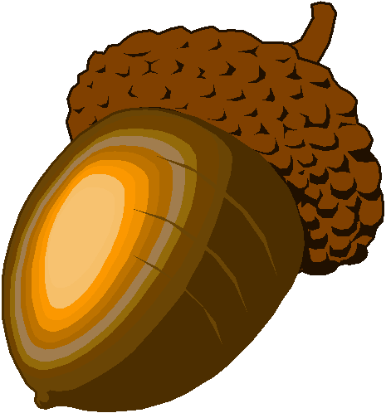 An acorn

Vocabulary
- invite – verb – To ask someone to come to something.
- feast – noun or verb – A big meal, or to eat a lot of food. “We had a
feast for my graduation.” “I feasted on turkey at Thanksgiving.”
- acorns – noun – A big seed from an oak tree.
- 1500s – noun – From the year 1500 to the year 1599.
- priests – noun – People who lead a church.
Vocabulary Practice

1.__ invite A. From the year 1500 to the year 1599

2.__ feast B. A big seed from an oak tree

3.__ acorns C. A place where a small number of people live

4.__ 1500s D. A big meal, or to eat a lot of food

5.__ priests E. To ask someone to come to something

6.__ ____________ F. People who lead a church

Questions

1. Who are the Ohlone?

2. What did they eat, before European people came to their homes?

3. How many Ohlone people were there before the Europeans came?

4. How many are there today? Why?

5. What are the names of the cities built on Ohlone land?

