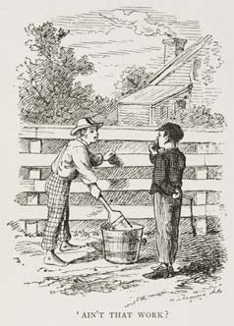
Tom Sawyer and the Fence (part 1)

Tom Sawyer was a 12 year old boy with a big job. One morning, he had to paint a 90 foot long fence. It was a hot day, and he could hear everyone in the neighborhood talking and laughing. He put his brush in the paint and painted some of the fence. Then he did it again. And again.

Tom thought about all the fun things he could be doing. He thought about swimming, or climbing trees. Just then, Tom's friend Jim walked by. He was carrying a bag of groceries.

"Hey Jim, will you help me paint this fence?”, asked Tom.

"Sorry, Tom, my mom says I have to bring these groceries home for lunch,” answered Jim.

"That's ok, Jim. I'll take those groceries and you can paint the fence. I'll come as soon as I'm finished,” Tom said quickly.

"Oh no, Tom. My mom said you'd try to make me paint the fence. Sorry!"

Tom watched Jim walk down the street. He started painting again, but he got bored. Then he heard his friend Ben Rogers walking down the street. Ben was pretending to be an airplane. He made loud airplane noises and ran around the street. After a while, he walked up to Tom.

"Hi Tom. It looks like you have a lot of work today,” Ben said.

"What? Oh, hello Ben. I didn't know you were here," Tom answered without looking at him.

"I'm going swimming today. Don't you want to go swimming? I guess you like to work."

Ben was making fun of Tom, but Tom didn’t stop painting. "Work? This isn’t work, Ben."

Ben couldn’t believe it. "Don't tell me you like painting the fence, Tom!"

"It's not every day you paint a fence,” Tom said while painting the fence.

Vocabulary
- pretend – verb – To believe in something that isn’t true. “I used to pretend to be the president.”
- making fun of – To laugh at someone, and make jokes about them. “My big brother makes fun of me.”
Questions

1. Who is Tom Sawyer? Who are Jim and Ben?

2. What does Tom say to Jim? Why?

3. What does Tom say to Ben? Why?

4. What do you think will happen next?
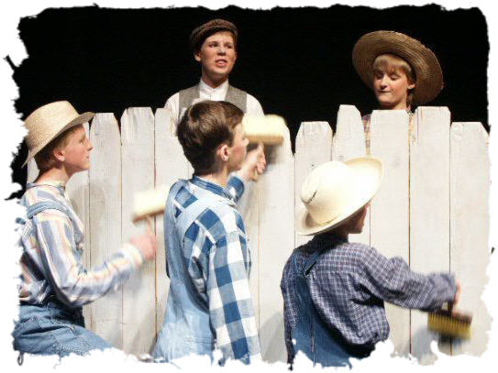
Tom Sawyer and the Fence (part 2)

This made Ben stop and think. Tom continued painting the fence, then stepped back to look at it before painting some more.

"Um Tom? Can I paint the fence?", Ben asked.

Tom thought about it for a minute. It looked like he was going to say yes. Then he said, "Well, I don't think so, Ben. This is Mrs. Smith’s fence, and she said I was the only one who could paint it. Not just anyone can paint a fence."

"Come on, let me try, Tom! Just a little bit. I'll do a good job. If I was painting a fence I'd let you do it." Tom looked like he was about to cry.

"Jenny asked Mrs. Smith if she could paint the fence, and Mrs. Smith said no. Andrew asked, too, and Mrs. Smith said no to him, too. What if you made a mistake? I’d get in big trouble."

“I’ll be careful, Tom, I promise! Here, I’ll give you half of my candy bar,” Tom said, as he took a candy bar out of his pocket.

It looked like Tom was going to say yes. “Ok, Ben – no, wait! I can’t...”

“I’ll give you ALL of my candy bar!”, Ben shouted, “Take it! Please!”

Tom pretended to be sad, but he was happy. While Ben painted, Tom ate his candy bar and looked for more kids. There were lots of kids in the neighborhood. They came to laugh at the work, but they stayed to paint the fence. In a few hours Tom had an apple, a broken watch, a small radio, a baseball hat and an old soccer ball. By the end of the afternoon the children had painted the whole fence.

Tom learned something important that day. He learned that if you want to make someone want something, you only have to make it difficult to get. What you have to do is work and what you want to do is fun.

Questions
1. Do you think Jenny and Andrew really asked Mrs. Smith if they could paint the fence?

2. Why did Ben paint the fence?

3. Do you know anyone like Tom? Are you like Tom?

