Paper Sons
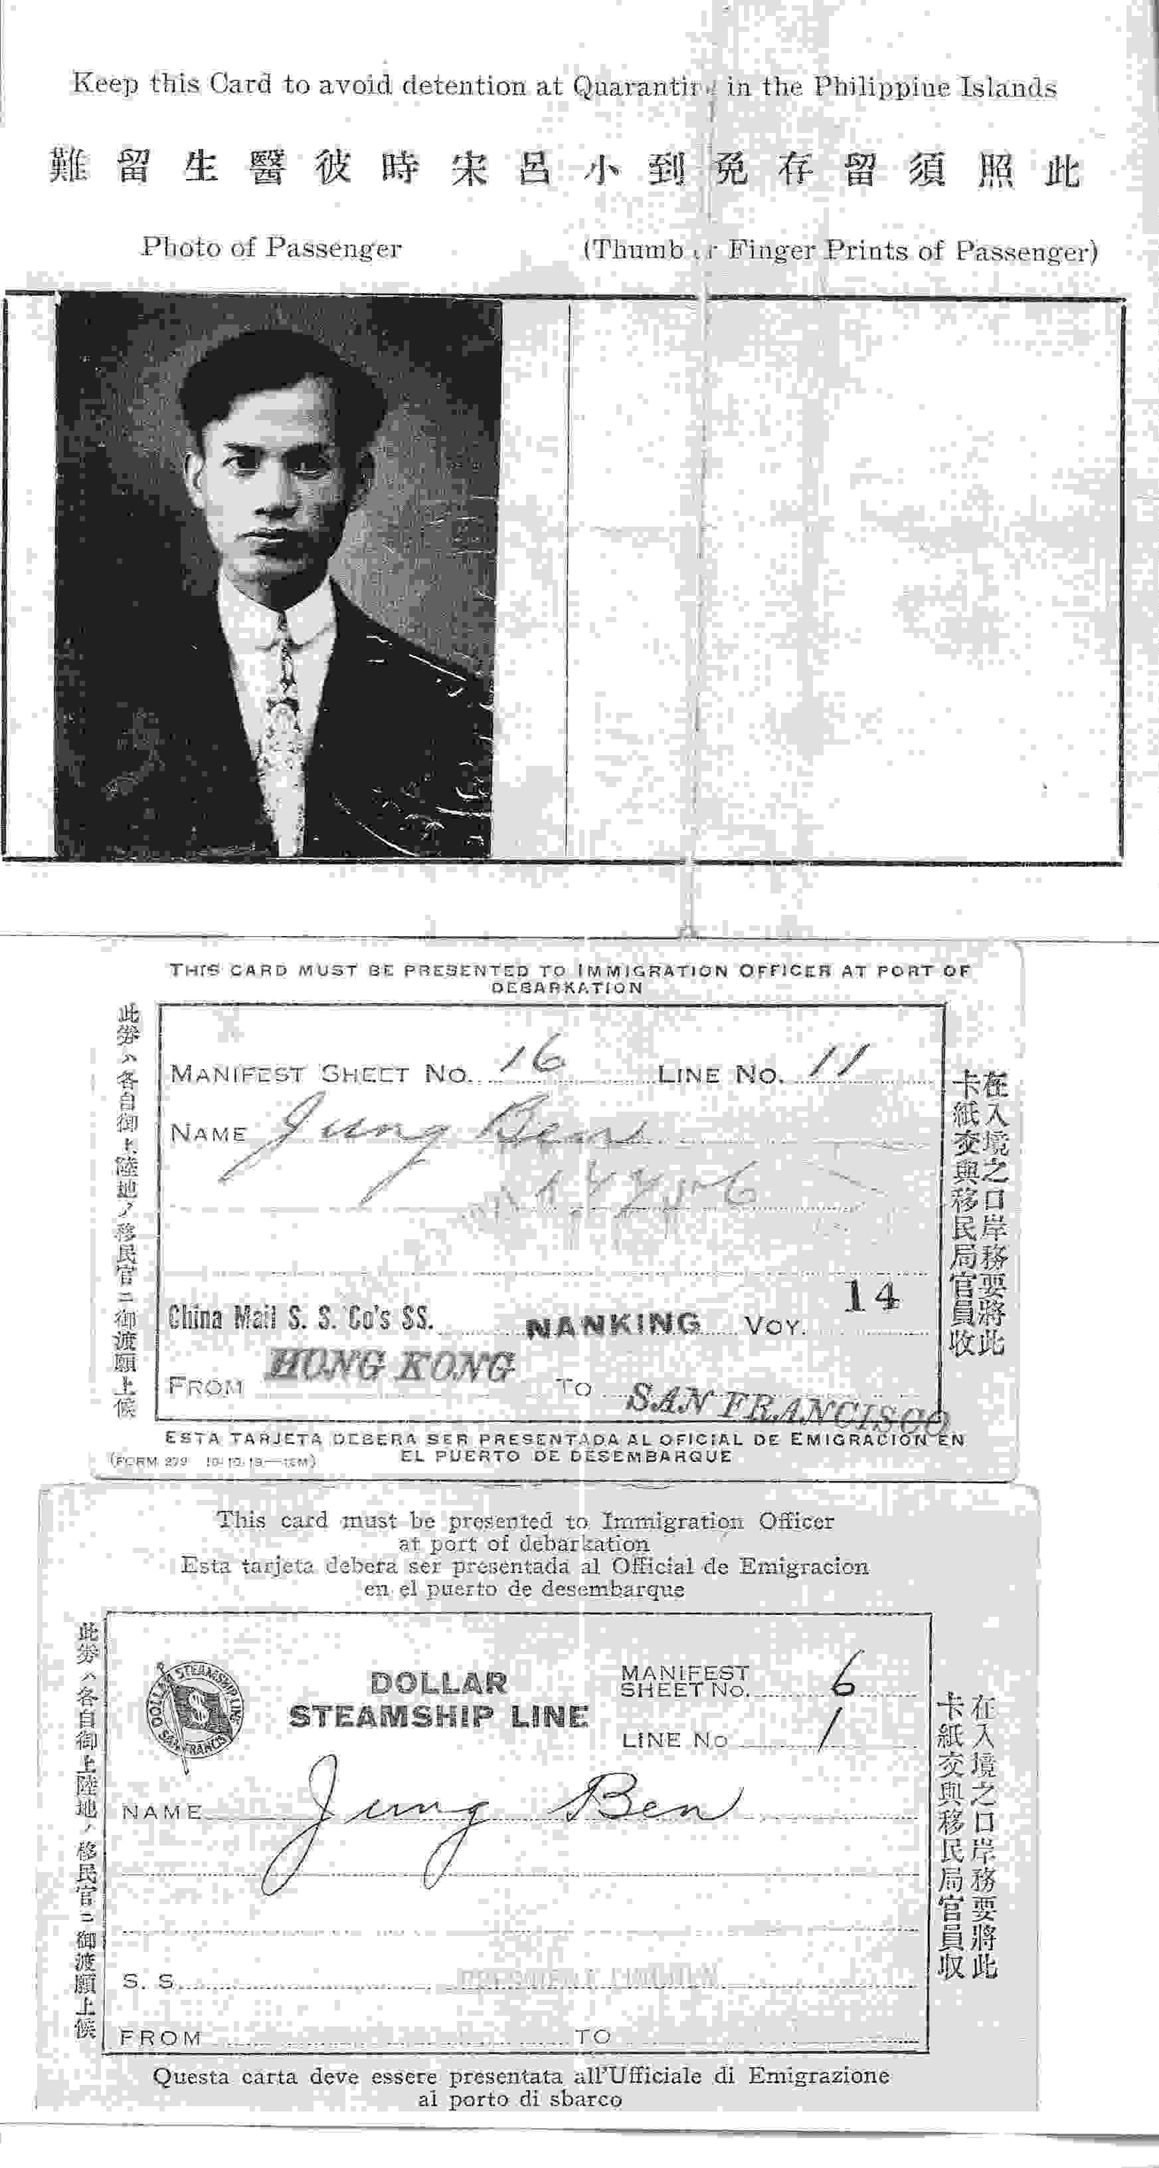 A paper son's travel papers

In 1906, a huge earthquake hit San Francisco. After the earthquake was a big fire. The earthquake and fire killed thousands, and many buildings were destroyed.

One of those buildings was San Francisco City Hall. Almost every city has a city hall. It’s a big building where the mayor and other local politicians work. It's also where the city keeps its important records, or papers. They have records of who owns what buildings, who was arrested, how the city spent money, and much more.

When immigrants came to the US, they had to answer many questions. They had to say how many children they had. They had to give their children's records to the US government. Many of these Chinese immigrants’ records were in San Francisco City Hall. All of these records were destroyed in the 1906 earthquake and fire.

In 1882, the US passed a law called the Chinese Exclusion Act. This law made it almost impossible for Chinese people to immigrate to the US, or become US citizens. After the earthquake, many Chinese men said they were born in America. This made them American citizens. This made their sons in China citizens, too. Their sons could then immigrate to the US.
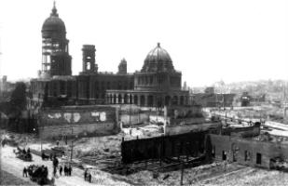 City Hall after the 1906 earthquake

Some Chinese immigrants said they had sons when they did not have any sons. A man in China would pay money to be their “son.” This man could then legally come to the US. These men were called “paper sons.”

Vocabulary
- huge – adjective – Very big. “I got a huge headache from eating ice cream too quickly.”
- destroyed – adjective – Broken, can’t be used any more. “The hurricane destroyed thousands of homes in Florida.”
Vocabulary Practice
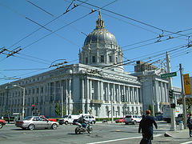
San Francisco City Hall today
1.___ huge | a. Chinese people who paid money to be US citizens
2.___ destroyed | b. Someone who came here from another country
3.___ records | c. A law that stopped Chinese immigrants
4.___ city hall | d. Broken, can’t be used any more
5.___ immigrant | e. Papers
6.___ Chinese Exclusion Act | f. A building that holds important records
7.___ _________________ | g. Very big

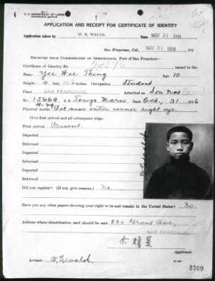 A paper son's American ID
Questions

1. What are records? What records were kept in San Francisco City Hall?

2. What happened to San Francisco City Hall and the records inside of it?

3. Why was it difficult for Chinese immigrants to become US citizens? What did they do after the 1906 Earthquake?

4. Do you think this was wrong for people to become “Paper Sons”?

