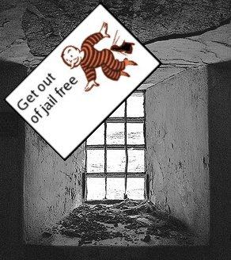
Pardon Me!

More than one million people are in jail in the US. People may go to jail for one day, 10 years, or longer. Sometimes they can get out early if they are good. Other times, the government will kill them.

A governor or the President can get you out of jail early. This is called a “pardon.” The most famous pardon was for President Richard Nixon. Nixon was a Republican, and did many illegal things to stop the Democrats. Politicians in Washington were very angry with him. They were going to make him quit, so he resigned. He was going to go to jail! After he resigned, the next President pardoned him. Richard Nixon never went to jail.

There's a long history of pardons in the US. Many people were pardoned at the end of the Civil War, in 1865. The American Civil War was when the states in the South tried to leave the United States and make a new country. They wanted to be independent and keep slavery. After the war, President Lincoln pardoned thousands of soldiers from the South. This helped the South become part of the US again.

America started a war in Vietnam in the 1960s. America needed many soldiers, so the government made many young men join the military. Rich people usually didn't have to fight, but many poor people, black people and Latino people had to fight in Vietnam. The war was very unpopular in the US. America lost the war. About 50,000 American soldiers died, and the US killed about a million Vietnamese people. Many American men left the country because they did not want to fight in Vietnam. This was illegal. But a few years after the war ended, President Carter pardoned all of them.

Presidents usually pardon people on their last day. On his last day, President Bill Clinton pardoned 140 people. One of them was a very rich man who stole about $100,000,000 dollars. President Clinton made him give that money to the US. President Clinton also pardoned his brother for having drugs. A year later, his brother was arrested again, for drunk driving.

Sometimes people are pardoned because they should not be in jail. One big problem in the US is domestic violence. When a woman is killed in America, she usually is killed by her husband or boyfriend. In California, many women are in jail because their husbands tried to kill them, and they had to kill their husbands. Some of these women have been in jail for 20 or 30 years. Governor Schwarzenegger has pardoned some of them, but many are still in jail.

Vocabulary
1. resign – verb – When you quit an important job. “The Mayor resigned after getting arrested.”
2. slavery – noun – When white people made black people work for no money.
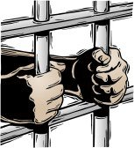
Questions

1. What does “pardon” mean? Do they pardon people in your country?

2. Why did President Carter pardon men who didn't want to be soldiers in Vietnam?

3. Why do you think Presidents pardon people on their last day?

4. Why has Governor Schwarzenegger pardoned some women who were victims of domestic violence? Should he pardon all of them?

5. Do you think pardons are good or bad? Who should get pardoned?

Why Jail?
People are put in jail for 4 reasons. Do you agree with these reason?

Why people go to jail | Do you agree?
1. People will not break the law if they know they will go to jail.
2. People learn to be good in jail.
3. When bad people are in jail, everyone else is safer.
4. We use jail to hurt people who break the law.

