Teacher Notes: “Please, Please, Please Let Me Get What I Want”
This is a good song to teach English language learners. The words are fairly simple and the song is short – the singing is done by about 1 minute and 20 seconds into the song!

Here’s how I taught “Please Please Please”:
1. Students listen to the song without writing anything or having the handouts (1-2 times)
2. Students listen and individually write down what they can (1-3 times)
3. Students compare their notes to try to piece together the lyrics to the song (~5 minutes)
4. Students listen again (1 time)
5. Students listen again and do the fill-in-the-blanks worksheet as a group (2-3 times)
6. Students read over the complete lyrics while listening to the song. Give each student a copy of the lyrics.

Please, Please, Please...
by The Smiths
 The Smiths, 1982 to 1987
Good times for a _______
See, the luck I’ve had
Can make a good man
__________________

So please please please
Let me, let me, let me
Let me __________________
_____________

Haven’t had a ________ in a long time
See, the life I’ve had
Can make a good man bad

So for __________________
Let me __________________
Lord knows, __________________
Lord knows, __________________
Please, Please, Please Let Me Get What I Want
by The Smiths
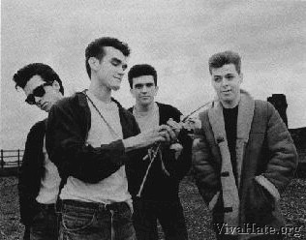 Johnny Marr, Morrissey, Mike Joyce, Andy Rourke
Good times for a change
See, the luck I’ve had
Can make a good man
Turn bad

So please please please
Let me, let me, let me
Let me get what I want
This time

Haven’t had a dream in a long time
See, the life I’ve had
Can make a good man bad

So for once in my life
Let me get what I want
Lord knows, it would be the first time
Lord knows, it would be the first time

