Rachel Carson
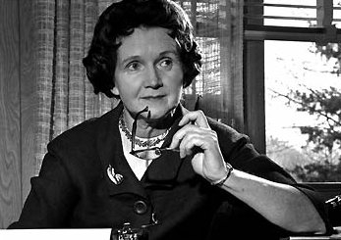 Rachel Carson, 1907 to 1964

Rachel Carson was born on a small farm in Pennsylvania in 1907. When she was young, she studied fields and forests for hours. She also wrote stories for a children’s magazine.

In college, Carson studied animals, and graduated as one of the best students in her class. She taught at a university in Maryland. But when her father died, she had to quit teaching to take care of her mother. She applied for a job with the government, writing about science for radio programs. To get the job, she needed to take a difficult test. This was in 1936. Many men didn’t think she could pass it. However, Rachel Carson got the highest score that year.

Carson was an excellent writer. Her job was to write for the radio, but she also wrote stories for newspapers and magazines to make a little extra money. She needed it. When her older sister died, she had to take care of her two nieces.

She wrote her first book, about the ocean, when she was 34. It was a good book, but didn’t sell very well. She wrote her second book 10 years later. This book, also about the ocean, was very popular, and was made into a movie. Rachel Carson finally had enough money. She quit her job with the government to write full-time. She finished her third ocean book in 1955. Then, her niece, 36 years old, died, and Carson had to take care of her 5 year old son, as well as her 90 year old mother.

Rachel Carson started studying pesticides. Pesticides kill pests: small animals and insects that eat our food or make us sick. Back then, pesticides were new and cheap. People used as much pesticide possible. They believed it was necessary to kill all pests. The government used pesticides on forests and lakes and fields around the US. Carson learned pesticides also killed birds and other animals we liked. She wrote a book, Silent Spring, about pesticides. She wanted us to use as little pesticide as possible.
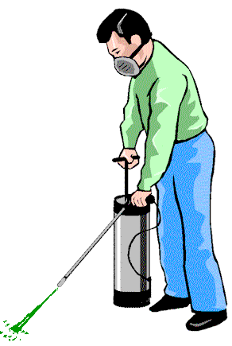 A man using
pesticides

Big chemical companies were angry at Rachel Carson. They spent lots of money telling people she was wrong. But hundreds of thousands of Americans read her book. The chemical companies made Silent Spring more famous.

Rachel Carson taught Americans to care about the environment: the air, the water, the plants and animals. Silent Spring is one of the most important books in American history. Rachel Carson died from breast cancer in 1964, at the age of 56. The world is a better place because of her.

Vocabulary
1. apply – verb – To try to get something, like a job. “I applied for 6 different government jobs.”
2. excellent – adjective – Very good. “The chicken soup was excellent tonight.”
3. silent – adjective – Quiet, no sound at all. “My new apartment is silent at night.”
Vocabulary Practice
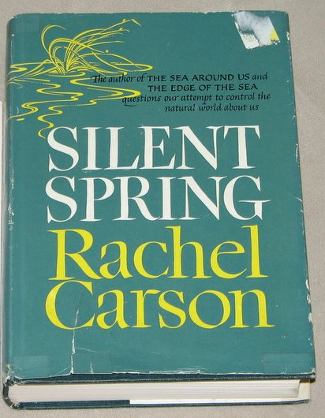 A 1962 copy of Silent Spring
- ___ apply | a. Very good
- ___ excellent | b. A very large body of water
- ___ silent | c. The air, water, land, plants & animals
- ___ ocean | d. To try to get something
- ___ pesticide | e. Chemicals that kill pests
- ___ pest | f. Small animals that bother people
- ___ _____________ | g. Quiet, no sound at all

True or False
- T / F Carson worked as an elementary school teacher in Maryland before her father died.
- T / F In 1936, Rachel Carson got the top score on her government test.
- T / F She wrote for magazines and newspapers to make extra money for her two neices.
- T / F Rachel Carson quit her job because she got married.
- T / F Pesticides kill plants that people don't like.
- T / F Rachel Carson wanted people to use as little pesticide as possible.

Questions
1. What kind of person was Rachel Carson? How do you know?

2. What was her first job? Why did she quit?

3. How did people in the US use pesticides before Silent Spring?

4. Why did chemical companies want to stop Rachel Carson?

5. Why did Rachel Carson choose the title “Silent Spring” for her book?

