The US government made this poster of “Rosie the Riveter” during World War II.
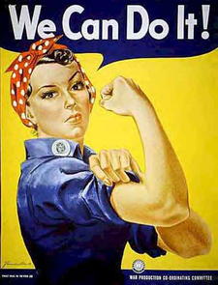
1. What can women do?

2. What type of work do women do in your country? In the US?

3. How do you think Rosie feels?

The US government made this poster of “Rosie the Riveter” during World War II.
1. What can women do?

2. What type of work do women do in your country? In the US?

3. How do you think Rosie feels?

Rosie the Riveter
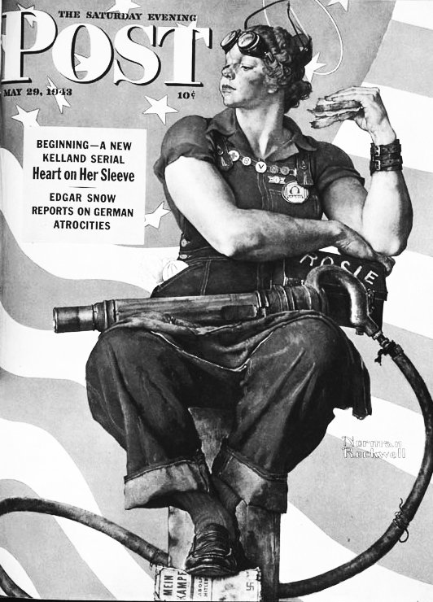 Rosie on the cover of a magazine

One of the most famous women in US history wasn’t a real person. She was Rosie the Riveter. Her story is the story of American women during World War II.

World War II started in 1941 for the United States. Millions of American men joined the military. Soon there was a problem. Who would work in the factories?

Factories made planes, bombs and guns for the military. Factory jobs were difficult, dirty and dangerous. They also paid a lot of money.

In 1940, only 10% of women worked outside the home. Men thought that paid work was bad for women. They said that women weren’t strong enough – or smart enough – to do paid work. They also said that when women worked outside the home, it was bad for families.

To win the war, the US needed women to work in factories. To convince women to do men's work, two painters made two famous paintings called “Rosie the Riveter.” (Riveting is a factory job.) The paintings and the government convinced millions of women to take men's jobs.

Women went to work. About 30% of women were working outside the home in 1944. Six million women worked in factories during the war. Their jobs weren’t easy, and they were paid less money than men: Men earned about $55 a week, and women only about $31. But for many women, this was their first experience working outside the home and making money.
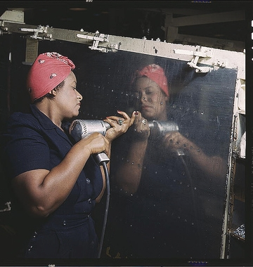 A woman factory worker during
WWII

World War II ended in 1945. The government asked women to leave their jobs so men could have them back. It was not until the 1970s that so many women had paying work again. But American women never forgot Rosie. She changed their lives forever.

Vocabulary
- factory – noun – A place where people build things. A factory can make cars, computers, or almost anything else. “There aren’t too many factory jobs in the US today.”
- convince – verb – To make someone have the same opinion you have. “I convinced my friend to move to San Francisco with me.”
- experience – noun – What happened to you. “I had a good experience working in LA.”
- forever – adjective – For all time. “I will love you forever.”
Vocabulary Practice
1. __ factory | a. When people think women are not as good as men.
2. __ convince | b. For all time.
3. __ experience | c. The money you make at work.
4. __ forever | d. A factory job.
5. __ riveting | e. To make someone have your opinion.
6. __ earn | f. A building where they make things.
7. __ | g. What happened to you.

Questions
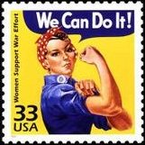 Rosie on a stamp
1. Where did 90% of American women work before World War II?

2. Why did the government need Rosie the Riveter?

3. Why did women factory workers earn less money than men?

4. The US government asked women to work in factories. Why do you think the government didn't ask women to be soldiers?

5. Why did the government ask women workers to quit their jobs at the end of the war?

