The Sanctuary Movement
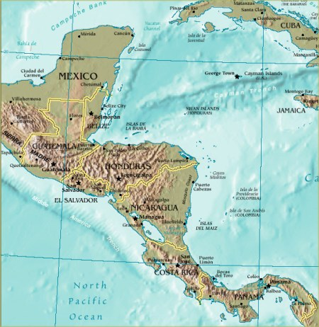
Central America is Guatemala,
Honduras, El Salvador, Belize,
Nicaragua, Costa Rica, Panama.

In the 1980s, people in Central America were fighting for democracy. The US government tried to stop them. It supported bad Central American governments. The US also taught Central American armies how to kill people who wanted democracy: teachers, students, people in unions, and their families. Those armies killed hundreds of thousands of people.

Many Central Americans had to leave. People who need to leave their country or get killed are called “refugees.” Some of the refugees from Central America went to the US, but this was a dangerous journey. It was illegal for them to come here. If the government caught them, they were deported. Too many times, people who went back were killed.

The refugees often paid people to help them into the US. These people are called “coyotes.” Sometimes a coyote got you into the US. Sometimes, they left you in the desert. But you always had to pay them a lot of money first.

In 1980, a coyote left 26 people from El Salvador in the desert. Half of them died and the rest went to jail. Two churches in the state of Arizona were outraged that this happened. They paid for the 13 refugees to get out of jail. The people from these churches said they'd help the refugees stay in the US. This was illegal – against the law.

The churches said they'd be a “sanctuary” for refugees. A sanctuary is a place where no one can hurt you. On March 24, 1982, the two churches in Arizona, two churches in Berkeley, California, and one church in Washington, DC, said they'd be sanctuaries for refugees.

Soon, there were over 400 sanctuary churches around the US. This was a movement. A movement is when many people around the country or the world fight for the same thing. The churches wanted the US to stop supporting armies in Central America. They also wanted the government to help refugees.

The people in these churches gave some money and information to refugees. Sometimes, refugees could stay in their homes. Sometimes they'd even help refugees get across the border and into the US. A few of these Americans were arrested. They didn't want to go to jail. But to do nothing while people died in the desert, or were killed in their country, was even worse.

Vocabulary
- journey – noun – A long trip. “We made the journey to my family home in 14 hours.”
- desert – noun – A hot, dry place with lots of sand and no water. “The desert is a beautiful and dangerous place.”
- outraged – adjective – Very angry at something that should not happen. “We are outraged that we have pay so much money to send our children to college.”
Vocabulary Practice
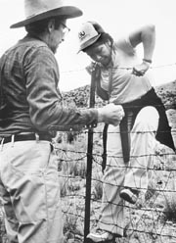
Someone in the Sanctuary Movement helping
a refugee across the border
1.___ journey a. Many people fighting for the same thing

2.___ desert b. Someone who helps you get into the US illegally

3.___ outraged c. A long trip

4.___ refugee d. A hot, dry place with lots of sand and no water

5.___ coyote e. A place where no one can hurt you

6.___ movement f. Very angry at something that should not happen

7.___ ________________ g. Someone who must leave their country

Questions
1. Why didn’t the US let refugees from Central America come in?

2. Do you agree or disagree with what the US government did? Why?

3. Can you think of any bad laws? Is it ok to break a bad law?

4. Churches were the best places to have sanctuaries. Why?

5. Do you know any movements like the Sanctuary Movement today? Do we need one?

