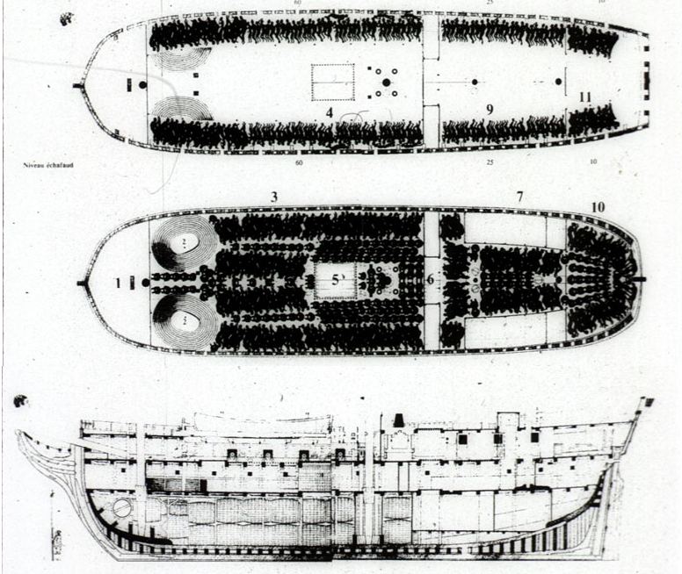
Questions
1. What do you see in these pictures?

2. What do you think these are pictures of? When are they from?

3. What questions do you have from these pictures?

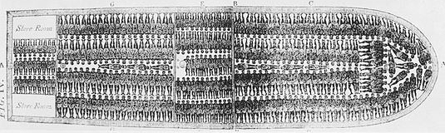
Life on a Slave Ship

The United States used to make most of its money from crops. The most expensive crops were tobacco and cotton. It was a lot of work to raise these crops. There were almost no machines to make the work easier. It was expensive to pay white people, so businessmen made slaves raise the crops. The first slaves were American Indians. But the businessmen soon needed more slaves. They paid a lot of money for them.
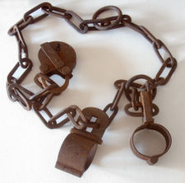 Shackles
Almost all slaves were from Africa. White people or black people took Africans from their homes to make them slaves. They made them go onto slave ships. For many of them, this was their first time seeing the ocean. Slave ships had up to 500 men, women and children on them. They only had enough room to lie down or sit up, and they had to wear shackles the whole time (see picture). They got bad food, and only a little of it. The trip lasted about 100 days.

As many as one third of Africans died on the trip to America. Many got sick from living so close to other people, and from bad food and water. Some Africans refused to eat. But the white people on the ship beat them until they ate their food. Other Africans tried to jump into the water to drown. The white people would try to get them back on the ship. Then they would beat them. The white people working on the ship watched the Africans all the time.

After about three months, the ships arrived in the US. Businessmen ran up to the ships. They would soon buy all the men, women and children from Africa. They made these African people slaves. The Africans made friends on the long trip to the US. They would probably never see their friends again.

Vocabulary
- crops – noun – Plants on a farm. “Rice and grapes are some of California's biggest crops.”
- raise – verb – To make something grow or get bigger. “I raised chickens in my backyard.” “I raised my nephew when he was a young boy.”
- trip – noun – A journey, when you go somewhere. “It's a 45 minute trip from my house to my job.”
- refuse – verb – To say no to something. “I refuse to work for less than $8 an hour.”
- beat – verb – To hit someone. “Some people beat their children.”
- drown – verb – To die from breathing water. “Hundreds of people die in swimming pools every summer.”
Vocabulary
- ___ crops | a. Something slaves had to wear on ships.
- ___ lucrative | b. To die from breathing water.
- ___ raise | c. Plants on a farm.
- ___ trip | d. To say no to something.
- ___ refuse | e. A journey, when you go somewhere.
- ___ drown | f. To make something grow or get bigger.
 | g. Money making.

Questions
1. How did the US used to make most of its money?

2.Why did businessmen want slaves? Why did they pay a lot of money for them?

3. Why did some Africans on slave ships refuse to eat, or try to drown?

4. Why did the white people on the ship try to save the Africans who jumped into the ocean?

5. What happened to the Africans when they got to the US? What happened to the slave ships?

6. What kind of people worked on a slave ship? What do you think people like that do today?

Enough!
What are all the phrases you can think of with “enough”?
Big enough ________________

______________________ ______________________

______________________ ______________________

______________________ ______________________

