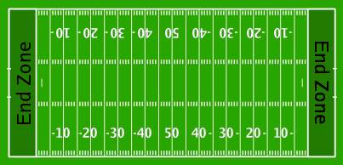
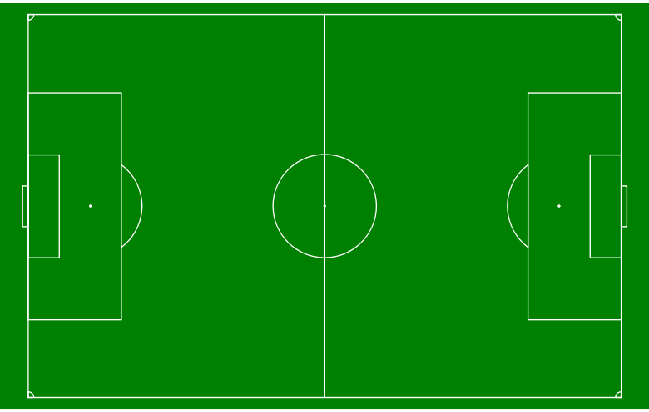
1. What sports are these fields for?

2. What do you know about these games?

3. Which game do you like more? Why?

Can You Name Them?

Soccer | Football
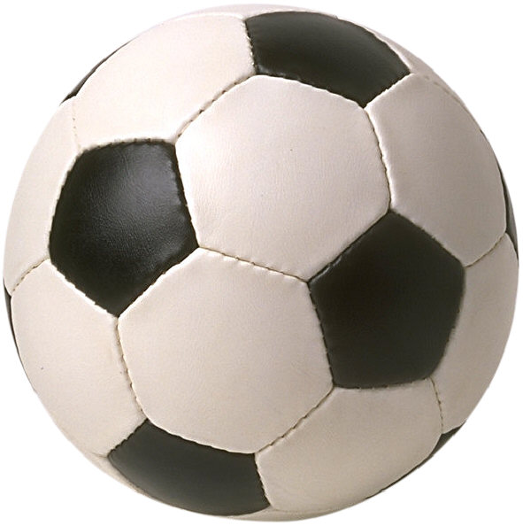  1. _____________  2.___________________________________  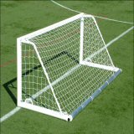  3. _____________  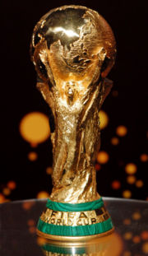  4. ________________ | 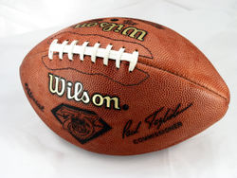  1. ______________  2. __________________________________  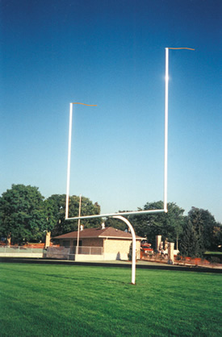  3. ______________  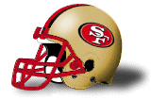  4. ________________
Soccer and Football
 A goalkeeper stopping a goal

Soccer is the most popular sport in the world. It’s a game people play in the smallest villages and the biggest cities in almost every country. Soccer is played with two teams of 11 people. A team scores a goal when they get the ball into the other team’s goal.

The goalkeeper (see picture) is the player who stays by the goal and stops the other team from scoring. Only the goalkeeper can use their hands. All the other players use their feet, heads and chests to move the ball. All goals are worth one point.

Soccer teams from 32 countries around the world play in the World Cup to see who is the best. The World Cup is played once every four years. Over a billion people watched it in 2006.

Football is the most popular sport in the United States. Most high schools and colleges in the US have football teams, and most big cities have professional teams. Football is played with two teams of 11 people. A team scores when they carry the ball into the other team’s end zone. This is called a touchdown.
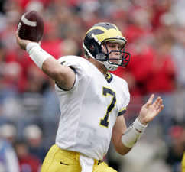 A quarterback

In football, one person on the team is the quarterback (see picture). The quarterback throws the ball to another player on the team. Players try to catch the ball and run to the end zone and get a touchdown. The quarterback can also run with the ball, or hand it to another player.

A touchdown is worth 6 points. After a touchdown, the team can try to kick the ball through the goal posts for one more point. If a team can’t get a touchdown, they can try to only kick the ball through the goal posts for 3 points.

The two best professional teams in the US play in the Superbowl. The Superbowl is played the first Sunday in February every year. About 90 million people watched it last year, almost all of them Americans. Football is also played in Canada and Europe, but it’s not as popular outside the United States.

Vocabulary
- village – noun – A very small town. “No more than 100 people lived in my village.”
- score – Verb: To make a point. “I scored twice in yesterday’s game.”
Noun: The number of points. “The score is 0 to 0.”
- professional – adjective – People who do something for money. “I wanted to play professional football, but I hurt my knee.” “I think she could be a professional singer.”
Questions
1. What’s the difference between soccer and football?

2. What do the two sports have in common?

3. Which do you think is more interesting? Why?

